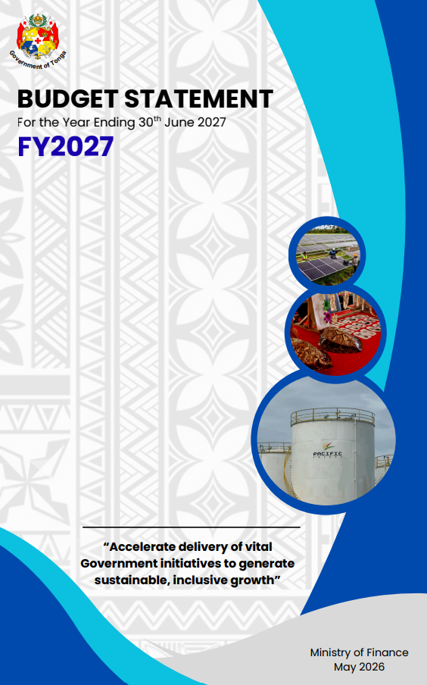

Budget Statement Financial Year 2027

TABLE OF CONTENT

Foreword 1
Executive Summary 4
1. Introduction 6
2. Strategic Framework 7
3. Economic and Social Development Outcomes and Outlook 11
4 Government Budget Details 20
5 Conclusion 31
Annexes I: TSDF OUTCOMES 32
Annexes II: MACROECONOMIC AND FISCAL OUTCOMES AND OUTLOOK 34
Annexes III: GFS SUPPLEMENTARY INFORMATION 61
Annexes IV: RECURRENT BUDGET SUPPLEMENTARY INFORMATION 66
Annexes V: DEVELOPMENT BUDGET 71
Annexes VI: KEY NEW AND ONGOING INITIATIVES 93
Annexes VII: Acronyms 96

LIST OF FIGURES

Figure 1: Share of the FY2027 Budget by SFA 21
Figure 2: Headline GDP growth and Sectors' contribution (%) 36
Figure 3: Tonga's Annual Inflation 42
Figure 4: Drivers of Inflation 42
Figure 5: Headline Inflation versus Brent Crude Oil (US$/Barrel) 43
Figure 6: BOP - Current Account (Quarterly) 43
Figure 7: Import Payments 44
Figure 8: Export Reciepts 44
Figure 9: Travel Receipts 44
Figure 10: Remittance by Currency 45
Figure 11: Gross Official Foreign Reserve 45
Figure 12: Nominal and Real Effective Exchange Rates 46
Figure 13: Banks’ Lending 46
Figure 14: Weighted Average Interest Rate Spread 46
Figure 15: Broad Money Formation 47
Figure 16: Aggregate Financial Stability Index 47
Figure 17: Key NCD Risk Factors (Baseline %) 57
Figure 18: Life Expectancy Trend (Years) 57
Figure 19: Student Enrollment by Education Level 58
Figure 20: Seasonal Worker Flows 59
Figure 21: Total Revenue ($m) 62
Figure 22: Grants ($m) 62
Figure 23: Contribution to Tax Revenue growth (FY2027, %) 62
Figure 24: Contribution to Expense (%) 63
Figure 25: Fixed Assets ($m) 63
Figure 26: Domestic Revenue to GDP 64
Figure 27: Fiscal Deficit to GDP (%) 65
Figure 28: Wage Bill (%) 65
Figure 29: External Debt to GDP (%) 65
Figure 30: Exemption by Tax types, FY2019-FY2025 69
Figure 31: Exemptions by Sector with Share Contribution, FY2019-FY2025 70
Figure 32: Total Development Budget (Expenditure) by Major Projects 75

LIST OF TABLES

Table 1: TSDF2035 National Outcomes and Strategic Focus Area Alignment 7
Table 2: Budget Overview 20
Table 3: FY2027 Budget by SFA 21
Table 4: Total Expenditure Budget Allocation (Recurrent / Development) by MDA 22
Table 5: Share of Budget by MDAs 22
Table 6: Total Receipts Budget Allocation (Recurrent / Development) by MDAs 23
Table 7: Recurrent Budget Overview 24
Table 8: Development Budget Estimate 26
Table 9:Development Budget Estimate by Development Partner 27
Table 10:Development Budget Estimate by Location 28
Table 11: GFS Summary 29
Table 12:Government Fiscal Indicator Performance for FY2025 to FY2029 30
Table 13: IMF Global Growth Projections 34
Table 14: IMF Regional Growth Projections 34
Table 15: FY2027 Fiscal Framework Targets 48
Table 16: Debt Position as at 30th June 2026 – External Debt by Creditor Type 50
Table 17: Domestic Debt by Major Holders as at 30th June 2026 51
Table 18: NPV of Debt to Indicators 51
Table 19: Cost and Risk Indicators 53
Table 20: On-lent Loans as of 30th June 2026 53
Table 21: Government Development Loans as of 31st of December 2025 (Facility closed on 30th September 2025 54
Table 22: Government Guarantee Loans as at end of June 2026 55
Table 23: GFS Detailed Overview 61
Table 24: Recurrent Budget initiatives by SFA in FY2027 66
Table 25: Tax Expenditures by Type of Tax as at FY2025 and Estimated Revenue forgone of a Selected Expenditure Item FY2021-FY2025 69
Table 26: Development Budget Allocation by SFA 71
Table 27: Total Development Budget (Expenditure) by Major Projects 74
Table 28: Key New and Ongoing Initiatives 93

Foreword

During my years serving as Speaker of the Legislative Assembly, I had the privilege of overseeing the passage of eleven national budgets under five different governments. In that role, I witnessed the difficult balance between fiscal responsibility, national expectation, and the realities of governing a small island developing state in an increasingly uncertain world.
Today, my perspective has shifted from stewarding parliamentary process to directly shaping the national direction through the Government’s Budget itself. It is both a profound responsibility and a rare privilege to help determine the trajectory of our Kingdom and the opportunities that will define the future for every Tongan family.
It is with humility and a deep appreciation for the weight of public responsibility that I present my first Budget as Acting Minister for Finance.
The theme for this Budget is:
“Accelerate delivery of vital Government initiatives to generate sustainable, inclusive growth.”
I acknowledge the important groundwork laid by previous administrations in the development of the Tonga Strategic Development Framework 2035 (TSDF 2035). Under this Government, we have formally adopted the framework and repositioned it with greater urgency, ambition, and strategic focus. The challenges confronting Tonga today cannot be solved through incremental change or a continuation of business-as-usual approaches that have left many structural issues unresolved over the past decade and beyond.
The targets we now set for ourselves must therefore be more ambitious because they must reflect the scale of transformation required if Tonga is to become more resilient, more self-sufficient, and more competitive in the years ahead. The true measure of the TSDF 2035 will not be found in policy documents alone, but in the discipline, consistency, and effectiveness of its implementation by this Government and those that follow.
Our nation undertook significant democratic reforms in 2010 with the promise of greater prosperity, stronger governance, and enhanced political stability. Yet many of the challenges that existed then remain with us today, compounded by new and emerging pressures. Tonga continues to face deep structural constraints to growth and development, including restrictive policy settings, legislative gaps, a high government wage bill, rising operational costs, a narrow private sector base, a high cost of finance, high import dependency, elevated energy costs, infrastructure deficits, capability shortages, youth unemployment, and the ongoing migration of skilled labor overseas.
These vulnerabilities are intensified by global economic instability, climate change, and the increasing frequency of natural disasters, all of which continue to erode development gains and place additional strain on public finances and national resilience.
At the same time, there are broader social challenges that demand urgent and coordinated action. Educational retention rates among boys remain critically low, vocational and alternative learning pathways are under-resourced, and our healthcare system continues to experience unsustainable workforce losses as skilled professionals seek opportunities abroad. Across many sectors, the pressures of limited manpower are increasing operational costs while placing significant strain on those who remain in service to our people.
In our outer islands, access to core public services and economic opportunity remains uneven. Large areas of productive land remain underutilized, while our economy continues to rely heavily on a narrow range of sectors vulnerable to external shocks.
Tourism, particularly our internationally recognized whale tourism industry, remains both an economic opportunity and a point of vulnerability. The decline in humpback whale sightings during the 2025 season has reinforced the need for stronger environmental stewardship, science-based policy, and diversification within the tourism sector to ensure long-term sustainability and resilience.
This Government also remains firmly committed to addressing the growing threat posed by illicit drugs. Building on the mandate established through His Majesty’s Illicit Drugs Symposium, we are strengthening a comprehensive national response focused not only on supply reduction, but equally on demand reduction and harm minimization. This work is being advanced in partnership with communities, non-government organizations, health services, law enforcement agencies, and His Majesty’s Prisons.
At the same time, we are investing in new capabilities to strengthen maritime domain awareness and border security, including the exploration of emerging technologies and strategic partnerships to combat transnational crime, improve surveillance capability, and enhance search and rescue operations across our vast ocean territory.
We present this Budget at a pivotal moment for the global economy and for Tonga. Ongoing geopolitical instability and conflict abroad continue to drive volatility in fuel prices and inflationary pressures that directly affect households, businesses, and government finances. These external shocks once again highlight the risks of prolonged dependence on imported energy and external supply chains.
For this reason, the Government is accelerating efforts to transition Tonga toward greater energy security and long-term resilience through the implementation of TERM Plus and the pursuit of innovative renewable energy solutions. While progress in previous years has been slower than intended, this administration is now actively pursuing new technologies, strategic partnerships, and power purchase arrangements to secure affordable, reliable, and sustainable baseload energy for the future.
The FY2027 Budget is therefore shaped by both necessity and long-term national purpose.
It addresses immediate public service delivery requirements, climate resilience priorities, and targeted investments in social and economic outcomes, while managing a projected cash deficit of $38.1 million. This deficit must be understood within the broader context of addressing longstanding foreign loan repayments, structural deficits across infrastructure, energy, capability, and institutional resilience that can no longer be deferred.
This Government does not view deficit financing as an end in itself, nor as a substitute for reform. Rather, it is a temporary but necessary measure to protect our people, respond to critical national gaps, and create the conditions required for long-term sustainability and growth.
The greater danger to Tonga is not strategic investment, it is continued underinvestment and delayed action.
At the same time, we recognize that Tonga cannot achieve true independence and self-sufficiency through public expenditure alone. We must become more innovative, more outward-looking, and more strategic in how we position ourselves for the future.
This requires smarter sequencing of national development priorities, stronger partnerships across government and the private sector, and the pursuit of new financing pathways that leverage nature and climate finance, philanthropic partnerships, renewable energy investment, digital infrastructure, and emerging economic opportunities.
It also requires us to better harness and protect our natural assets, our oceans, biodiversity, and environment not only as part of our national heritage, but as strategic assets capable of supporting long-term economic sustainability under a Blue Pacific for future generations.
The pathway ahead demands a fundamental shift in mindset: from constantly reacting to crises, to deliberately building resilience; from dependency to capability; and from short-term management to long-term nation-building.
Despite the many challenges before us, I remain very optimistic about Tonga’s future.
The resilience of our people has always been our nation’s greatest strength. In times of hardship, Tongans have consistently demonstrated unity, sacrifice, faith, and determination. Those same qualities will be essential as we navigate the challenges and opportunities that lie ahead.
I therefore call upon all Tongans, government, communities, churches, businesses, civil society, and our diaspora abroad to work together in a spirit of shared national purpose. The responsibility of building a stronger and more resilient Tonga belongs to all of us.
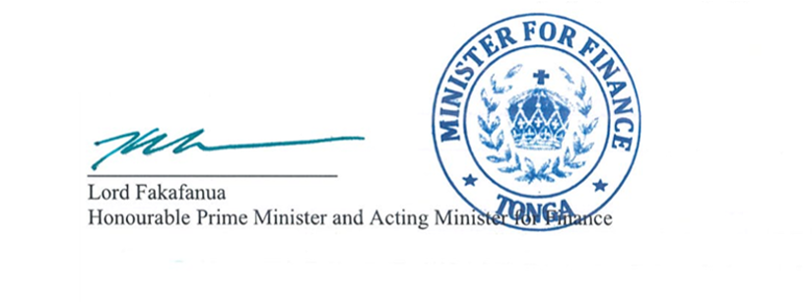
May we continue to work together in service of our people, our sovereignty, and the future of the Kingdom of Tonga. May God continue to bless Tonga.
‘Otua mo Tonga ko hoku Tofi’a!

Executive Summary
Government Policy Direction and Long-Term Vision
The FY 2027 Budget marks the beginning of this Government’s long-term vision for Tonga - a vision founded on building a more innovative, energy-secure, and economically resilient nation capable of driving higher growth, attracting investment, and delivering improved outcomes for our people.
The Government recognises that long-term economic prosperity depends not only on fiscal stability, but also on the country’s ability to strengthen infrastructure, secure energy, improve productivity, and embrace innovation and technology as key drivers of development. This Budget therefore repositions national progress toward a forward-looking growth model grounded in digital transformation, infrastructure renewal, and accountable public service delivery.
This approach builds on the foundation of the Government’s 100-Day Action Plan, where early wins restored momentum and confidence across government. They represented the first phase of a broader national development agenda. The focus now shifts from stabilisation towards strengthening the long-term drivers of growth, investment, resilience, and competitiveness.
We advance this vision in an increasingly uncertain global environment. Geopolitical tensions, including conflicts in Middle East, have contributed to global supply chain disruptions and rising fuel and commodity prices continue to place strain on our local economy and delivery of essential services. These external pressures compound Tonga’s own vulnerabilities from climate change and natural disasters to unforeseen shocks such as the COVID-19 virus and the Hunga Tonga–Hunga Haʻapai volcanic eruption and tsunami.
From a strategic perspective, this requires a more proactive and forward-looking approach to national planning and public finance management. This Budget therefore is not only meeting immediate service needs, but also supports longer-term investments in resilience, energy security, infrastructure, innovation, and institutional capability to ensure the country is better positioned to withstand future disruptions.
In short, we must “accelerate delivery of vital Government initiatives to generate sustainable, inclusive growth”.
The FY2027 Budget moves beyond growth and development, it is about strengthening national resilience and building capacity to anticipate absorb and respond to external shocks, securing a stronger future for Tonga. Resilience – whether in relation to climate change, natural disaster, growth security, economic shocks or unforeseen crises - are integrated across the Budget, recognizing the compounding risks faced by the country. At the same time, the Budget maintains a strong community-centred focus, prioritizing support for vulnerable households, and promoting inclusive growth.
A key strategic focus of the FY2027 Budget is the Government’s commitment to strengthening infrastructure and connectivity. Priority investments include the continuation of the development of the Fanga’uta bridge, Nafanua bridge and centralised e-government projects, New Fua’amotu International Airport Project, Tala Kei Kapa Grant Preparedness, Response and Recovery, Pacific Healthy Islands Transformation Project, Social Welfare Scheme through a 50.0 percent top-up, youth leadership initiatives, HACCP-certified multipurpose packhouse in Vava’u, Food processing equipment, Canberra Tonga High Commission mission, and 3.0 percent Cost of Living Adjustment.
Together these initiatives form part of a broader strategy to strengthen domestic connectivity, support private sector development and economic diversification, improved service delivery, reduce transportation and operational costs, and build the foundations for long-term economic resilience and growth. In the context of the ongoing fuel crisis, improve infrastructure and connectivity will also contribute to greater efficiency in the movements of goods and services across Tonga.
The FY2027 Fiscal and Economic Outlook
The FY2027 Budget projects an overall budget deficit of $38.1m reflecting the Government’s deliberate policy choice to support the domestic economy through stimulus spending during this period of heightened pressure. This deficit will be financed through domestic financing. While we have made consistent progress, global pressures continue to challenge our momentum and we estimate economic growth for FY2027 at 1.9 percent - a decline of 0.6 percentage points from previous projections, directly attributed to these international instabilities.
In addition to the sharp rise in fuel prices, temporary fuel management measures and potential supply disruptions are also expected to weigh on economic activity across several sectors, with risks particularly elevated in the transport sector and other fuel-dependent industries. Under the more severe scenarios considered, prolonged disruptions could place significant pressure on economic activity, with GDP projected to contract by around 4.0 percent, exceeding the decline experienced during the COVID-19 period. The indicative fiscal envelope for the energy crisis is estimated to range from approximately $11.0m to near or over $120.0m depending on the severity and duration of the disruption, based on the latest GDP projections. This range reflects the substantial uncertainty surrounding the ongoing Middle East conflict and its potential impact on fuel supply and prices.
To support the emergency response to fuel disruption and other unforeseen events, the Government has allocated targeted funding measures worth $31.8m in FY2027. This is in addition to the range of non-financial measures currently under implementation, while the Government will also continue to closely monitor global developments and their potential domestic impacts. These measures include:
- $18.0m in electricity subsidies to cushion tariff increase resulting from the energy crisis while maintaining the existing lifeline tariff scheme for the most vulnerable households;
- $1.0m in contingency funding to respond to worsening or prolonged impacts;
- $5.0m allocated to fund a 3.0 percent Cost-of-Living Allowance (COLA) for all civil servants in response to increased living costs as a result of the energy crisis (this is classified under SFA 5.1 Public Service Delivery);
- $3.2m in subsidies for the domestic airline Lulutai;
- $3.7m in subsidies for domestic shipping vessels; and
- $0.9m allocated to provide a one-off top-up payment for elderly and disability welfare recipients.
In terms of Government revenue, the potential losses attributed to the energy crisis are estimated to result in a decline of $14.0m from the current year’s target. This places a total cost of the energy crisis on the national budget of between $40.0m - $50.0m, requiring the Government to pursue combination of financing measures, including support from development partners, domestic bond issuances, utilization of Government cash reserves, and where necessary, a Supplementary Budget in the event of severe disruption.
Over the medium term (FY2027–FY2029), economic growth is expected to recover to an average of 2.5 percent, supported by accelerated project implementation, increased construction activity, and easing external price pressures, leading to a normalization in economic conditions.
The effective implementation of this Budget will require strong coordination across Government, development partners, the private sector, and the broader community. Through disciplined execution and collective effort, Tonga will be better positioned to manage the current fuel crisis, strengthen resilience, support economic recovery, and advance toward a more sustainable and prosperous future.

Introduction
The FY2027 Budget sets out the Government’s fiscal priorities, policy direction, and key expenditure measures for the financial year ahead. It outlines the Government’s approach to supporting economic stability, strengthening service delivery, responding to emerging national challenges, and advancing longer-term development priorities.
The Budget also provides the broader economic and fiscal context informing Government decision-making, including the pressures arising from global instability, the fuel crisis, and domestic resilience challenges. In doing so, it sets out the key policy measures, strategic investments, and implementation priorities that will guide Government action over the coming financial period.
Note:
- All amounts stated in this document are in Tongan Pa’anga unless otherwise indicated.
- Totals in tables may not sum due to rounding.
- Financial Year (FY) is read as, for example: FY2027 = 2026/2027 ending to the 30th of June 2027
- $xx m: the letter ‘m’ refers to a ‘million’ or millions of Tongan Pa’anga unless otherwise indicated.

Strategic Framework

2.1 Tonga Strategic Development Framework 2025-2035
The third Tonga Strategic Development Framework (TSDF2035) continues to guide Tonga’s long-term strategy for improving our economic, social and environmental well-being, to be achieved through transformation of our strategic approach, good governance and inclusive policies over the period 2025 – 2035. TSDF2035 has been designed to build upon the progress and the challenges realized under the two earlier TSDFs (TSDF I & TSDF II) and will provide a long-term framework to support the design and implementation of effective policy.
Over the next decade, TSDF2035 will guide the Government’s strategic direction across seven national outcomes as follows:

- National Resilience & Climate Adaptation Strengthened;
- People & Communities Empowered;
- Inclusive Economic Growth Fostered;
- Tongan Culture Utilized & Promoted;
- Governance Enhanced;
- National Security & Sovereignty Safeguarding; and
- Sustainable Resource & Environment Management Ensured.

The National Outcomes and Strategic Focus Area alignment
TSDF2035 provides the overarching framework for the Medium-Term Fiscal Strategy FY2027 - 2029. The proposed Strategic Focus Areas for the FY2027 Budget Estimates are consistent with this framework, clearly aligning long-term high-level objectives with short-term priority targets.
Table 1: TSDF2035 National Outcomes and Strategic Focus Area Alignment
TSDF2035 National Outcome | TSDF2035 Strategic Focus Area
Objective 1: National Resilience
National Resilience and Climate Adaption Strengthened (1) | Climate Resilient Infrastructure and Disaster Preparedness (1.1)
National Security and Sovereignty Safeguarded (6) | National Security, Disaster Response, Community Safety, Law Enforcement and Drug Control (6.1)
Sustainable Resource and Environment Management Ensured (7) | Sustainable Resource Use, Environmental Protection and Oceans Resilience (7.1)
Objective 2: Social Sector Improvement
People and Communities Empowered (2) | Quality and Inclusive Education for All (2.1)
 | Health, Wellbeing, and Inclusive Social Services (2.2)
Tongan Culture Utilized and Promoted (4) | Cultural Preservation, Education and Tourism Integration (4.1)
Objective 3: Inclusive Growth and Public Sector Efficiency
Inclusive Economic Growth Fostered (3) | Productive Sectors, Employment and Private Sector Development (3.1)
Governance Enhanced (5) | Efficient Service Delivery and Accountable Public Service (5.1)
Source: Prime Minister’s Office

Overall, under the FY2027 Budget theme there will be a renewed focus placed on seeking to improve government operations and delivery, in light of the performance of several key initiatives in FY2026. This will require close collaboration across the Government, as well as the continued development of effective partnerships with key stakeholders.

2.2 Policy Measures by Strategic Focus Area
For each of the SFAs outlined below, the MDAs have considered specific measures in the formulation of their corporate plans. The successful implementation of such measures will promote responsible public financial management, protect macroeconomic stability, and support sustainable long-term growth.
Objective 1: National Resilience
SFA 1.1: Climate Resilient Infrastructure and Disaster Preparedness
Strengthen Tonga’s capacity to anticipate, withstand, and recover from external shocks including global disruptions through improved disaster risk governance, resilient infrastructure, adaptive financial mechanisms, and robust communication systems. These ensure that public institutions, communities, and critical services are climate proof and financially prepared. Selected specific areas are identified to enhance disaster preparedness, infrastructure resilience, environmental sustainability, and sovereign risk protection mechanisms.
Specific output areas under this SFA include:
- Ongoing efforts to strengthen disaster preparedness and risk management (MEIDECC).
- Ensure adherence to building code for resilient buildings and infrastructure (MOI, MLNSPR).
- Ongoing measures for energy supply diversification and addressing the rising fuel crisis (MEIDECC, MOF, MPE).
- Strengthening climate and disaster financing supported by effective budget system reforms (MEIDECC, MOF).
SFA 6.1: National Security, Disaster Response, Community Safety, Law Enforcement and Drug Control
Safeguard national sovereignty and public safety by enhancing internal security systems, border protection, law enforcement capacity, and emergency response coordination. Promote a stable, peaceful, and resilient society that mitigates internal and external threats while maintaining social cohesion and community trust. Selected specific areas under this SFA include initiatives to strengthen border protection, law enforcement capability, diplomatic presence, and national security infrastructure.
Focus areas under this SFA include:
- Strengthen efforts towards combating illicit drugs and cybersecurity (PMO, Tonga Police, MOF, MEIDECC, HMDS, MORC, HMAF, HMP).
- Increase support towards overseas missions and specific measures for immigration related issues (HMDS, MOF, Tonga Police).
SFA 7.1: Sustainable Resource Use, Environmental Protection and Oceans Resilience
Implement proactive policies to enhance land and forest management procedures, strengthen ocean preservation protections, improve waste management and further integrate renewable energy into Tonga’s existent energy supply. Focus on the protection of Tonga’s natural wealth, the preservation of ecosystems, and meeting climate-change commitments to ensure sustainable livelihoods for all Tongans citizens.
Specific output areas under this SFA include:
- Scaling renewable energy and energy security and prioritization of sustainable land and forest management (MEIDECC, MAFF, MoF).
- Continue efforts towards Invasive species and recommendations of the Ocean Management Act 2025 (MEIDECC, MoF).
Objective 2: Social Sector Improvement
SFA 2.1: Quality and Inclusive Education for All
Ensure equitable access to high quality education across all islands, integrating modern skills, innovation, and resilience into curricula while preserving Tongan values and identity. Strengthen institutional capacity, teacher quality, and education infrastructure to empower children, youth, and lifelong learners for productive participation in the economy.
Specific output areas under this SFA include:
- Ongoing reviews to curriculums, improving education information systems, building capacity for teachers, and enhancing delivery and access to all levels of education (MET).
- Implementation of the Tonga Safe & Resilient Schools Project (MET, MOI, MOF).
SFA 2.2: Health, Wellbeing, and Inclusive Social Services
Improve population health outcomes through accessible, affordable, and resilient healthcare systems. Strengthen primary care, preventative health services, and social protection mechanisms to protect vulnerable groups and enhance preparedness against health crises.
Specific output areas under this SFA include:
- Enhance the delivery of and accessibility to primary healthcare, curative and preventative services, while improving NCD management (MOH, Tonga Health, MORC, MAFF, MoF).
- Support ongoing health measures/initiatives for better health service delivery (MOH, MOF, MOI).
- Support to social protection measures for vulnerable groups (MIA, MOH, MOF, MTED).
SFA 4.1: Cultural Preservation, Education and Tourism Integration
Protect, promote, and integrate Tongan culture, language, and traditional knowledge into national development planning and education systems. Ensure that cultural values remain central to policy design and community development while enabling adaptation to modern economic and social realities.
Specific output areas under this SFA include:
- Support ongoing works and initiatives preserving cultural sites, Tongan language, and culture. (MET, MOT, MAFF, MoF, MTED, Palace Office, MIA).
Objective 3: Inclusive Growth and Public Sector Efficiency
SFA 3.1: Productive Sectors, Employment and Private Sector Development
Stimulate inclusive economic growth across all islands, providing employment opportunities, strengthening entrepreneurship, improving access to finance, and enhancing sector productivity. Support local economic resilience through targeted investment, innovation, and private sector development.
Specific output areas under this SFA include:
- Support the implementation of key infrastructures for economic development across all sectors (MTED, MAFF, MoF, MOT, MOI, MEIDECC).
- Promote initiatives on access to finance and consumer protection to support private sector development (MOF, MTED).
SFA 5.1: Efficient Service Delivery and Accountable Public Service
Promote a high trust, accountable, and performance driven public sector that delivers effective services nationwide. Strengthening transparency, fiscal discipline, institutional capability, and citizen engagement to ensure efficient policy implementation and sustainable national development.
Specific output areas under this SFA include:
- Support the strengthening existing mechanisms for better coordination and service delivery among Government ministries (PMO, MOF, PSC).
- Support measures to increase transparency, accountability and efficient policy implementation (ACC, AGO, TOAG, MOF, OMB).

Economic and Social Development Outcomes and Outlook

3.1 Global and Regional Development

Global Outlook
The global outlook remains highly uncertain due to the ongoing conflict in the Middle East and its impact on energy markets. The IMF projects global growth to remain stable at 3.1 percent in 2026, supported by technology investment and easing trade barriers. This outlook assumes that energy disruptions are temporary, with prices expected to ease from mid-2026. The outlook for FY2027 is projected to increase to 3.2 percent assuming that the pressure gradually eases, particularly if the energy markets stabilize and inflation moderates; however, it’s still highly uncertain.
However, disruptions to energy supply routes have already increased global energy and commodity prices. This is placing an upward pressure on inflation and extending inflationary pressures for longer. G20 inflation, which indicates the average inflation across developed economies, is now projected to remain elevated at 4.0 percent in 2026 before easing to 2.7 percent in 2027.

Regional Outlook
The World Bank projects Pacific Island economies to moderate to an average growth of 2.8 percent in 2026, before recovering to 3.0 percent in 2027, compared to 3.2 percent in 2025. The weaker outlook is mainly attributed to higher global energy prices arising from the conflict in the Middle East. Pacific economies remain highly vulnerable due to their dependence on imported fuel, with further pressures from rising transport costs, food prices, and persistent global uncertainty.
Tonga’s growth outlook remains below several regional peers, reflecting its narrow production base and continued outward migration. However, these projections may not fully reflect the downside risks associated with sustained fuel price pressures and broader external shocks. Key neighboring economies are also expected to record moderate growth, although they remain exposed to global inflationary pressures and disruptions in energy markets.

Fiscal Outcomes and Outlook for Tonga

3.2.1 Medium-Term Fiscal Strategy (FY2027 – FY2029)
The three-year fiscal strategy for FY2027–FY2029 is designed in alignment with the TSDF2035: SFA priorities for the fiscal year ahead. The strategy can be summarized as follows:
i. Strengthening domestic revenue mobilization to maintain collection at or above 22.0 percent of GDP, through continued tax administration reforms, enhanced compliance, and efficiency gains; with no increase in tax rates or new tax imposed;
ii. Maintaining fiscal discipline while targeting a budget deficit/surplus between -1.0 and +1.0 percent of GDP under the GFS framework by enforcing expenditure controls and aligning spending with SFA prioritized areas;
iii. Meeting debt repayment obligations and ensuring prudent debt management, implementing the reforms outlined in the Medium-Term Debt Strategy 2026-2028 and continuing to develop the domestic bond market to diversify financing sources and manage risks;
iv. Enhancing public finance management systems and consistently implementing all aspects of the public financial management Reform Action Plan (2025–2029);
v. Building resilience to shocks, natural disasters, and economic crises by incorporating fuel crisis response, climate resilient debt instruments and exploring innovative financing options;
vi. Supporting inflation management and cost-of-living measures through collaboration with relevant stakeholders to monitor risks, explore subsidy arrangements, and promote renewable energy;
vii. Prioritizing investment in key infrastructure and human development, including bridges, schools, hospitals, and expanding social protection programs, while also exploring options to expand existing storage capacity for fuel and/or proposals for new storage facilities for further discussion with development partners;
viii. Fostering partnerships with the private sector and communities, unlocking growth opportunities and delivering increased investment to support key sector initiatives;
ix. Promoting environmentally responsible initiatives across key industries, including agriculture, fisheries, and tourism which can further diversify Tonga’s economy through sustainable growth practices;
x. Strengthening fiscal-monetary coordination between Ministry of Finance (MOF) and National Reserve Bank of Tonga (NRBT) to avoid conflicting policy signals, aligning budget expansion and monetary tightening to reinforce macroeconomic credibility and avoid inflationary pressures. This will include collaboration across the following initiatives:
a. Expanding access to finance through a strengthened credit environment, fast-tracking the Credit Registry Bill, and promoting credit guarantees, improved land administration, and insurance access for growth sectors;
b. Deepening domestic financial markets, issuing sovereign and ADB-backed bonds, and developing a yield curve to attract investment; and
c. Improving monetary policy effectiveness by redefining the policy interest rate framework, issuing NRBT notes, maintaining the SRD at 15.0 percent, and enhancing public communication and stakeholder engagement.

Revenue and Expenditure Measures in the fiscal strategy (FY2027–FY2029)
Revenue and expenditure measures under the medium-term fiscal strategy are designed to support sustainable fiscal management, promote inclusive growth, and ensure prudent use of public resources, while closely monitoring the evolving global oil crisis and its potential impact on the domestic economy. Specific revenue and expenditure measures within the medium-term fiscal strategy include:
Revenue Measures
1. Strengthen enforcement and compliance:
• Expansion of the Electronic Sales Register system remains a priority to strengthen Consumption Tax compliance; and
• Greater collaboration and coordination among relevant MDAs is required to improve information sharing for enforcement purposes.
2. Better coordination between the MDAs regarding revenue policies:
• In the development and administration of revenue-related policies; and
• In reviewing tax exemptions and non-tax fees to ensure value-for-money and that the relevant policies remain fit-for-purpose.
3. System modernization:
• To improve operational efficiency;
• To improve audit capacity; and
• To improve monitoring and evaluation of revenue policy

Expenditure Measures
      - Strengthen Expenditure Controls
• Strengthen prudent expenditure management by rationalizing non-essential operational spending while maintaining efficient and effective government service delivery;
• Continue the Civil Servants’ Personal Accident Insurance Trust Fund to provide a more cost-effective alternative for employee coverage and reduce fiscal pressures; and
• Maintain fiscal buffers to allow flexibility in responding to unexpected increases in global fuel prices.
      - Reprioritize Government Spending Toward National Priorities
• Investment in fuel crisis response, data and e-government, and operational support reforms to improve workforce efficiency;
• Sustain commitments to critical infrastructure investments, including Fanga’uta SECURE Bridge, schools, hospital, and other essential public assets;
• Increase investment in climate resilience, renewable energy, and disaster preparedness, while exploring options to strengthen fuel storage capacity and energy security in partnership with development partners; and
• Continue targeted social protection programs, including support for the elderly and vulnerable groups.
3. Strengthen Wage Bill Management
• Closely monitor new recruitment and utilize contract-based arrangements where appropriate;
• Assess opportunities for greater private sector outsourcing where cost-effective; and
• Remove outdated budget provisions for long-term unfilled vacancies.
4. Maintain Prudent Debt Management
• Avoid new external borrowing unless it is highly concessional;
• Limit new borrowing to essential needs only;
• Continue efforts to meet existing debt obligations; and
• Continue to develop the domestic bond market.
5. Mitigate Inflation and Cost of Living Pressures
• Closely monitor global oil crisis movement, consider temporary and targeted support measures for essential goods and services where necessary; and
• Ensure any intervention remains well-targeted to avoid excessive fiscal costs and unintended inflationary pressures.

Economic Sector Outcomes and Outlook
Real GDP growth figures for FY2025 are yet to be ratified, however, under the latest projections, growth is expected to have increased to 2.7 percent, up from 1.7 percent in FY2024, driven by a recovery in the agriculture sector following the FY2024 El Niño impact and sustained activity in the services sector. Growth was partly moderated by a slowdown in construction activity following the completion of a number of major projects.
In FY2026, GDP growth is expected to ease to 2.3 percent, reflecting delays in the implementation of key development initiatives, including postponements in large infrastructure projects, which are weighing on construction activity. In addition, the heightened geopolitical tensions in the Middle East, with associated global oil price volatility, is expected to have negatively influenced economic momentum toward the end of the fiscal year.
Looking forward, real GDP growth is forecast to recover to reach an average annual rate of 2.5 percent over the medium term. However, while the economy is currently expected to remain broadly stable given the status of the fuel supply to date, the outlook is tilted to the downside. Sustained geopolitical tensions in the Middle East risk continued volatility in global oil prices, with downstream impacts likely to affect domestic inflation and economic activity.

Primary Sector
The primary sector is expected to record real growth of 2.2 percent in FY2026, moderating from the stronger rebound recorded in FY2025 (4.7 percent). This easing reflects a normalization following the post-El Niño recovery, with agricultural output stabilizing and fisheries activity showing modest improvement. While production levels have recovered, growth momentum has softened as the sector transitions from recovery to a more stable path.
Primary sector activity is estimated to account for around 15.3 percent of Tonga’s total GDP in FY2026. The sector’s contribution to total GDP has undergone a gradual decline in recent years, with output negatively affected by the natural disasters and adverse weather conditions experienced. Additionally, structural shifts within the economy, particularly concerning labor supply and land management, have limited agricultural output, with the proportion of fallow agricultural land having increased significantly.
Looking ahead, the primary sector is projected to grow at an average rate of around 2.1 percent over the medium-term (FY2027 - FY2029), supported by steady agriculture and a gradual recovery in fisheries. However, the outlook remains exposed to risks, including natural disasters and climate-related weather events, which can disrupt production and damage infrastructure. Rising global prices for fuel, inputs, and transport may increase operating costs and reduce production levels. Supply disruptions could delay the arrival of key inputs and the shipment of exports, affecting both production and market access, and ultimately slowing overall growth.
Overall, while the sector is expected to stabilize, its contribution to overall GDP growth is projected to remain modest, reflecting both structural limitations and exposure to external and environmental shocks.

Industrial Sector
Activity in the industrial sector rebounded slightly in FY2026; however, this followed a drop in activity in FY2025, where the sector contracted by 0.3 percent. This contraction was primarily attributed to a decline in both construction activity (-1.3 percent) and mining and quarrying (-2.0 percent) following the completion of major projects such as Tonga High School Sports Complex, as well as a slowdown in the implementation of new projects. Of the other sub-sectors which comprise the industrial sector, electricity and water supply grew by 2.9 percent, while manufacturing activity remained broadly stable with 0.2 percent growth.
In FY2026, the industrial sector accounted for a 19.6 percent share of GDP, and is projected to recover modestly with a 0.5 percent expansion in activity. However, growth remains subdued due to continued delays in implementing key infrastructure projects such as SECURE Fanga’uta bridge, Vava’u hospital and Tonga National Museum and the impact of the fuel crisis, which has increased operational costs and disrupted production across all sub-sectors. Construction (1.0 percent) and mining and quarrying (1.5 percent) show only minor improvements, while manufacturing growth remains limited at 0.4 percent, and electricity and water supply is expected to contract slightly (-1.0 percent).
Over the medium-term (FY2027 – FY2029), the industries sector is expected to strengthen, with average growth of 2.3 percent. This positive outlook is supported by the rollout of new major infrastructure projects and increased budget support, alongside a recovery in private sector investment. The construction sector is expected to remain the key driver, while mining and quarrying will benefit from renewed demand for materials. Manufacturing is projected to gradually strengthen, supported by improved economic conditions and business confidence. The utilities subsector is expected to expand steadily, particularly in the outer years, supported by ongoing investment in renewable energy, including solar and water infrastructure.
Importantly, the positive outlook for the outer years is reliant on the assumption that fuel supply conditions normalize, with no further fuel crisis disruptions. This is expected to ease cost pressures and improve production efficiency across all sub-sectors, although the outlook remains uncertain.

Tertiary Sector
In FY2026, the tertiary sector occupies 51.3 percent share of GDP and growth is projected at 3.3 percent, a moderation from 3.8 percent in FY2025. This is mainly driven by the wholesale and retail trade subsector, reflecting its strong dependence on household income, remittance inflows, and consumer confidence. Elevated inflation, particularly fuel, alongside rising living costs, is expected to constrain household spending and dampen retail activity and related distribution services.
Tourism activity is also expected to remain positive in FY2026, driven by major national celebrations, including the 150th anniversary of the Tonga Constitution, the Centenary of Queen Salote College, and the Bicentennial anniversary of the arrival of Christianity in Tonga. These celebrations are anticipated to boost visitor arrivals and related services across the economy. However, growth in the transport sector is likely to remain volatile as a result of the fluctuations in global fuel prices and changes in shipping and flight frequencies. In addition, expansion in public administration may be constrained by workforce shortages and skills mismatches, as well as continued reliance on external funding. Collectively, these factors are expected to contribute to a moderation in overall growth within the Tertiary sector.
Over the medium-term (FY2027 – FY2029), the tertiary sector is projected to grow at an average of 3.4 percent. This outlook is underpinned by a gradual recovery in tourism, consistent with the Tourism Roadmap 2023-2028, alongside improvements in airline capacity and increased cruise ship arrivals. In addition, resilient remittance inflows are expected to continue supporting household consumption, underpinning retail trade, and stimulating residential construction. Together, these factors will help sustain domestic demand despite ongoing external uncertainties.

3.3 Social Outcomes and Outlook
In the health sector, the Government continues to prioritize the health sector as a cornerstone of human development, recognizing that improved health outcomes are essential for productivity, economic resilience, and quality of life. Efforts will focus on strengthening primary health care, addressing the growing burden of Non-Communicable Diseases (NCDs), and advancing progress toward Universal Health Coverage (UHC). Key investments include the continuation of the Queen Salote Nursing School project ($7.0m) and the Health Clinic ($5.0m), alongside ongoing maintenance of health centers. In addition, the new Dialysis Centre has been fully constructed, with training and recruitments of key staff now underway, while a formal agreement has been signed for the development of the new Vava’u Hospital.
For the education sector, the Government recognizes the central role of education in economic development, with the Government undertaking marked efforts to promote education accessibility, improve partnerships with non-government schools, and bolster infrastructure resilience. These efforts extend across multiple educational investment programs focused on revising the school curriculum and injecting better resources towards the overarching principle of raising education standards. This includes the continuation of grants to non-government schools, an increase of $2.0m in grant allocation to Tonga National University, the provision of $1.5m for the school breakfast program, and a further increase to the Tonga National Qualifications and Accreditation Board, scholarships, and annual member contribution to the University of the South Pacific. These efforts help address the financial barriers faced by households, which the Ministry of Education and Training’s Education Sector Analysis (ESA) has identified as a primary driver of school drop-out rates.
Regarding labor force participation, the latest data concerning the domestic labor force found that Tonga’s labor market was relatively stable, with an unemployment rate of 2.2 percent representing a decline of 0.9 percentage points from 2018 (Labor Force Survey 2023). The Labor Force Participation Rate (LFPR) was estimated at 45.0 percent, with stronger participation in urban areas compared to rural areas. This is low compared to global averages of 60.0 percent, but broadly in-line with other Pacific Island nations. Additionally, labor mobility schemes continue to play a significant role in shaping Tonga’s labor market outcomes with data for 2025 and the first quarter of 2026 indicating sustained participation in employment programs such as the Pacific Australia Labor Mobility (PALM) scheme and the New Zealand Recognised Seasonal Employer (RSE) scheme. Going forward, labor mobility policy efforts will focus on strengthening skills development to support access to higher-value employment opportunities, improving reintegration pathways for returning workers, and enhancing labor market participation, particularly among youth. Accordingly, the FY2027 budget includes additional funding for extra liaison officers under the seasonal workers’ scheme stationed in Queensland and Western Australia.
For social protection and social welfare, the Government remains committed to supporting vulnerable groups by continuing the provision of social welfare benefits for both the elderly and persons with disabilities. The total number of beneficiaries currently stands at 6,057 for the elderly and 2,669 for persons with disabilities. In recent years, Tonga has experienced increasing economic pressures, including rising inflation and a higher cost of living. Additionally, ongoing volatility in global energy markets has contributed to increased transportation costs and upward pressure on the prices of essential goods and services. These developments have placed considerable strain on vulnerable groups, particularly those who rely primarily on government assistance.

3.4 Public Debt Outcomes
As of the 30th of June 2026, Tonga’s total disbursed outstanding public debt is projected to reach $396.8m, equivalent to 22.9 percent of GDP. External public debt is projected to have declined by $34.6m from June 2025 to June 2026, primarily due to external debt repayments. Domestic debt repayments are fully offset by rollovers, with the new issuance of Government Bonds worth $20.8m to be fully issued by end of June 2026.
The majority of the reduction in public debt over recent years is primarily attributable to scheduled repayments of the EXIM loan. This approach is complemented by the Government’s debt strategy, under which new borrowing is limited to that required for essential needs only. By adopting a disciplined approach, the Government seeks to support the medium-term objective of maintaining sustainable debt levels while allowing fiscal space for priority development expenditure.

3.5 Public Financial Management
Accelerating the delivery of new government initiatives requires addressing several interrelated constraints, particularly those associated with implementation processes. There is no single factor responsible for delays; however, the Government’s principal focus is the reform of procedural requirements, particularly concerning procurement activity, which is viewed as key to unlocking public sector delivery. Additionally, revisions to the budgeting approach, including moving towards a medium-term (three-year) framework and introducing program budgeting, are seen as key in improving delivery efficiency.
Additional Government reforms program underway include those concerning revenue and tax administration; economic and fiscal reforms focused on strengthening fiscal stability, budget management and debt control; monetary reforms shifting NRBT policy towards more market-based monetary tools; and reforms targeting the private sector and business environment, seeking to simplify business registration, modernize foreign investment laws and improve towards digital business registry systems.

External Sector Development

3.6.1 Balance of Payments
The current account has deteriorated, shifting from surplus to deficit in recent periods (2nd – 3rd Quarter 2025). This reflects:
  - Higher import spending;
  - Increased service-related outflows; and
  - Moderating inflows from remittances and aid.
Imports remain the largest component of foreign exchange outflows, accounting for over half of total payments, with fuel imports continuing to pose a key risk. Export performance remains limited and concentrated, although agricultural exports have shown improvement. Tourism receipts have continued to recover from the trough experienced during the COVID-19 pandemic period, supporting services exports.
Promoting import substitution in key areas, particularly food and energy, remains essential in order to reduce external vulnerabilities. At the same time, supporting export-oriented sectors and strengthening value chains will be critical to improving external balances and sustaining growth.

Foreign reserves
Foreign reserves remain strong, rising to approximately $924.5m in March 2026, equivalent to around 10.8 months of import cover, well above recommended adequacy thresholds. This strong reserve position reflects sustained inflows from remittances, official grants, and budget support, providing an important buffer against external shocks.
Maintaining prudent fiscal and external management remains essential to preserve adequate reserve buffers. External inflows should be utilized efficiently to support long-term growth and strengthen economic resilience.

Remittances
Remittances remain a critical pillar of Tonga’s external sector and domestic economy. As of February 2026, remittances had increased by 9.7 percent annually to reach approximately $582.3m. They account for an estimated 38.8 percent of GDP, and continue to support household consumption and banking system liquidity. Remittance inflows are largely driven by private transfers, with flows concentrated in major currencies such as the Australian dollar, US Dollar, and New Zealand dollar. While remittances remain strong, they are vulnerable to global economic conditions, particularly those affecting key partner countries.
Encouraging channels that direct remittances towards savings and productive investment remains important to enhance their development impact. Strengthening financial inclusion and expanding digital financial services will further improve the effective use of remittance flows across the economy.

Exchange Rate Developments
The nominal effective exchange rate has slightly depreciated, falling by 0.5 percent. This development supports remittance inflows but has contributed to higher imported inflation. Meanwhile, the real effective exchange rate has increased by 1.4 percent, indicating some loss in competitiveness.
Monitoring exchange rate developments remains essential in order to balance inflationary pressures while maintaining external competitiveness. At the same time, advancing productivity-enhancing reforms will be critical to sustaining competitiveness over the medium-term.

Monetary Outcomes & Outlook

3.7.1 Inflation trends and outlook
Inflation has accelerated sharply, rising to 4.6 percent in March 2026, with core inflation significantly higher at 9.5 percent. The increase has been driven primarily by imported inflation, particularly in fuel, transport, and food product prices. Rising global oil prices and supply disruptions are expected to further intensify inflationary pressures, with an elevated risk of inflation reaching double figures in the second quarter of 2026.
Targeted and temporary fiscal measures should be implemented to cushion vulnerable households from rising price pressures. The Government will seek to ensure fiscal sustainability by avoiding broad-based subsidies, with emphasis placed on efficient and well-targeted interventions to provide effective support.

Interest Rates and Monetary Policy
The NRBT has maintained a neutral monetary policy stance, keeping the policy rate at 2.0 percent to balance inflation risks and economic recovery. The weighted average interest rate spread narrowed by 2.2 basis points to 6.1 percent in the year to February 2026, driven mainly by higher deposit rates. Lending rates also increased by 4.7 basis points, reflecting higher borrowing costs for both businesses and households across key loan categories.
Strengthening monetary and fiscal co-ordination is essential to enhancing overall policy effectiveness. Continued reforms to improve liquidity management and financial market functioning are also required to support more efficient monetary transmission and financial stability.

Lending and Credit Conditions
Credit growth remained positive but moderated to 2.4 percent ($14.5m) for the year ending February 2026, bringing total lending to $607.9m, with a peak of $611.9m in January. Growth was driven by both business lending ($8.5m or 2.7 percent) and household lending ($5.9m or 2.1 percent). While credit is expected to remain positive in the near term, risks persist from the fuel crisis and weaker lending appetite. Non-performing loans edged down slightly to 13.9 percent but remained above the internal threshold of 10.0 percent, requiring continued close monitoring.
Expanding targeted financing initiatives, including development loans and credit guarantee schemes, is important to improve access to finance for productive sectors. At the same time, addressing structural constraints is essential to enhance financial inclusion and support greater investment, growth, and productivity.

Broad Money and Liquidity
Broad Money increased by $79.1m (8.6 percent) to $994.0m as of February 2026, driven by higher net foreign assets, while net domestic assets declined due to movements in capital accounts and net credit to government. Reserve Money rose by $24.9m (4.1 percent) to $639.1m, supported by growth in currency in circulation and statutory reserve deposits, alongside higher NRBT Notes, while Exchange Settlement Accounts declined. Excess liquidity fell to $211.0m in January 2026 following NRBT Note issuance, but remains elevated, reflecting weak investment absorption and delays in the utilization of available funds in the banking system.
Improving public investment execution is necessary to better absorb excess liquidity in the financial system. Strengthening financial intermediation is also essential to ensure that available funds are effectively channeled into productive economic activities.

Government Budget Details

4.1 Budget Overview
The FY2027 Budget is primarily designed to navigate an ongoing fuel crisis while maintaining national stability. To protect households and businesses from rising costs, the government has allocated significant funding toward electricity subsidies, transportation support, and targeted social assistance. By prioritizing these immediate relief measures, the budget aims to cushion the economy against external shocks and ensure that essential public services remain functional during a period of heightened financial pressure, particularly safeguarding the most vulnerable.
For the FY2027 projection, the table below shows an overall budget deficit of $38.1m.
Over the medium-term, the government projects a narrowing of this gap to $1.2m in FY2029, which suggests a long-term strategy of fiscal consolidation, aimed at returning Tonga to a more sustainable financial position by reducing heavy reliance on budget support, improving domestic revenue collection, and recovering from the impacts of the fuel crisis.
Total receipts are expected to decrease by $58.8m in FY2027 to $891.4m from the current budget, and total payments to also decrease by $49.8m to $929.5m; due mainly to completion of some development projects in the current fiscal year such as the Hawaiki cable project and one-off capital injection of funds under the recurrent budget to the GDL program.
The FY2027 budget deficit of $38.1m will be financed through:
  - $35.0m in new domestic bond issuance; and
  - $3.1m drawdown from Government’s cash reserves.
Any potential support received from development partners would help alleviate pressure on the Government’s local budget and its financing measures.
Table 2: Budget Overview
Source: Ministry of Finance

4.2 Funding by Strategic Focus Area (SFA)
The FY2027 budget reflects increased allocation of resources toward long-term resilience, human capital and inclusive growth. This is demonstrated by the expansion in funding made available for SFA 1.1, focused on strengthening national resilience against external shocks including natural disasters and the impacts of the fuel crisis. This is followed by the increased allocation in FY2027 towards education (SFA 2.1), for national security (SFA 6.1), and health and community development (SFA 2.2), which also contribute to supporting economic growth that is inclusive and sustainable.
Table 3: FY2027 Budget by SFA
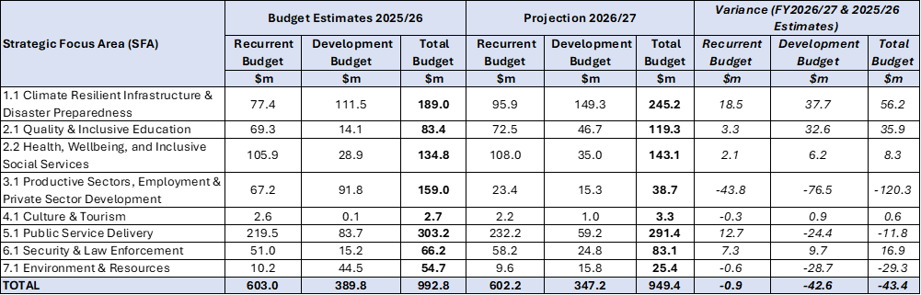
Note: Support towards emergency response measures to assist Private Sector under SFA 1.1 is around $6.9m.
Source: Ministry of Finance
On the other hand, FY2027 will see a reduction in spending on SFA 3.1 (productive sectors, employment and private sector development), due to high value one-off expenditures related to programs introduced in the current fiscal year FY2026, including:
  - $56.0m investment made towards the GDL program with the TDB, with future allocations to be determined based on the performance of the current year’s investment.
  - $20.0m biogas project (development budget component only, the recurrent budget portion continues)
  - $20.0m ADB local currency bond (pending projects)
  - $21.7m from ADB instrument for the WE-LIFT project (de-risking loans to support women entrepreneurship program - this is still undergoing recruitment for the project management unit).
Similarly, the decrease in allocation for SFA 7.1 (Environment & Resources) reflects the one-off commercial fishing vessel development project worth $30.0m.
Figure 1: Share of the FY2027 Budget by SFA
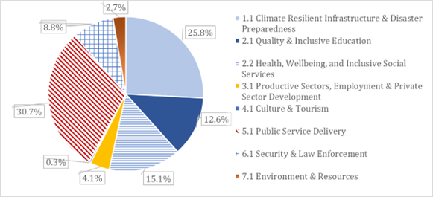
Source: Ministry of Finance
In terms of the share of the FY2027 budget by SFA, the largest allocation (30.7 percent) is directed towards public service delivery, which mainly includes the general administration and leadership across line ministries and central agency services. This is followed by 25.8 percent towards strengthening national resilience against the impacts of external shocks, including the fuel crisis and natural disasters. The Government will also continue to allocate 27.7 percent to social and community development through combined investment in education (12.6 percent) and health services (15.1 percent).

4.3 Funding by MDAs
In terms of budget allocation by Ministry in FY2027, the MDAs with significant budget increases were for the Ministry of Infrastructure, largely because of the SECURE bridge project, followed by the Office of the Legislative Assembly, due to the construction of the new parliament building, and Ministry of Commerce, Consumer, Trade, Innovation and Labor, for the construction of the multipurpose packhouse in Vava’u. Conversely, the MDAs with significant budget decreases were the Ministry of Finance, due to one-off estimates for the Women’s Entrepreneurs Leveraging Innovative Financing in Tonga (WE-LIFT) project and the ADB Local Currency Bond program, followed by the Ministry of Public Enterprise, due to the completion of the Hawaiki cable project, and the Ministry of Agriculture, Forestry, and Fisheries due to the estimated allocation for the biogas project which has yet to secure any development partner support for next fiscal year.
Table 4: Total Expenditure Budget Allocation (Recurrent / Development) by MDA
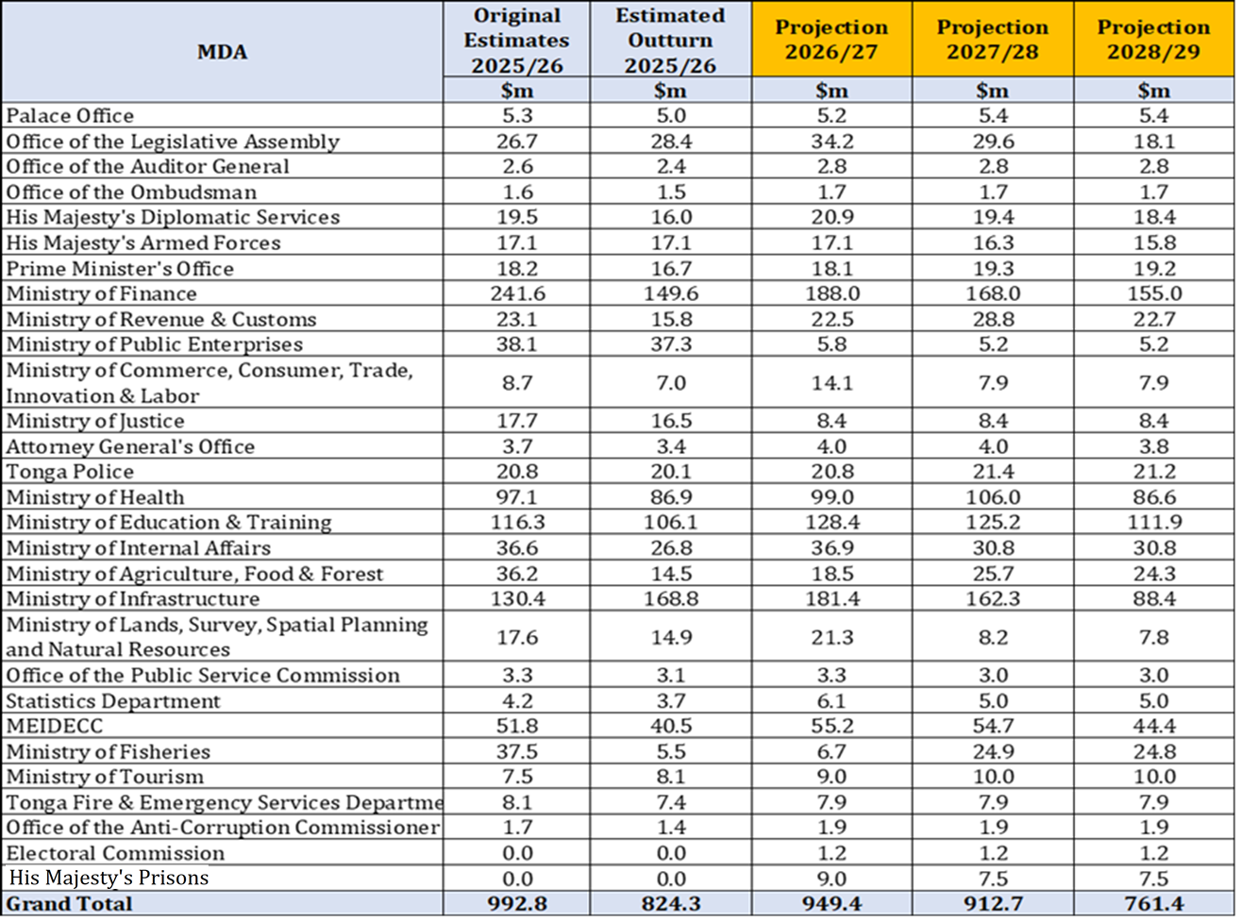
Source: Ministry of Finance

The five largest MDAs, ranked by the share of FY2027 budget allocation, are also provided below:

Table 5: Share of Budget by MDAs
MDA | Share of the Budget (%) | Key Drivers
Finance | 20.0 | Debt repayments, centralized votes under the Government general fund, and contingency funds.
Infrastructure | 19.0 | Road maintenance and the Fanga’uta SECURE bridge construction.
Education & Training | 14.0 | Teachers’ compensation, climate resilient school infrastructures, Tonga National University & Tonga National Qualifications and Accreditation Board developments, scholarships, school breakfast program, and grants to non-government schools.
Health | 10.0 | Nurses and doctors’ compensation, hospital services, nursing school, Vava’u hospital, and health clinics.
MEIDECC | 6.0 | Climate change, disaster reduction and resilience projects.

Source: Ministry of Finance

In terms of revenue collection by MDA, the FY2027 target shows major increases from the current original estimates:
  - Ministry of Finance: with the most significant increase, rising by $14.0m due to budget support.
  - Ministry of Revenue & Customs remains the primary driver of revenue collection, responsible for more than half of government’s annual collection, with a $6.9m increase in target resulting from expected increase in consumption tax revenue generation; factoring in potential lower revenue collection resulting from the impact of the fuel crisis.
  - Ministry of Lands, Survey, Spatial Planning & Natural Resources: While smaller in total value, revenue expectations have nearly doubled from $1.3m to $2.5m, reflecting focused investment in land administration and reform initiatives.
Major Decreases in FY2027:
  - Ministry of Health & Infrastructure: Reduction in revenue expectations as a result of the June 2026 conclusion of DFAT additional budget support for various civil works, including the Vava’u hospital (to be funded by the World Bank instead in FY2027), as well as the conclusion of New Zealand funds provided for health clinics, which will phase out in the current year.
  - Ministry of Infrastructure: Reduction in revenue collection target in line with historic trends.
Table 6: Total Receipts Budget Allocation (Recurrent / Development) by MDAs
Source: Ministry of Finance

Recurrent Budget

4.4.1 Recurrent Budget Overview
The recurrent budget balance recorded a surplus of $24.0m in FY2025, attributed to underspending of the budget as a result of delays both in filling vacancies and in program implementation, such as the further investment in the GDL facility which was instead delayed for FY2026. In FY2026, the estimated outturn is for a projected deficit of $18.9m versus the original targeted deficit of $29.1m, with the reduction in the deficit due to delays in the progress of civil works such as the construction of the Vava’u hospital and part of the health clinics.
Over the medium-term, the recurrent budget position shows a gradual consolidation path, allowing for the impacts of the fuel crisis, withf a deficit of $38.1m in FY2027, but with the expectation of a near balanced budget by FY2029. This trend largely reflects the Government’s expectation that the temporary fuel crisis-response measures will gradually unwind, coupled with strengthened fiscal measures which will improve revenue performance, rationalize expenditure and support economic recovery.
Table 7: Recurrent Budget Overview
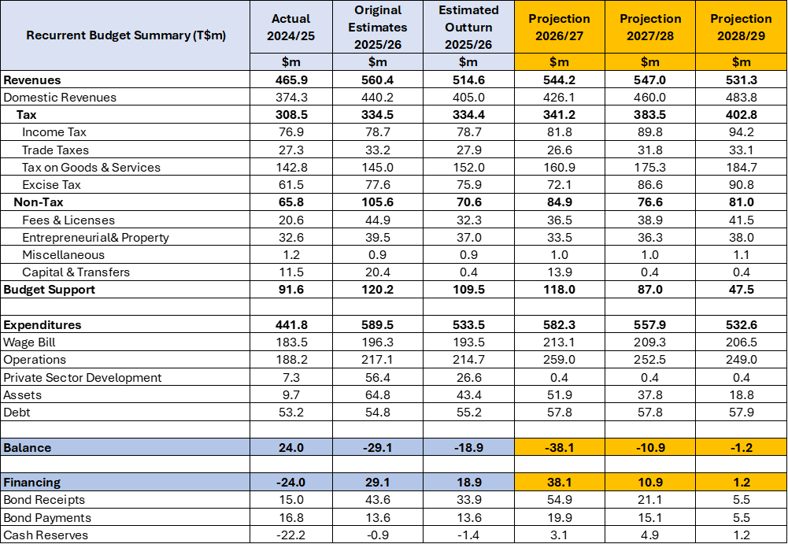
Source: Ministry of Finance

Revenue Performance
The FY2027 recurrent revenues are projected at $544.2m, which represents a decrease from the current year’s target by $16.2m. The majority of the decrease is due to the estimated domestic revenue foregone as a result of the impact of the fuel crisis, both from the rise in prices depressing economic activity and a potential decrease in volume of imported fuel. On the other hand, positive growth is expected in consumption tax revenues as the prices of goods and services increase, particularly goods for which demand and consumption are less responsive to price changes.
In terms of non-tax revenues, a downward adjustment is estimated due to normalization of one-off and administrative revenues, including:
  - Fees & licenses – review of government fees and charges currently underway;
  - Entrepreneurial/property income – one-off receipts from the NRBT of $10.0m that was subject to amendments of the NRBT Act; and
  - Capital & transfers - mainly from on-lent loan repayments, of which are currently being negotiated for installments in forthcoming years.

Recurrent Expenditures
Total recurrent expenditure is estimated to decline to $582.3m from the current FY2026 budget by $7.2m, indicating fiscal tightening while reprioritizing core spending and implementing measures in response to the fuel crisis. In terms of the expenditure categories, the key changes in the FY2027 budget from the current year include:
  - Increase in wage bill expenses - due to the 3.0 percent COLA worth $5.0m, $8.0m worth of vacancies maintained, increased overtime costs required to cover for the duties of unfilled positions, and $3.0m for annual performance awards;
  - Increase in operational expenditure, including fuel crisis response measures;
  - Decrease in private sector development, reflecting the one-off investment in the GDL Program;
  - A decrease in assets by $12.9m, reflecting one-off capital works including $7.0m for the Vava’u hospital funding which is to be funded by the World Bank instead, and the completion of some of the health clinics; and
  - The increase in debt payments, due to external debt service costs.
Generally, the FY2027 Budget will shift focus to allocate significant resources towards immediate crisis response programs and national connectivity. To protect households from soaring utility costs, $18.0m is dedicated to electricity tariff subsidies, in addition to the introduction of measures to subsidize domestic air and sea travel to ensure the outer islands remain connected despite global economic pressures. Infrastructure remains a top priority, evidenced by a $20.0m continued commitment to the Fanga’uta SECURE Bridge and a total road maintenance investment exceeding $22.0m.
Human capital and social protection are addressed through expanded grants and targeted welfare enhancements for vulnerable populations. Education will see a major boost, including a $2.0m increase for Tonga National University, the provision of the schools’ breakfast program to help improve learning outcomes, higher funding for scholarships and continued grants to non-government schools. In the health and social sectors, the budget will sustain funding for health facilities at $5.0m, with an additional $1.2m for the dialysis center; while also sustaining financial support for the elderly and persons with disabilities (+$100 one-off assistance in response to the fuel crisis). Community-level development is also empowered through increased constituency grants and an increase in district and town officers’ salaries to improve local service delivery.
Economic recovery and institutional modernization are supported through strategic investments in productive sectors and digital transformation. This includes the multipurpose packhouse in Vava’u, tourism marketing, and a dedicated fund to help new commercial and residential developments connect to the power grid. To improve government efficiency, $5.7 million is provided for centralized e-government initiatives alongside reforms in land administration and border security. While debt repayment obligations have increased by $9.3m to $77.7m, the budget aims to balance these fiscal pressures by strengthening domestic revenue systems and supporting labor mobility schemes to boost overseas employment and remittances.

Tax Expenditures
Tax expenditures are provisions within revenue laws that reduce or exempt tax obligations for specific groups or individuals, as outlined in Table 25 in Annex IV.
While these measures support specific economic and social objectives, including lowering business costs, encouraging investment, supporting priority sectors, and reducing the cost of essential goods and services for households, they also impose a substantial fiscal cost through government revenue foregone, as summarized in Table 26 in Annex IV. Of this cost burden, 98.1 percent is attributed to tax exemptions while the remaining 1.9 percent relates to tax holidays. Tax exemptions policies apply across various tax types, primarily consumption tax, customs duty, and excise tax.

4.5 Development Budget
The Development Budget estimates for FY2027 presented in Table 8 show grant support equivalent to $347.3m, comprising $133.1m cash grant transfers (38.3 percent of total) and $214.2m in-kind grant transfers (61.7 percent). Relative to the previous year, the total funding provided for FY2027 has decreased by $42.5m, a decline of 10.9 percent.
Table 8: Development Budget Estimate
Source: Ministry of Finance
The cash component has decreased by 8.8 percent from the original estimate for FY2026 to the FY2027 projection. This is mainly due to the completion of major projects such as the Pacific Resilient Project, Hunga Tonga Hunga Ha’apai Project, the ‘Eua Bridge construction, and the Statistical Innovation and Capacity Building in Tonga Project. In addition, delayed implementation of projects has also contributed to the decrease, particularly the Health Enhancement and Resilience Tonga – Vava’u Hospital Construction, the Tonga National Museum, the Tonga Sustainable Economic Corridor Urban Resilient Project, the Tonga Renewable Energy Stabilization Package Project (GREST), and the Tonga Safe and Resilient School Projects. However, the reduction is partially offset by new projects proposed for FY2027, including the Pacific Healthy Island Transformation, the Accelerating Trade Facilitation Project, the Tonga Rural Innovation Project III, and the Multipurpose Packhouse Facility Vava’u.
In-kind contributions declined by 12.2 percent from FY2026 to FY2027, primarily due to the completion of several projects, including the Hawaiki Project, the Royal Tomb Upgrade, the Nuku’alofa Port Upgrade Project, and the Tonga Renewable Energy Project. Additionally, a number of initiatives originally scheduled for FY2026 have been deferred and are now in the pipeline for future assistance. These include the issuance of ADB local currency bonds, the Women Entrepreneurship Leveraging Innovative Financing in Tonga project (WE-LIFT), the longline fishing vessels, and the biogas production project under MAFF.

Development Expenditure by Development Partners
International partnership assistance continues to play an important role in supporting Tonga’s national development priorities by complementing domestic resources and helping advance the Government’s strategic vision. Assistance from development partners enables the implementation of key programs and investments that contribute to sustainable growth, resilience, and improved public services.
Programs financed by multilateral development institutions are currently delivered largely through grant-based arrangements, which provide valuable support while helping to maintain fiscal sustainability. The multilateral partners, including the World Bank (WB), Asian Development Bank (ADB), the Green Climate Fund (GCF), and various United Nations agencies, have continued to make significant contributions through financial assistance, technical cooperation, and support for major national initiatives.
In addition, bilateral partners such as the Governments of Australia, New Zealand, the People’s Republic of China, Japan, Saudi Arabia, and other development agencies such as Pacific Catastrophe Risk Insurance Company (PCRIC) as well as the Council of Regional Organizations in the Pacific (CROP agencies), remain valued contributors to Tonga’s development efforts. Their continued partnership and collaboration are highly appreciated as Tonga works towards inclusive, resilient, and sustainable development.
Table 9:Development Budget Estimate by Development Partner
Source: Ministry of Finance

Development Expenditure by Location
Table 10:Development Budget Estimate by Location
Source: Ministry of Finance
Table 10 presents the distribution of the development budget by geographic location, including Tongatapu, Vava'u, Ha'apai, 'Eua, and the two Niuas.
In terms of funding for specific locations, in FY2027 Tongatapu will be allocated the largest provision of the total budget, with funding of $221.0m (63.6 percent). This covers large infrastructural projects on the main island, such as the continuation of the construction of the New Parliament Building, the Tonga Renewable Energy Stabilization Package Project (GREST), the Fua’amotu International Airport upgrade project, the Fanga’uta Bridge under the Tonga SECURE Project is in its early stages of civil works, and the construction of the seawall under the Tonga Coastal Resilience Project in the Eastern District.
Projects with major components or activities related to the outer islands are as follows:
- Nationwide: Certain projects benefit all locations, with the FY2027 nationwide project allocation coming to a total of $83.4m. This allocation accounts for the ADB's Integrated Age Care project, the Digital Health project and Vaccines project, the World Banks's Tonga Climate Resilience Transport Project II, the Integrated Urban Sector Resilience Project, the Statistical Innovation and Capacity Building in Tonga, the Tonga Safer & Resilience Schools Project, the Tonga Climate Change fund supported by the Gov't of New Zealand, the IFAD'S Tonga Rural Innovation Project III, the PICRC Insurance premiums, and the ongoing scholarship opportunities from New Zealand, Australia & the Government of Japan.
- Vava’u: The outer island of Vava’u is allocated an estimated $15.6m in FY2027, which represents an increase of $8.7m relative to the funding provided in FY2026. The funding comprises the HEART Project for the reconstruction of the Vava’u Hospital, which is expected to commence in early 2027, the Tonga Safe and Resilient Schools Project which will continue with renovations to risk-based schools in Vava’u, and the construction of the agricultural packhouse in Vava’u co-financed by the Government of Tonga and DFAT.
- ‘Eua: The Development Budget allocation for ‘Eua increased to $15.6m, relative to $6.7m in FY2026. This funding is largely derived from the Tonga Climate Resilience Transport Project II that is now focusing on the works with the Nafanua Port and the road maintenance for the Major Roads in ‘Eua.
- Niuafo’ou & Niuatoputapu: The Tonga Safe and Resilient Schools Project completed the designs and commenced procurement for three Risk-Based Schools located in Niuafo’ou in late 2025. These schools include GPS ‘Alele’uta, GPS Tongamama’o, and Niuafo’ou High School.
- Ha’apai: Ha’apai has an allocation of $4.6m in FY2027, which will cover the rehabilitation of roads (HP-A34, Main Road 2) under the Tonga Climate Resilience Transport Project II, due to be completed in June of 2026. In addition, the funding will cover the continuation of the construction of the NDRMO warehouse, which is still underway, and also cover the renovations to risk-based schools for Ha’apai.

4.6 Government Financial Statistics (GFS) - Budget Presentation
The Government aims to maintain fiscal stability under the GFS framework despite the impact posed by external shocks. A minimal fiscal deficit of $0.3m is expected for FY2027, with the impact of crisis response measures considered to prioritize those which will protect domestic revenue while maintaining fiscal prudence.
Table 11: GFS Summary
Source: Ministry of Finance
Total revenue growth is expected to be limited in FY2027 as the impact of the fuel crisis is realized, before rebounding with strong growth from FY2028 onwards. Total expenses are forecast to decline over the medium-term. During periods where expenses are lower, this can cushion debt repayment obligations while still allowing for the maintenance of adequate levels of Government service provision.

Fiscal Position - on GFS Presentation
A fiscal deficit of $0.3m is expected for FY2027 under the Government Finance Statistics (GFS) framework, meaning the Government is projected to spend more money than it collects. The deficit is driven by a drop in Government revenue resulting from the negative impacts of the fuel crisis, although there have been positive revenue developments which partially mitigate the fuel crisis impact, including ongoing improvements in both revenue administration and compliance. On the expenditure side, Government spending will be managed in order to deliver the appropriate fuel crisis response, with the focus on maintaining essential services and supporting key priority sectors such as energy.
Notably, the $0.3m fiscal deficit recorded under the GFS framework is lower than the FY2027 Budget deficit, which is recorded at $38.1m. The disparity arises as the Budget deficit includes large fiscal spending items which relate solely to non-debt receipts and payments (operational costs), while it also accounts for the need to repay an outstanding $51.2m to external loans. As a result, the GFS fiscal balance provides a clearer picture of the Government’s underlying financial position from year to year. The projected deficit therefore indicates that public finances have become less stable as a result of the fuel crisis shock. However, the Government will continue to prioritize meeting its external debt obligations, and with the current fiscal measures the EXIM Bank loan is expected to be cleared within the next four years.
The economic uncertainty resulting from the fuel crisis will affect both Government revenue and expenditure. The situation underlines the need to strengthen revenue collection, while also adopting a strategy of fiscal consolidation to achieve a positive fiscal outcome while the effects of the shock dissipate. The measures discussed above will aid economic stability, while also creating fiscal space for more strategic investments in the priority sectors.
The table below summarizes the Government Fiscal Indicator Performance for FY2025 to FY2029.
Table 12:Government Fiscal Indicator Performance for FY2025 to FY2029
Source: Ministry of Finance
An assessment of the economic impact of the current fuel crisis has been undertaken within the context of the fiscal anchor framework. Fuel prices have increased significantly since the 1st of April, placing immediate pressure on households and government finances. Fuel supply conditions also remain highly uncertain, largely due to continuing geopolitical developments in the Strait of Hormuz. Domestic onshore fuel storage capacity is estimated to cover approximately two weeks of demand, while offshore reserves located in Fiji provide an additional buffer of up to two months.

Conclusion
The Budget estimate for FY2027 comes at a critical juncture for the Kingdom. As the country continues to navigate the ongoing impacts of fuel crisis, this Budget prioritizes the fuel crisis response, with targeted investments to support resilience, growth, and the wellbeing of all Tongans through the uncertainty of fuel supply. The FY2027 Budget projects an overall budget deficit of $38.1m, reflecting the Government’s deliberate policy choice to support the domestic economy during this period of heightened pressure, with the deficit to be financed through domestic financing.
This Budget reaffirms the Government’s commitment to prudent fiscal management, ensuring that public resources are allocated efficiently and transparently to areas of greatest need and essential services. In FY2027, Government policy will shift from expansionary investment towards a heightened focus on prudential spending and consolidation due to revenue uncertainty and increased external risks. At the same time, the Government recognizes the urgency of climate change and disaster resilience and has sought to ensure that these priorities are embedded across all aspects of TSDF2035, as well as the initiatives and policies outlined under this Budget.
Importantly, the Budget reflects a people-centered approach. It seeks to:
“Accelerate delivery of vital government initiatives to generate sustainable, inclusive growth”
to protect the most vulnerable, support livelihoods, and create opportunities for inclusive growth.
We need to collaborate together as Tongans to successfully implement this Budget with donor partners, private sectors and all stakeholders with shared vision to overcome the fuel crisis and build a more stable, prosperous, and climate resilient economy.

Annexes I: TSDF OUTCOMES
Objective 1: National Resilience
SFA 1.1: Climate Resilient Infrastructure and Disaster Preparedness
Specific output areas under this SFA include:
- Ongoing implementation of the Disaster Risk Management Act 2021, improvement of existing systems, the continuous implementation of the multi-hazard early warning system policy and the development of related disaster plans to strengthen disaster preparedness and risk management effort.
- Prioritizing resilient buildings and infrastructure across all sectors to withstand extreme disaster events.
- Continue to implement energy sector reforms to diversify energy supply under the Tonga Energy Roadmap, including the continuous implementation of the Nuku‘alofa network upgrade project (NNUP), and the continued efforts to address fuel shortages.
- Enhance efforts to activate climate and disaster financing including an update of the Disaster Risk Financing Strategy. Implement climate budget tagging and tracking to support climate finance decision-making.
SFA 6.1: National Security, Disaster Response, Community Safety, Law Enforcement and Drug Control
Specific output areas under this SFA include:
- Review and update the National Action Plan for Combating Illicit Drugs (NAPID), aiming to reduce drug supply, usage and rehabilitation services including essential infrastructure such as prisons. Expedite the utilization of the Illicit Drug Response Fund (IDRF) and operationalize the Cybersecurity Act 2025
- Strengthen support for the overseas missions including financial administration and implementing relevant policies related to providing support to integrating returnees and trafficking in person.
SFA 7.1: Sustainable Resource Use, Environmental Protection and Oceans Resilience
Specific output areas under this SFA include:
- Scale renewable energy and energy security efforts in line with the Tonga Low Emission Development Strategy 2021-2050.
- Prioritize sustainable land and forest management program under the Management Plan for the Forests and Tree Resources (2017).
- Continue to implement the National Invasive Species Strategy Action Plan 2021-27.
- Implement the recommendations of the Ocean Management Act 2025, including the National Ocean Policy and the Marine Spatial Plan, and integrate sustainable financing through the Ocean Management Fund.
Objective 2: Social Sector Improvement
SFA 2.1: Quality and Inclusive Education for All
Specific output areas under this SFA include:
- Enhance the delivery of and accessibility to primary, secondary and tertiary education services.
- Continue the review of school curriculums and assessment, supported by improving education information management systems and building capacity through teacher training programs.
- Continue the implementation of the Tonga Safe & Resilient Schools Project to ensure resilient school infrastructure and equipment and regular maintenance
SFA 2.2: Health, Wellbeing, and Inclusive Social Services
Specific output areas under this SFA include:
- Support the development of health infrastructure.
- Strengthen health workforce, planning to also assist in reducing growing overtime costs.
- Support the establishment of a domestic accident insurance trust fund for public servants to increase access to accident insurance products.
- Support the poverty reduction measures/initiatives to protect vulnerable groups (elderlies, less advantaged groups, women, children and poor households)
SFA 4.1: Cultural Preservation, Education and Tourism Integration
Specific output areas under this SFA include:
- Construction of the Tonga National Museum to promote cultural tourism and preserve heritage.
- Continue to support the existing cultural committee plans to spearhead initiatives designed to preserve Tongan culture.
Objective 3: Inclusive Growth and Public Sector Efficiency
SFA 3.1: Productive Sectors, Employment and Private Sector Development
Specific output areas under this SFA include:
- Support the implementation of economic infrastructure through investment in key economic sectors including agriculture, fisheries, SMEs, and tourism.
- Support the development of transport infrastructure (land, sea and air).
- Support digital transformation through the integration of ICT infrastructure.
- Promote access to finance to support sector development through initiatives including the Government Development Loan Facility (GDL).
- Progress the consumer protection bill and foreign direct investment initiatives to provide a supportive environment for private sector development.
SFA 5.1: Efficient Service Delivery and Accountable Public Service
Specific output areas under this SFA include:
- Strengthening core accountability institutions to deliver independent oversight of the functions of Government.
- Strengthening public service delivery and efficiency through capacity building, workforce planning, and digitization of government services.
- Support revenue mobilization with the upgrade of the revenue management system
- Monitoring fiscal measures include streamline expenses and accelerating revenue reform.
- Improving reform execution through strengthened monitoring & evaluation and reporting of progress.
- Progress on the implementation of the PFM Reform Action Plan towards enhancing fiscal transparency and reporting, including program/output-based budgeting.

Annexes II: MACROECONOMIC AND FISCAL OUTCOMES AND OUTLOOK

AII.1 Global Outlook in Detail
Table 13: IMF Global Growth Projections
Economy | Real GDP Growth 2026 (%)
World | 3.1
US | 2.3
China | 4.4
Eurozone | 1.1

Source: IMF World Economic Outlook, 2026
The global outlook is currently highly uncertain, with the evolving conflict in the Middle East testing the resilience of the global economy. The latest IMF economic outlook (April 2026) expects GDP growth to remain broadly stable at 3.1 percent in 2026 before edging up to 3.2 percent in 2027, with drivers including significant technology-related investment and the gradual decline of effective tariff rates. However, these projections assume that the current energy market disruption is temporary, with prices expected to ease from mid-2026 onward.
Even in the event of a swift resolution to the conflict, the halt in shipments through the Strait of Hormuz and the closure and damage of energy infrastructure have already generated a surge in energy prices, disrupted the global supply of energy, and led to significant price increases for other important commodities, such as fertilizers. Partially because of this, global inflationary pressures are now expected to persist for longer, The OECD projects 2026 average inflation in the G20 group of developed economies to be 1.2 percentage points higher than previously forecast at 4.0 percent, before easing to 2.7 percent in 2027 with an assumed fading of energy price pressures.

AII.2 Regional Outlook in Detail
The World Bank expects growth in the Pacific Island nations to slow to an average of 2.8 percent in 2026, before recovering to 3.0 percent in 2027. This forecast represents a notable slowdown from the 3.2 percent growth recorded in 2025.
Table 14: IMF Regional Growth Projections
Economy | Real GDP Growth 2026 (%)
Tonga | 2.3
Fiji | 3.1
Vanuatu | 2.8
Samoa | 3.2

Source: IMF World Economic Outlook, 2026
The energy shock resulting from the Middle East conflict is the principal driver of the regional slowdown, with the conflict expected to have an outsized impact on Pacific Island economies given the majority of the region’s fuel is sourced in the Middle East. Energy grids also remain largely reliant on imported fuel, the supply of which is uncertain, while Pacific Island nations are also vulnerable to expected price pressures for imported goods, including food products. The adverse effects of the fuel crisis, combined with the impact of additional factors including elevated trade barriers, global policy uncertainty, and domestic economic difficulties, mean that the region faces significant barriers to growth in the year ahead.
Tonga’s expected growth lags behind comparable Pacific Island nations in the most recent IMF projections, with the discrepancy resulting from Tonga’s narrow production base and high emigration rates. However, it is notable that the fuel crisis is expected to lead to slower growth in the region, which is not fully accounted for in these figures.
Australia-Tonga Economic Relations and Growth Outlook
Australia is a key trade and development partner for Tonga, with a high number of Tongans participating in the PALM labor mobility scheme, and a large Tongan diaspora who make a significant contribution to domestic living standards through remittances. The latest OECD economic outlook report expects Australian GDP growth to accelerate to 2.3 percent in 2026, a notable increase on the 2.0 percent recorded in 2025. Inflation is expected to accelerate in 2026, reaching 4.1 percent from the 2.8 percent recorded in 2025, with the Reserve Bank of Australia expected to increase interest rates in response. The conflict in the Middle East represents a significant risk to the Australian economy given its reliance on imported fuel, while a broader economic slowdown affecting Australia’s key trading partners, particularly China and India, would materially impact demand for Australia’s critical mineral exports.
New Zealand-Tonga Economic Relations and Outlook
New Zealand is one of Tonga’s key trade and development partners, home to a large Tongan diaspora. The Tonga-New Zealand partnership extends across trade, remittances, labor mobility schemes, while New Zealand’s development assistance supports projects across infrastructure, education, and disaster resilience, playing a key role in Tonga’s economic sustainability. In recent years, the New Zealand economy has been navigating a fragile recovery, with the latest OECD projections indicating that growth will accelerate from 0.7 percent in 2025, to 1.8 percent in 2026 and 2.8 percent in 2027. However, this positive trajectory was based on expectations of a reduction in interest rates and is therefore subject to increasing risks regarding the inflationary pressures resulting from the conflict in the Middle East.

AII.3 Domestic Economy in Detail
Tonga is a small and open economy characterised by structural constraints and a narrow domestic production base. These features result in high dependence on remittances, foreign aid, and imports, which heightens the economy’s vulnerability to external shocks.
Real GDP growth is projected to increase to 2.7 percent in FY2025, up from 1.7 percent in FY2024, driven by a recovery in the agriculture sector following the FY2024 El Niño impact and sustained activity in the services sector. Growth is partly moderated by a slowdown in construction activity following the completion of a number of major projects.
Growth is expected to ease to 2.3 percent in FY2026, reflecting delays in the implementation of key development initiatives, including postponements in large infrastructure projects, which are weighing on construction activity. In addition, the heightened geopolitical tensions in the Middle East, with associated global oil price volatility, are expected to influence economic momentum toward the end of the fiscal year.
While the economy remains broadly stable at green colour (L1) to date, the outlook is tilted to the downside. Elevated external uncertainties from the geopolitical tensions in the Middle East could sustain global oil price volatility, with its ripple effects on Tonga’s domestic inflation and economic activity.
Amid this elevated external uncertainty, economic growth is projected to moderate by 0.6 percentage points to 1.9 percent in FY2027, assuming continued oil supply remains normal and that increases in global oil price volatility remain contained domestically. The downward revision reflects the anticipated impact of temporary fuel management measures, including the prioritising of the formal sectors, essential services only, and reductions in domestic maritime and air transport activity. Should this measure be limited to the first quarter of the fiscal year, the major sectors' economic performances are expected to remain positive. The primary sector is projected to continue its recovery from the El Niño impact, construction activity is expected to strengthen, and the tourism sector is anticipated to expand further as it continues to recover from the effects of the pandemic and the volcanic eruption.
Figure 2: Headline GDP growth and Sectors' contribution (%)
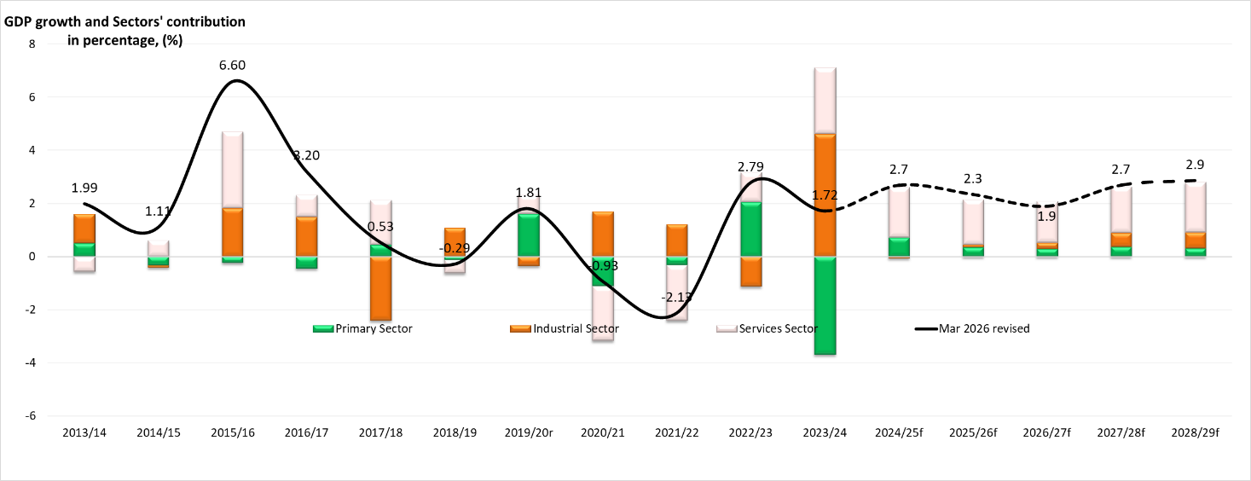
Source: Ministry of Finance / Tonga Statistics
However, in a worst-case scenario, if the event that a State of Emergency (Levels 3 or 4) is declared, economic activity is expected to contract further to negative growth. Under a prolonged scenario, where disruptions persist for more than nine to twelve months, the economy could contract by around 4.0 percent, potentially exceeding the contraction experienced during the COVID-19 period.
Over the medium-term, growth is projected to average 2.5 percent, supported by ongoing recovery efforts in the primary and tourism sectors and planned development projects intended to increase economic productivity, though fiscal space remains tight due to significant debt repayment obligations. However, broader global risks, including trade war and ongoing geopolitical conflicts, continue to pose challenges to commodity prices and external stability, which are particularly relevant given Tonga’s reliance on external sources. At the same time, the expansion of overseas labor mobility schemes continues to support remittance inflows, while also contributing to domestic labor shortages and pressure on local economic activity.
Prior to the Middle East crisis, headline inflation had moderated, falling to 2.4 percent in February. Inflation had remained below the 5.0 percent reference rate throughout FY2026, last exceeding this threshold in January 2025 (5.4 percent). However, with the impact of the crisis on the price of fuel and imported goods, headline inflation has since risen to an annual rate of 4.6 percent in March 2026 (latest available data), with the crisis posing a significant risk to the inflation outlook going forward. Brent crude prices have increased sharply, rising by over 40 percent since the onset of the conflict, which has placed upward pressure on domestic fuel prices, as Tonga experienced in April. The full pass-through is expected to materialise in May and June, given lagged effects, which are anticipated to further increase household costs and further erode and weaken consumers’ purchasing power.
Access to finance continues to act as a drawback on economic growth, with high collateral requirements limiting access to funds outside of a concentrated pool of borrowers, for whom debt levels have largely reached capacity. Additionally, domestic labor supply issues are also pronounced as overseas labor mobility programs continue to attract a significant proportion of the working-age population. The Government continues working towards considering appropriate mitigation strategies, such as those highlighted in the Ministry of Internal Affairs' 2023 review of labor mobility supply management strategy. These include reintegration strategies such as the reinforcement of reintegration policy guidelines, refining the worker selection criteria, and developing a domestic skills development strategy.
In response, the MOF, in partnership with the NRBT, and ADB working towards expanding and building further active domestic financial bond market, aiming to provide alternative financing options for both the government and private sectors. The Government is also exploring options to institute a domestic stock market to provide equity financing for businesses. Looking forward, to secure long-term, sustainable growth, Tonga must implement policies focused on economic diversification, climate adaptation, infrastructure development, private sector revitalization, and development of an oil-buffer facility to build a more self-reliant and resilient economy.

AII.3.1 Primary Sector
In FY2026, the primary sector is expected to register real growth of 2.2 percent, contributing 0.3 percentage points to overall GDP growth. This represents a moderate slowdown from the 4.7 percent (0.71 percent) recorded during FY2025, reflecting a transition from post-shock recovery to a more stable growth path. Growth is primarily driven by the agriculture sub-sector, which is expected to expand by 2.4 percent as output normalizes following the strong rebound experienced in FY2025. In contrast, the fisheries sub-sector is expected to record a more modest increase of 0.8 percent, reflecting the early stages of recovery alongside continued cost pressures, particularly fuel costs.
In FY2027, under the baseline scenario broadly consistent with Level 1 to Level 2 (L1–L2) National Fuel Control Levels, the primary sector is forecast to grow by 1.9 percent, contributing 0.3 percentage points to GDP. Agriculture is expected to grow by 1.8 percent (0.25 percent contribution), while fisheries, supported by gradual improvements in capacity and supply conditions, is projected to strengthen by 3.3 percent (0.05 percentage points contribution).
This baseline outlook is developed under conditions where external pressures—particularly elevated fuel prices and supply-side constraints remain present but manageable. However, the threat of escalation in the Middle East conflict poses a significant risk to baseline expectations. Tonga is heavily reliant on imported fuel, meaning that any shift resulting in higher fuel prices, supply chain disruption, or weaker external demand would have direct implications for production costs, output, and export performance.

Agriculture and Forestry
The agriculture and forestry sub-sector is expected to remain the principal driver of primary sector growth over the medium-term. Under the baseline scenario, the sub-sector is projected to expand at an average annual rate of approximately 2.0 percent, with its contribution to GDP remaining broadly stable.
The expected expansion will be supported by ongoing investment in sector development, including the expansion of packhouse infrastructure, livestock production facilities, agro-processing facilities, and renewable energy initiatives such as the planned bio-gas systems. In addition, continued efforts to promote climate-resilient agriculture and sustainable land management are expected to enhance productivity and strengthen the sector’s resilience to environmental shocks.
However, the sub-sector remains vulnerable to adverse weather conditions, natural disasters, and external cost pressures. Under higher shock scenarios (L3–L4), increased input costs and weaker export demand may constrain production and reduce growth outcomes. Additionally, issues concerning labor supply and land management are growing in prominence, with the proportion of fallow agricultural land having increased significantly. These developments are linked in part to the increase in outbound migration as a result of the success labor mobility schemes, with the MOF undertaking detailed analysis to develop suitable policy solutions.

Fisheries
The fisheries sub-sector is projected to play an increasingly supportive role in the primary sector over the medium-term, with growth expected to strengthen in FY2027 before stabilizing, with an average annual medium-term growth rate of approximately 3 percent in the baseline scenario. This outlook is underpinned by ongoing investments in fishing capacity, aquaculture development, and improvements in both domestic and export supply chains.
The expansion of long-line fishing capacity, alongside strengthened partnerships with domestic and foreign operators, is expected to enhance both production and export performance. It is anticipated that these developments will support improved product availability in the domestic market, while also contributing to export earnings.
Notwithstanding these positive developments, the fisheries sub-sector remains particularly sensitive to external conditions, especially concerning fuel price volatility. Under elevated global shock scenarios, higher operating costs could significantly constrain fishing activity, limiting both output and growth.

Supplementary Activities
In addition to core agricultural and fisheries production, the development strategy for the primary sector continues to emphasize import substitution, diversification, and export expansion as key priorities. These supplementary activities are expected to enhance economic resilience, reduce reliance on imports, and support the creation of additional income-generating opportunities.
In the context of ongoing global uncertainty, these strategic priorities assume heightened importance. Efforts to expand domestic production, promote value addition, and diversify export markets will be critical in strengthening the sector’s capacity to withstand external shocks and sustain growth over the medium-term.

Medium-Term Outlook (FY2027–FY2029)
Over the medium-term (FY2027 to FY2029), the primary sector is projected to grow at an average annual rate of approximately 2.1 percent, with its contribution to overall GDP growth stabilizing at around 0.3 percentage points per annum. This baseline outlook is predicated on conditions broadly consistent with a Level 1 to Level 2 (L1–L2) scenario, where external pressures—particularly elevated fuel prices and global supply constraints—remain contained and manageable.
Growth is expected to be driven by steady performance in the sub-sector agriculture, alongside a gradual strengthening in fisheries activity. In particular, growth in the fisheries sub-sector is expected to improve significantly in the outer years, reflecting ongoing investment in sector capacity, including longline vessel acquisition, aquaculture development, and improvements in supply chain efficiency. Agriculture is expected to maintain stable growth, supported by continued investment in infrastructure, agro-processing, and climate-resilient farming practices, although issues concerning capital investment, labor supply, and land management require consideration to ensure the sector realizes its long-term potential.
However, the medium-term trajectory remains subject to significant downside risks associated with a potential deterioration in global economic conditions. Under a Level 3 (L3) scenario, characterized by heightened global stress, further increases in fuel prices, tighter supply chains, and weaker external demand, it is expected that production and export performance would decline across both agriculture and fisheries. Under a more severe Level 4 (L4) scenario, involving a sharp escalation in global disruptions, the primary sector could experience a substantial weakening in activity, with growth falling to negligible levels or contracting. In such circumstances, the sector’s contribution to GDP would be significantly reduced, with broader implications for inflation, external balances, and overall economic performance.

AII.3.2 Industrial Sector

Construction
The construction sector is estimated to decrease to a negative 1.3 percent in FY2025, mainly reflecting the completion of major projects such as the THS Complex and a slowdown in the implementation of new projects. With fewer major projects in progress, overall activity in the sector has weakened. In FY2026, construction is expected to recover modestly by 1.0 percent; however, this growth remains constrained by delays in key infrastructure projects, including the Secure Bridge, Vava’u Hospital, and the Tonga National Museum.

Mining and Quarrying
Mining and quarrying activity closely follows trends in construction, as demand for aggregates and raw materials is largely derived from building activity. In FY2025, the sector is estimated to decline by 2.0 percent due to reduced demand following the completion of major construction projects. In FY2026, a slight recovery of 1.5 percent is projected, supported by an increase in construction activity and reflecting a gradual recovery in demand and overall economic activity.

Utilities (Electricity and Water)
The utilities subsector is expected to perform relatively well in FY2025, growing by 2.9 percent, supported by stable demand for electricity and water services. However, in FY2026, the sector is projected to contract declined to 1.0 percent. This decline is largely attributed to the impact of the fuel crisis, which has increased the cost of energy generation and placed pressure on service delivery.

Manufacturing
Manufacturing activity remains moderate across the forecast period. In FY2025, the sector is expected to grow marginally by 0.2 percent, reflecting limited domestic demand and limited production capacity. In FY2026, growth is projected to improve slightly to 0.4 percent, but remains constrained by high input and transportation costs, particularly due to the fuel crisis. These cost pressures have limited the ability of firms to expand production.

Medium-Term Outlook (FY2027–FY2029)
Over the medium-term, the industrial sector is projected to increase by 1.4 percentage points as conditions gradually improve across all subsectors. Construction is anticipated to be the main driver of growth, supported by the implementation of new major infrastructure projects, and a recovery in private sector investment. As construction activity expands, mining and quarrying are also expected to benefit from rising demand for raw materials, leading to a steady recovery in output.
Manufacturing is projected to gradually strengthen as economic conditions improve, supported by increased demand and improved business confidence. At the same time, the utilities subsector is expected to expand steadily, particularly in the outer years, driven by continued investment in renewable energy, especially solar and improvements in water infrastructure.
This positive outlook assumes that fuel supply conditions normalize over time. The easing of fuel-related constraints is expected to reduce operational costs, improve production efficiency, and support more sustained growth across all industrial subsectors.

AII.3.3 Services Sector
The Services sector is projected to grow by 3.3 percent in FY2026, a moderation from the 3.8 percent expansion in FY2025. This relative slowdown is mainly attributed to weaker performance in the wholesale and retail trade sub-sector, reflecting its strong dependence on household income, remittance inflows, and consumer confidence. Elevated inflation, particularly for food and fuel, alongside rising living costs, is expected to constrain household spending and dampen retail activity and related distribution services.
Tourism activity is also expected to soften in FY2026, driven by weaker global demand from key markets such as Australia and New Zealand, high travel costs, and ongoing capacity constraints in air travel and accommodation. In addition, the transport sector is expected to remain volatile due to fluctuations in fuel prices and changes in shipping and flight frequency, while public administration growth may be constrained by workforce shortages and reliance on external funding. Collectively, these factors contribute to the moderation in the Services sector growth.
Over the medium-term (FY2027 – FY2029), the services sector is forecast to grow at an average of 3.4 percent, supported by a strong public investment pipeline in infrastructure, including roads, ports, energy, and climate resilience projects. A gradual recovery in tourism, improved airline capacity, and the return of cruise arrivals are also expected to support growth. In addition, resilient remittance inflows will continue to underpin household consumption, support retail trade, and stimulate residential construction, thereby sustaining domestic demand despite external uncertainties.

Wholesale and Retail
The wholesale and retail trade subsector is estimated to moderate to 4.9 percent in FY2026, compared to 6.2 percent in FY2025. This reflects its strong sensitivity to household income, remittance inflows, and consumer confidence. As these income sources come under pressure from broader economic conditions, household spending is expected to moderate. Elevated inflation, particularly for essential items such as food and fuel, combined with persistently high living costs, is further eroding real purchasing power. This is expected to constrain discretionary expenditure and reduce overall consumption, thereby dampening retail turnover, import demand, and related distribution and supply chain activities.
Despite these challenges, the subsector is expected to record steady near-term growth, supported by rising imports, remittance inflows, an increasing number of businesses surpassing the $0.1m turnover threshold, improved formalization, and stronger Consumption Tax (CT) performance. National events are also expected to provide temporary support to the sector. However, recent and anticipated increases in fuel prices are expected to raise distribution costs and place upward pressure on goods prices, thereby weighing on real consumption.
Over the medium-term, growth is projected to moderate to an average of 2.9 percent, reflecting continued dependence on household income, remittances, and consumer confidence, alongside sustained inflationary pressures.

Accommodation & Food Services
Tourism activity is expected to soften in FY2026, driven by weaker global demand from key markets such as Australia and New Zealand, high travel costs, and ongoing capacity constraints in air travel and accommodation. As a result, growth in the accommodation and food services subsector is estimated to moderate to 9.0 percent in FY2026, compared to a strong expansion of 13.7 percent in FY2025, which was supported by the post-recovery rebound in visitor arrivals and increased domestic tourism activity.
The moderation reflects easing momentum in visitor arrivals, alongside rising operating costs for accommodation providers and food service operators, particularly due to higher imported food prices, energy costs, and labor pressures. While demand for hospitality services remains resilient, firms continue to face margin pressures that constrain expansion in service capacity. In addition, limited hotel capacity and air connectivity are expected to moderate growth in tourism-related services.
Over the medium-term, the subsector is expected to grow at an average of 7.5 percent, supported by a gradual recovery in international tourism, improved airline capacity, and the return of cruise arrivals.

Transport and Storage
The transport sector is expected to remain volatile in FY2026, reflecting fluctuations in global fuel prices and associated cost pressures on shipping lines, airlines, and land transport operators. Elevated fuel costs are expected to increase operating expenses, resulting in higher freight and passenger transport costs. This may lead to adjustments in shipping schedules and flight frequencies as operators manage profitability under cost pressures. Reduced service frequency and higher transport costs are likely to constrain passenger mobility and freight movements, with direct implications for trade, tourism, and domestic distribution.
Fuel-related pressures are also expected to generate broader spillovers across the economy, including higher logistics costs and increased import prices, thereby weighing on consumption and business activity.

Public Administration and Defense
Public administration growth is expected to be constrained by ongoing workforce shortages, including outmigration and difficulties in filling key positions, which may reduce service delivery efficiency. The subsector’s reliance on external funding, including donor support and budget assistance, introduces uncertainty, as delays or reductions in these inflows could slow the implementation of government programs.
In addition, elevated fuel costs and related transport expenses may indirectly increase government operating costs and logistics expenses, contributing to broader fiscal pressures. These factors are expected to weigh on activity in the subsector and contribute to the moderation in the Services sector growth in FY2026 and over the medium-term. Labor constraints, particularly in specialised and technical roles, are also expected to limit the expansion of government operations.

Financial and Insurance
The financial and insurance sector is projected to grow by 3.9 percent in FY2026, before strengthening to 4.8 percent over the medium-term. This reflects banking system stability, positive credit growth, strong bank profitability, and reforms to improve financial intermediation. Growth will be supported by the Credit Registry Bill, credit guarantees, improved land administration, insurance access for growth sectors, domestic bond market development, the Correspondent Banking Relations Project, national payment systems work, and the ADB Local Currency Bond initiative. However, elevated fuel costs, inflationary pressures, and external uncertainties may place pressure on household incomes, business cash flows, repayment capacity, and borrowing conditions in the near term.

AII.3.4 Monetary and External Sector Developments

Inflation
Figure 3: Tonga's Annual Inflation
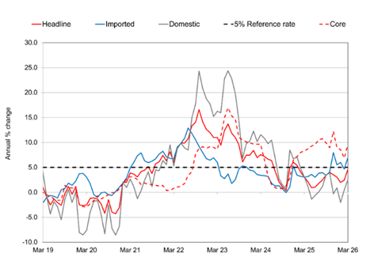
Source: Tonga Statistics Department
The headline rate of annual inflation in Tonga rose swiftly to 4.6 percent in March 2026 from 2.4 percent in February 2026, reflecting the impact of resurging global oil prices amid the Middle East conflict as it led to higher imported and domestic costs. Over the month, import inflation pressures stemmed from international airfares and non-alcoholic beverages, while domestic increases were driven by local food items and kava Tonga. Price declines were observed in several imported items, which helped ease the overall upward pressure on prices during the month. Nonetheless, global oil prices have continued on an upwards trajectory since February 2026, signaling renewed external risks which are expected to result in intensified production costs, driving consumer prices higher in the near term. This is coupled with strong demand anticipated in the upcoming festive months. In the medium-term, risks remain heightened from energy and supply chain vulnerabilities and uncertainties.
Figure 4: Drivers of Inflation
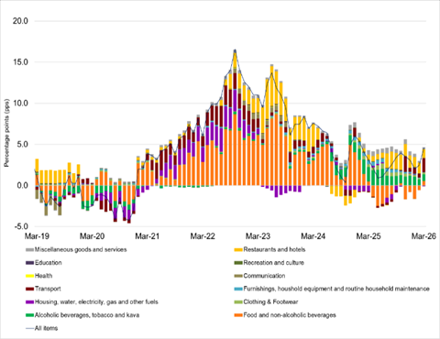
Source: Tonga Statistics Department
Meanwhile, core inflation surged to an annual rate of 9.5 percent in February 2026 from the 6.9 percent figure recorded in January 2026, with import inflation as the dominant driver, intensifying domestic production costs and aggravating the burden on households and business.
Annual import inflation accelerated to 6.9 percent in March 2026 from 4.7 percent in February 2026, driven by higher costs in international airfares, imported food items, goods for personal care, and clothing & footwear. The surge in airfares may also reflect travel disruptions stemming from the Middle East conflict, compounded by the seasonal downturn in demand. Meanwhile, risks that had previously lingered for other imported items are now surfacing and intensifying as the conflict continues. At the same time, domestic inflation rose to 2.5 percent from 0.5 percent, fueled by higher costs in food and beverage serving services, alcoholic beverages, tobacco, and kava. Rising global oil prices and potential supply disruptions further compromise domestic production, raising expectations that local businesses will pass higher energy costs on to consumers. Notably, these external shocks and local pressures underscore the mounting strain on household budgets and businesses’ production costs, and the growing inflationary risks facing the economy.
On the outlook, headline inflation is projected to trend upwards with heightened risks, driven by downside pressures and uncertainties stemming from the prolonged and escalating conflict in the Middle East, which has exerted an immediate and severe impact through energy commodities, the critical drivers of production and broader economic activity. For Tonga, as a small, import-dependent, and geographically isolated economy, the pass-through effect of higher fuel prices is immediate and direct. The risks also extend beyond energy, with potential disruptions to supply chains and spillovers into non-oil commodity prices and domestic production costs.
Figure 5: Headline Inflation versus Brent Crude Oil (US$/Barrel)
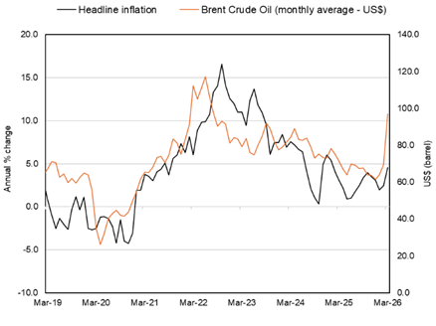
Source: Tonga Statistics Department; Reuters
After more than four weeks of conflict, Brent Crude surged to a record high of US$118.35/barrel during April 2026, marking a 63 percent increase since the onset of the conflict. The fluctuating rebound in global oil prices introduces significant uncertainty for both producers and consumers. If elevated prices persist, firms will face sustained increases in input costs, which are likely to be passed through to consumers in the form of higher goods and service prices. This cost-push dynamic prolongs inflationary pressures, constraining household purchasing power and elevating living costs. Persistent conditions risk embedding inflation expectations. This erosion of consumer confidence may, in turn, dampen aggregate demand. Against this backdrop, the trajectory of oil prices and the pass-through mechanism become critical determinants of near-term economic stability and household welfare.
Globally, inflationary pressures continue to intensify. In the United States, headline inflation rose to 3.3 percent in March 2026, its highest level in nearly two years. The Reserve Bank of New Zealand projects headline inflation to reach 4.2 percent by mid-2026, driven primarily by surging fuel and food costs. Similarly, the Reserve Bank of Australia anticipates headline inflation will peak by mid-2026 at 4.2 percent, underscoring the widespread impact of global energy and commodity price shocks from the Middle East conflict.
For Tonga, inflation is expected to accelerate at a steeper and faster pace than previously anticipated, as global energy shocks translate more immediately into local prices. The forecast trajectory further points to a more prolonged rise, with both headline and core inflation expected to reach double digits in the near term. Tonga’s inflation, in both its scale and persistence, is influenced by the course of the conflict, the capacity of domestic production to absorb external shocks, and the policy measures taken by the major economies and trading partners. A subsequent slowdown in global demand and economic activity would eventually ease inflationary pressures, filtering through to Tonga’s inflation. However, inflationary dynamics shaped by successive shocks including the pandemic, the volcanic eruption, and other external disruptions, have made core prices particularly slower to decline, especially in the context of heightened uncertainty.

Balance of Payments (BOP)
Figure 6: BOP - Current Account (Quarterly)
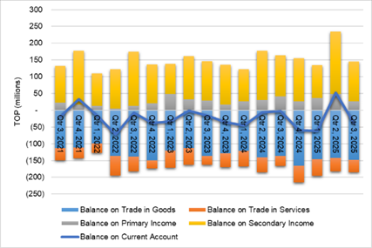
Source: Tonga Statistics Department
Tonga’s latest Balance of Payments report from the Statistics Department shows that the current account recorded a deficit of $39.3m in Quarter 3, 2025, a contraction from the $52.4m surplus in the previous quarter. This deterioration was largely driven by a decline in secondary income inflows, particularly remittances and foreign aid. On an annual basis, the current account deficit widened significantly by $80.8m to $108.7m for the year ended September 2025. This was mainly driven by wider deficits in goods and services, resulting from increased import spending and higher service-related outflows, underscoring ongoing pressures on the external sector.
The Balance of Payments in Tonga continues to reflect the nation’s reliance on imports, a narrow export sector, remittances, and foreign aid. These dependencies expose the economy to external shocks that can strongly affect inflation and growth. The NRBT also monitors the following high-frequency performance indicators sourced from its Overseas Exchange Transactions (OET) data, to assist with the assessment of the external sector.
Figure 7: Import Payments
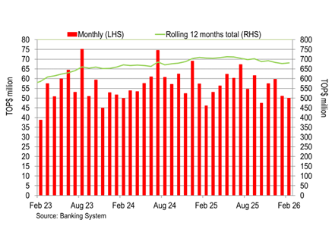
Source: NRBT OET
Import payments declined by 3.5 percent over the year to February 2026 to $681.1m. Despite this decrease, imports remained the largest component of total foreign exchange outflows, accounting for 53.8 percent. The contraction was primarily driven by lower payment for oil which account for about 16.0 percent of total imports, followed by declines in other imports (mostly government imports). Most payments continued to be denominated in US dollars (57.0 percent), followed by New Zealand Dollars (24.0 percent) and Fijian Dollars (9.2 percent). This moderation follows a period of sustained growth, underpinned by Tonga’s post-disaster reconstruction efforts and ongoing development requirements. Looking ahead, import payments are projected to recover over the medium-term, supported by the implementation of development projects and public infrastructure investment, and higher transport costs for imports as a result of the Middle East conflict.
Figure 8: Export Reciepts
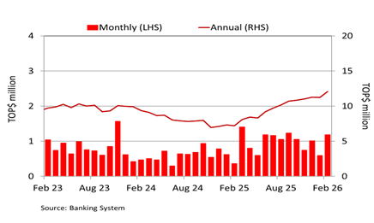
Source: NRBT OET
Export receipts recorded annual growth of 67.1 percent to a total of $4.8m, primarily driven by increased proceeds from agricultural exports. Agricultural exports rose by $3.9m over the year, with other exports also increasing by $0.7m, while marine exports recorded a slight decline, indicating divergent trends across major export categories. The increase in proceeds from agricultural exports is in line with the increasing volumes of agricultural exports. This reflected improved production and harvest outcomes, impacts of previous development initiatives, favorable weather conditions, and stronger external demand. Meanwhile, the weak outturn in marine exports highlights the sector’s continued exposure to operational constraints and subdued external demand, reinforcing the need for diversification and strengthened sector resilience.
Figure 9: Travel Receipts
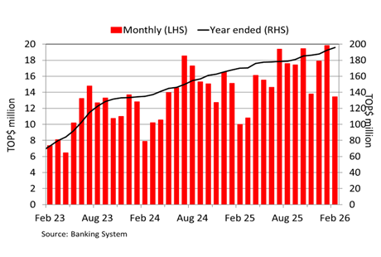
Source: NRBT OET
Travel receipts increased by 15.3 percent ($26.0m) over the year to February 2026, reaching $169.9m, reflecting sustained tourism demand. This corresponds with an increase in passenger arrivals by 0.5 percent (537) and departures rose by 0.8 percent (837). Travel activities remained vibrant throughout the year, coinciding with annual conferences, national celebrations and holiday festivities. Travel receipts account for 55.9 percent of total service receipts, and the remaining 44.1 percent consists of other service receipts mainly professional and management, construction, and telecommunication services.

Figure 10: Remittance by Currency
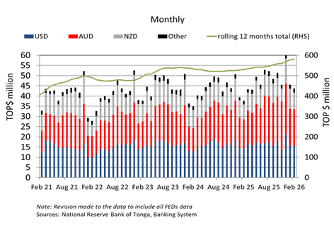
Source: NRBT OET
Remittances grew over the year by 9.7 percent to $582.3m with majority of receipts were private transfers from family and friends abroad (88 percent), followed by compensation of temporary workers abroad (10.0 percent). Strong remittance inflows continue to underpin household consumption and banking liquidity, underscoring the need to ensure these resources are channeled into productive investment. As a share of GDP, remittances are estimated to have edged up from 38.4 percent in the previous year to 38.8 percent as of February 2026 in Tonga, supporting consumption and investment activities. Foreign exchange dealers remained the dominant transmission channel, facilitating 90.5 percent of total flows. The currency composition of remittance receipts remained concentrated in Australian dollars (41.7 percent), followed by US dollars (34.2 percent) and New Zealand dollars (19.8 percent), indicating sustained reliance on major remittance corridors
Capital receipts increased over the year to February 2026 by $20.7m to $36.4m, driven primarily by higher official receipts for development projects. Receipts of capital transfers, mostly for donor-funded projects and public infrastructures rose by $21.6m from the previous year. This was partially offset by a $0.9m decline in private capital receipts, mostly for construction projects for non-profit organizations and households. Meanwhile, capital transfer payments increased modestly by $3.3m over the year to $3.9m, up from $0.6m in February 2025, indicating a relatively smaller rise in outward capital flows compared to inflows.
Financial transactions involving financial assets and liabilities with the rest of the world have also picked up over the year. Inflows of financial transfers rose by 35.6 percent ($93.4m) over the year to February 2026, attributed mostly to interbank transfers and foreign investments. In contrast, outflows of financial transfers contracted by 41.3 percent ($46.7m) during the same period, primarily due to a decline in offshore investments. Overall, these developments point to a net improvement in financial inflows, supporting external balances.

Foreign Reserves
Figure 11: Gross Official Foreign Reserve
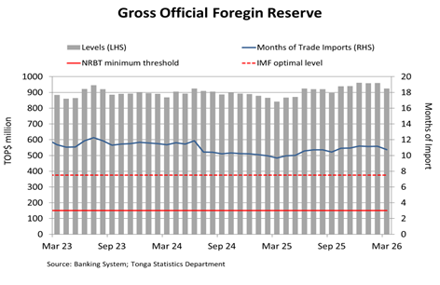
Source: NRBT; Tonga Statistics
Tonga’s official foreign reserves remained above minimum thresholds, supporting Tonga’s external stability. Foreign reserves increased by $81.9m over the year to $924.5m in March 2026, sufficient to cover 10.8 months of imports. This level remained above the IMF’s recommended benchmark of 7.5 months and the NRBT’s minimum threshold of 3-4 months. The increase in reserves reflects inflows of budgetary support, official grants and remittances over the year, reinforcing Tonga’s external resilience and capacity to safeguard economic stability. Foreign reserves are mostly held in USD, AUD, and NZD. Going forward, foreign reserves are projected to remain above the minimum thresholds in the near term, supported by steady inflows of budget support, official grants, and remittances. Meanwhile, import payments are expected to rise in line with the economic recovery. However, the medium-term outlook is uncertain.

Exchange Rates
Figure 12: Nominal and Real Effective Exchange Rates
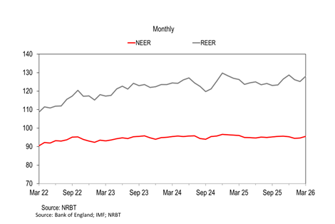
Source: NRBT
Tonga’s nominal effective exchange rates depreciated against most of it its major trading currencies over the year to March 2026. The nominal effective exchange rate index (NEER) fell by 0.5 percent, which supported remittance inflows but contributed to higher imported inflation. Conversely, the real effective exchange rate (REER) increased over the year by 1.4 percent, indicating a general increase in real prices of Tongan exports relative to our trading partner countries.

Lending Balance
Figure 13: Banks’ Lending
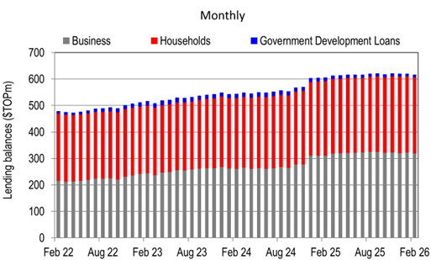
Source: NRBT
Despite moderating from double-digit growth, credit growth including government development loans (GDL) remained positive at 2.4 percent ($14.5m) for the year ending February 2026. Total lending reached $607.9m, although January recorded a peak of $611.9m, reflecting the ongoing economic recovery and stronger investment appetite. Business lending rose by $8.5m (2.7 percent), driven mainly by the professional and other services, construction, and entertainment and catering sectors. Household lending also expanded by $5.9m (2.1 percent), largely for personal, vehicle, and housing loans. The NRBT expects credit growth to remain positive in the near term, supported by recovery efforts and improved business confidence. However, this is subject to the risks of adverse implications of the fuel crisis on the economy and lending appetite. Total non-performing loans declined slightly from 14.0 percent to 13.9 percent of total loans but remained above the internal trigger level of 10.0 percent. The NRBT continues to work closely with commercial banks to ensure prudent management of non-performing loans and the maintenance of adequate provisions.

Interest Rates
Figure 14: Weighted Average Interest Rate Spread
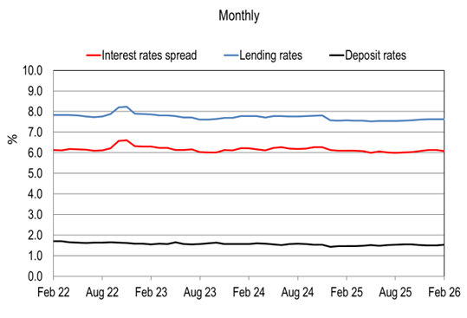
Source: NRBT
The weighted average interest rate spread, a key indicator of interest rate movements under Tonga’s weak credit market conditions, narrowed by 2.2 basis points to 6.1 percent in the year to February 2026. This contraction was largely driven by a 6.9 basis point increase in the weighted average deposit rates, reflecting higher demand and time deposit rates. Similarly, weighted average lending rates rose by 4.7 basis points, driven mainly by increases for businesses in the professional and other services, distribution, and manufacturing sectors, as well as for households. All categories of household loan rates recorded growth, led by vehicle loans, followed by housing and other personal loans.

Broad Money
Figure 15: Broad Money Formation
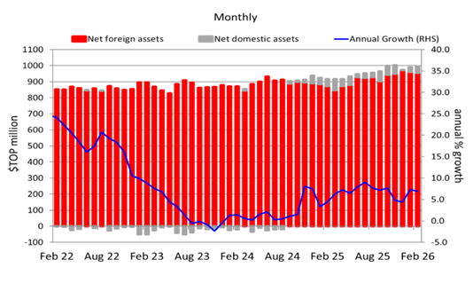
Source: NRBT
Broad Money grew by $79.1m (8.6 percent) over the year to February 2026, reaching $994.0m. This expansion was driven by a significant rise in net foreign assets, consistent with the higher foreign reserves. In contrast, net domestic assets declined, reflecting increases in capital accounts and net credit to the central government. Reserve Money also increased by $24.9m (4.1 percent) to $639.1m, supported by higher other deposits—mainly NRBT Notes—alongside growth in currency in circulation and statutory reserve deposits (SRD). Conversely, Exchange Settlement Accounts (ESA) fell over the year. Excess liquidity in the banking system is estimated to have declined to $211.0m in January 2026, following NRBT’s issuance of NRBT Notes to commercial banks. The elevated level of excess liquidity highlights limited investment opportunities and delays in the utilization of project funds already injected into the banking system.

Aggregate Financial Stability Index
Figure 16: Aggregate Financial Stability Index
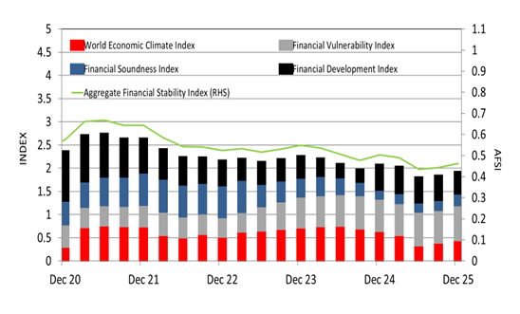
Source: Tonga Statistics Department, National Reserve Bank of Tonga, IMF, Chicago Board Exchange
While the financial system is broadly stable, the Aggregate Financial Stability Index slightly fell by 0.06 points over the year to December 2025 underpinned by the heightened uncertainties in the global economy. Both the Financial Development Index (FDX) and the World Economic Conditions Index (WECI) declined, and outweighed moderate improvements in the Financial Soundness Index (FSI) and the Financial Vulnerability Index (FVI). The slowdown in the FDX reflected GDP growth surpassing total lending, while the lower WECI was driven by an elevated World Uncertainty Index, underscoring pressures from trade, debt, and energy challenges. Conversely, the FSI benefited from the stronger risk weighted capital ratio and improved NPL metrics, partially offsetting weaker liquidity. The FVI also recorded gains, supported by favorable movements in the current account, public debt, and net exports relative to GDP. Nonetheless, the AFSI index is still trending lower compared to pre-COVID times underscoring shallow financial markets, stagnating credit environment, weak growth dynamics, and increased vulnerability to external shocks.

AII.3.5 Fiscal and Public Debt Outlook

Medium-Term Fiscal Framework (MTFF)
The FY2027 Budget is guided by the three established Public Financial Management (PFM) objectives. These objectives guide fiscal outcomes and the management of public resources over the medium-term. They ensure that spending and revenue decisions remain sustainable, efficient, and effective.
    - Aggregate fiscal discipline; by maintaining a sustainable balance between revenues, expenditures, and the level of public debt
    - Allocative efficiency: allocating and spending resources in such a way to maximize the attainment of government objectives, as set out in the TSDF2035
    - Operational efficiency; by utilizing resources efficiently and effectively in the implementation of strategic priorities in the MDAs Corporate Plan
These principles support fiscal policy implementation and ensure alignment between annual budgets, medium-term fiscal outcomes, and the TSDF2035.
The fiscal framework targets presented in this Budget Statement provide the basis for assessing the medium-term fiscal position.
Table 15: FY2027 Fiscal Framework Targets
Fiscal Policies | Short-term | Long-term | Update (March-2026)
Growth | Tonga’s economy recorded an average growth rate of 0.8 percent over the period 2021 – 2025. This growth is projected to rise to 2.3 percent in FY2026 and to average 2.5 percent over the period 2027 – 2029, supported by Government-led fiscal measures and ongoing development initiatives. | A growth long-term target of between 2.0 to 4.0 percent per annum is set to be consistent with macroeconomic stability. | The latest forecast projected a growth of 2.3 percent in FY2026 and a moderation to 1.9 percent in FY2027 due to ongoing geopolitical tensions.
Debt | In line with the Medium-Term Debt Strategy (MTDS) 2026-2028, the government aims to manage debt within sustainable levels over time through the following practises:  - no new external borrowing, except for highly concessional debt if borrowing is required  - Improve transparency of debt management via Quarterly Bulletin publications.  - reduce current external debt through loan repayments.  - external borrowing used only as a last resort.  - Pivot to domestic debt to reduce exchange rate risk via the ADB-backed local currency bond issuance. | The objective is to manage debt risks to Government.  Government can only borrow as a last resort if alternative financing options have been exhausted. | Continue to execute no external borrowing policy except for highly concessional debt if Government required.  Loan repayment of the EXIM loan continues.
Operating balance | The Government will use fiscal policy to increase both productivity and the affordability of key public services through continuous implementation of the PFM reforms, focusing on the efficiency of Government operations and service delivery in the implementation of key initiatives. | The Government will:  - improve fiscal discipline through targeted spending on key focus areas.  - intend to achieve an average of 10.2 percent of GDP operating surplus. | The total budget outturn for FY2026 was $271.6 m, which is 16.0 percent lower than the original budget estimate of $312.3m
Revenue | Target is to improve revenue collection through:  - continuous implementation of revenue reforms.  - strengthening of compliance and administration.  - System modernization  - Better coordination between the MDAs regarding revenue policies | Continue improving the revenue targets set in the medium-term as some of the reforms may need to undertake in phases.  Some revenue targets may amend from time to time depending on the decision made by the Government at the time. Hence, the reform activities will be amended accordingly to be in line with the decision made.  Target is to improve collection to and above the threshold of 22.0 percent of GDP to improve fiscal sustainability. | Domestic revenues for FY2027 are expected to be broadly stable at $441.0m comprised of  83.0 percent of domestic revenue coming from tax revenue and 17.0 percent from non-tax revenue.
Expenses | Strengthen transparency and alignment with the macro-fiscal framework by focusing on prudent spending and efficient public sector service delivery to pivot investment towards the financing of productive and impactful initiatives. | Target is to meet PFM objectives in terms of allocative and operational efficiency towards achieving national development objectives. | Total expenses outturn for FY2026 $539.0m which is 10.0 percent lower than the original budget estimate of $589.4m.  Total compensation of employees recorded an outturn 1.4 percent below the original budget estimate, reflecting controlled personnel spending during the fiscal year.
Cashflow | Focus on ensuring sufficient Liquidity to meet the immediate payment obligations of the Government. | Continue a sustainability and structural balance to ensure future cash inflows and sustain long-term spending and debt | Report on weekly basis the status of the Cashflow to the Minister and CEO for Finance
Inflation | Government, in collaboration with NRBT, will implement the targeted measures to address the impacts of inflation, such as the high cost of electricity, focusing on the provision of electricity subsidies and increased investment in renewable energy projects. | Maintain price stability consistent with the current economic situation and to ensure macroeconomic stability. | The latest CPI stood at 4.6 percent in March 2026. The future inflation outlook remains uncertain but is expected to reach double-digit figures due to increased instability in international trade and the risks posed by geopolitical conflict.

Source: Ministry of Finance

Debt Strategy
Tonga's debt management objectives are to continue maintaining a sustainable level of sovereign debt over time while ensuring that any financing requirements are met at a low cost with a minimum degree of risk. The MOF will continue to service its debt obligations in full compliance with the Medium-Term Debt Strategy (MTDS) 2026 – 2028. The MTDS aims to maintain the Government’s debt within levels that are sustainable over time, as reflected in the Ministry’s Corporate Plan (2025-26). The MOF monitors the strategic targets for public debt to evaluate and manage its financial health effectively. This involves assessing the sustainability of debt levels and aligning borrowing requirements with economic growth. As per Cabinet Decision No.283 dated 27th March 2024, and as part of the PFM reform for improvement of debt management, the MOF will continue to ensure that the Quarterly Debt Bulletin is published on the MOF’s website within a one-month period following quarter-end to improve debt transparency and accountability. The key objectives include maintaining sustainable debt levels, reducing the cost of borrowing, and ensuring that public debt does not negatively impact fiscal stability.

Public Debt
As of the 30th of June 2026, Tonga’s total disbursed outstanding public debt is projected to reach $396.8m, equivalent to 22.9 percent of GDP. External public debt is projected to decline by $34.6m from June 2025 to June 2026, primarily due to the external debt repayments, but also taking into account ongoing disbursement of project-related expenditure and fluctuations in exchange rates. Domestic debt repayments are fully offset by rollovers, with new issuance of Government Bond $20.8m fully issued by end of June 2026.
The majority of the reduction in public debt over recent years is primarily attributable to scheduled repayments on the EXIM loan, in line with the Government’s strategic priority limiting new borrowing to that required for essential needs only. This disciplined approach supports the Government’s medium-term objective of maintaining sustainable debt levels while allowing fiscal space for priority development expenditure.

External Debt
The total external debt is estimated at $307.4m, representing 17.7 percent of GDP by end of June 2026. The external debt portfolio is composed of bilateral and multilateral obligations, with 35.0 percent bilateral and 65.0 percent from multilateral facilities.
For FY2026, total external debt is anticipated to decrease by $47.8m, primarily reflecting principal repayments on the EXIM Bank loan for the Nuku’alofa CBD Reconstruction Project of $39.4m, as well as scheduled repayments on other multilateral and bilateral loans. No significant new external borrowing was undertaken during the year, consistent with the Government’s strategy to limit new debt to essential and high-priority projects only.
Outlook for 30th June 2026, the currency composition of external debt remained largely stable, with 50.3 percent in SDR, 35.3 percent in CNY and 14.4 percent in USD. The reduction in CNY-denominated debt reflects the active repayment of the Nuku’alofa CBD loan, supporting the Government’s broader objective of reducing exposure to non-concessional borrowing.
Table 16: Debt Position as at 30th June 2026 – External Debt by Creditor Type
Creditor Type | Outstanding Debt ($m) | % of Total External Debt | Notes / Purpose
Bilateral
EXIM Bank | 107.4 | 35.3 | Reconstruction Projects – CBD & Roads
Multilateral
ADB | 42.2 | 13.2 | Development projects focused on economic reform, infrastructure, energy, agriculture, fisheries, and disaster resilience
IDA | 103.2 | 33.6 | Supporting Tonga’s economic reform, social services, infrastructure, and disaster resilience.
IFAD | 10.8 | 3.6 | Agriculture programs
IMF | 43.8 | 14.4 | Concessional Financial Assistance to LICs to assist Balance of Payments due to Covid-19
Total External Debt | 307.4 | 100.0

Source: Ministry of Finance
Tonga continues to maintain a prudent external debt management strategy, prioritizing concessional and grant-based financing and ensuring that repayment obligations are aligned with fiscal sustainability targets.

Domestic Debt
By the 30th June 2026, Tonga’s total domestic bond debt will be at $89.4m (5.2 percent of GDP). The largest holders are financial institutions (46.9 percent), followed by the National Retirement Benefit Fund (20.2 percent), the Retirement Fund Board (16.3 percent), and Others (12.9 percent), which include churches, NGOs, private schools, public enterprises, and individual investors. Public Enterprises’ share decreased sharply from 31.0 percent in 2024 to 2.4 percent, reflecting a shift toward private and institutional investors.
Under the current Medium-Term Debt Strategy (MTDS), the Government continues to prioritize domestic borrowing while limiting external financing to highly concessional loans. The $30.0m Government new issuance bond appropriated for FY2026 to support financing of priority projects under the GDL facility was not fully issued, due to the delay in the effective date of the facility and the fuel crisis. Hence, only $20.8m issued to fund the facility in the FY2026 and the remaining to be funded from the prior GDL funds at the TDB.
Interest rates on the domestic portfolio range from 2.0 percent to 3.5 percent, with nearly half of the principal at 2.5 percent. The portfolio is concentrated in 5-year maturities, representing approximately 65.0 percent of bonds at the 2.5 percent rate, reflecting investor preference for shorter maturities despite MTDS objectives to extend the maturity profile.
The largest redemption concentration occurs in FY2027, accounting for 25.0 percent of total maturity. This includes the February 2024 issuance and rollovers from 2022. The Government plans to consolidate multiple rollovers, reducing the administrative burden and ensuring efficient debt servicing.
Table 17: Domestic Debt by Major Holders as at 30th June 2026
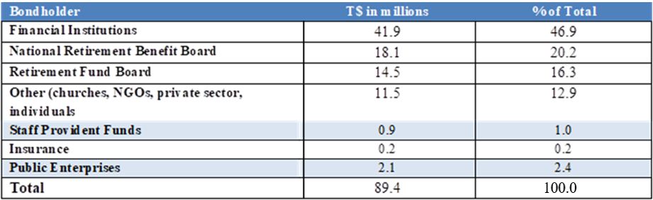
Source: Ministry of Finance

Performance Metrics
Under the baseline scenario, Tonga’s level of public debt is still below the IMF thresholds (International Monetary Fund, 2024). The NPV of the external debt-to-GDP ratio is expected to decline by approximately 4.0 percent in each financial year, reflecting large repayments to China Exim Bank until FY2030. This is shown in Table 18 below:
Table 18: NPV of Debt to Indicators
Indicators | (IMF) Tonga Target | FY2026 | FY2027 | FY2028
NPV of external debt as:
% of GDP | 55.0 | 23.0 | 20.0 | 16.0
% of GDP & remittances | 36.0 | 15.0 | 14.0 | 11.0
% of exports | 240.0 | 774.0 | 673.0 | 526.0
% of exports& remittances | 120.0 | 43.0 | 42.0 | 35.0
% of government revenues | 250.0 | 86.0 | 72.0 | 58.0
Debt Service as:
% of exports | 21.0 | 113.0 | 185.0 | 166.0
% of exports & remittances | 16.0 | 6.0 | 12.0 | 11.0
% of revenues | 23.0 | 13.0 | 20.0 | 18.0

Source: Ministry of Finance

Repayment Strategy
Tonga's public debt repayment strategy is guided by the MTDS 2026 - 2028. The Government is aiming to meet its debt obligations as due and to maintain the country's debt within sustainable levels by not contracting any new loans except for highly concessional loans and developing the domestic market including the following key components:
• Focus on Grant Financing and Domestic Bond Issuances
The MTDS prioritizes grant financing and domestic bond issuances at lengthened maturities to manage the public debt effectively.
• External Debt Share and Average Term Maturity
The strategy targets an external debt share of 70.0 percent and an average term maturity of 40 years. As at 30th June 2026, the debt share is 76.0 percent, and 24.0 percent of the total outstanding debt for both external and domestic debt respectively.
• Debt Service Due to China EXIM Bank
The total debt service due to China EXIM Bank in FY2026 was estimated at $41.4m, accounting for 61.0 percent of Tonga's total debt service for FY2026.
• Domestic Bond Market Development
The government is supporting the maintenance of adequate foreign reserves and liquidity in the domestic bond market to assist with government new initiatives and external debt repayment.
• Refinancing Opportunities
The government appropriated a new domestic bond of $30.0m in FY2026 to assist with private sector development and Government Development Loans facility. This new issuance is to support domestic bond market development. The government will continue to assess and monitor domestic market conditions and investor responses to foster economic recovery and growth.

Monitoring and Reporting
For effective debt management, monitoring and reporting is crucial as they provide a clear picture of a Tonga’s financial health and helpful for the CEO and Minister for Finance in making informed decisions. This will allow for the identification of potential risks associated with debt, enabling timely intervention to mitigate them, and ensure that the Debt team is processing the debt repayments as due to avoid payment in arrears. Regular debt reporting as directed by Cabinet helps ensure adherence to the PFM Act 2002 and promote transparency in financial reporting, which is essential for effective investor relations.
Monthly reconciliation of debt votes to SUNSystem and Commonwealth Meridian is a must to ensure all transactions are captured and appropriately recorded.

Cost and Risk Indicators
Foreign Exchange risk is still the primary concern for the existing debt portfolio, given that the Exchange rate risk is 80.8 percent of the total debt. This immense change is an indication that the Government continues with the repayment of the Nuku’alofa CBD Reconstruction Project loan and the Roads Improvement project loan to China until FY2029 and FY2030 respectively.
Refinancing risk is still a risk of concern for the existing debt portfolio. The domestic debt portfolio is exposed to refinancing risk at 13.4 percent of the government securities due for redemption within one year and an average time to maturity (ATR) of only 3.2 years. However, as a percentage of GDP, this risk is less in the domestic debt than that with the external debt by 1.6 percent. Cost and Risk indicators are shown in Table 19 below:
Table 19: Cost and Risk Indicators
Risk Indicators |  | External Debt | Domestic Debt | Total Debt
Amount (in millions TOP) |  | 307.4 | 89.4 | 396.8
Nominal debt as percent of GDP |  | 17.7 | 5.2 | 22.9
Cost of debt | Interest payment as percent of GDP | 0.3 | 0.2 | 0.4
 | Weighted Av. IR (percent) | 1.0 | 2.4 | 1.2
Refinancing risk | ATM (years) | 7.8 | 3.2 | 7.0
 | Debt maturing in 1yr (percent of total) | 7.1 | 13.4 | 8.2
 | Debt maturing in 1yr (percent of GDP) | 2.1 | 0.8 | 3.0
Interest rate risk | ATR (years) | 7.8 | 3.2 | 7.0
 | Debt refixing in 1yr (percent of total) | 7.1 | 13.4 | 8.2
 | Fixed rate debt incl T-bills (percent of total) | 100.0 | 100.0 | 100.0
 | T-bills (percent of total) | 0.0 | 0.0 | 0.0
FX risk | FX debt (percent of total debt) | 80.8 | 0.0 | 80.8
 | ST FX debt (percent of reserves | 2.8 | 0.0 | 2.8

Source: Ministry of Finance

Contingent Liabilities
On-lent Loans
The Government continues to collect the loan repayments revenue from the on-lent loans offered to support investments through public and private entities, fostering economic growth while bearing the associated risks of borrower defaults. This is in line with the first-ever On-lent Loan Policy developed in the FY2025 under the Sustainable Development Policy Financing Agreement (SDPFA) of the World Bank and marked a significant step toward formalizing procedures for managing on-lent loans.
Table 20: On-lent Loans as of 30th June 2026
Borrowers | 2024/25 ($) | 2025/26e ($) | YTD change $
Nuku'alofa CBD Project | 25.2 | 23.6 | -1.6
Tungi Colonnade Ltd | 16.6 | 16.6 | -
O G Sanft Ltd | 1.6 | - | -1.6
M F Taumoepeau Ltd. | 5.4 | 5.4 | -
Royco Amalgamated Ltd | 1.6 | 1.5 | -0.1
Public Enterprises | 4.1 | 3.9 | -0.2
Tonga Broadcasting Commission | 1.9 | 1.9 | -
Tongatapu Market Ltd | 1.3 | 1.3 | -
TAMA | 0.9 | 0.7 | -0.2
Total ONLENT | 29.2 | 27.5 | -1.7

Source: Ministry of Finance
The total on-lent loans, as of 30th June 2026, owed to the Government are estimated at $27.5m equivalent to 1.6 percent of GDP and 9.5 percent of total external loans. To continue addressing the repayment challenges, the Debt team is liaising with the CBD Borrowers how to assist with their loan repayments given the financial hardships that they are experiencing especially with the quality of the buildings.
Government Development Loan
The Government Development Loan (GDL) facility, established in 2017 to stimulate private sector growth across key sectors, has now reached the end of its lending phase, with the facility formally concluded in September 2025. Following the Government’s decision to convert $7.8m of the facility to settle outstanding Government share obligations with Tonga Development Bank (TDB), the remaining capital balance stands at approximately $10.4 m.
As at end of the most recent reporting period December 2025, total GDL loan outstanding amounts to $8.5m, as presented in Table 21. These balances represent the remaining loan portfolio across sectors, with notable concentrations in the Primary Sector, Manufacturing, Retail and Wholesale, Tourism-related funds, and Education.
With the facility no longer issuing new loans, the focus has shifted to recovery and portfolio management. TDB continues to actively pursue collections, including arrears management, to progressively reduce the outstanding balance.
At the same time, the Government has established a new GDL facility, signed on 23rd February 2026, amounting to $56.4m. This new facility is designed to support renewed Public Sector Development (PSD) initiatives, including $30.0m allocated to the private sector development initiatives, with the remaining funds directed towards assistance for health treatment, school fees, women’s groups, and non-government schools.
Table 21: Government Development Loans as of 31st of December 2025 (Facility closed on 30th September 2025
Sector | Loan Funds | GDL Loan Outstanding ($)
Primary Sector (Agriculture, Fisheries, and Livestock) | Agriculture Marketing & Production Fund | 687,186.32
 | Agriculture & Forestry Development Fund | 1,804,200.88
 | Fisheries Development Fund | 447,811.02
 | Fisheries Development & Export Fund | 385,065.71
 | Fisheries Development Fund COVID-19 & TC Harold | 157,789.52
 | Livestock Development Fund | 3,360.63
 | Micro Loans for Women | 330.20
Secondary Sector (Manufacturing and Industry) | Manufacturing Loan Fund | 1,275,413.46
Tertiary Sector (Retail, Wholesale, and Tourism) | Retail and Wholesale Fund | 914,183.80
 | Tourism Loan Fund COVID-19 & TC Harold | 873,892.49
 | Tourism Loan Fund | 147,359.63
Infrastructure & Utilities | Construction and Utilities Fund | 21,979.19
Social Sector (Education and Health) | Education Loan Fund | 1,473,101.78
 | Overseas Medical Fund | -
Special Facility & Relief Funds | SPECIAL FACILITY FUND for HTHH & COVID-19 | 334,629.51
Total |  | 8,526,304.14

Source: Ministry of Finance
Government Guaranteed Loan
Government guaranteed exposure reduced significantly during FY2026, with the outstanding balance declining to $2.4m (0.1 percent of GDP), compared to $3.9m in the previous year. This reflects the completion of the Lulutai Airlines Ltd guarantee and progress made in resolving earlier guaranteed obligations. The remaining portfolio is now concentrated in two entities, Cost Low Company Ltd and Royco Ports Services, which continue under recovery arrangements with the lending institution. Exposures related to road contractors are currently under settlement with the Government and are no longer recorded as active guarantees.
Although the portfolio has narrowed, residual risks remain linked to recovery outcomes and beneficiary performance. Strengthening contingent liability management remains a priority, with continued focus on active monitoring, timely resolution, and maintaining adequate fiscal buffers in line with the revised Guarantee Policy.
Table 22: Government Guarantee Loans as at end of June 2026
Guarantee Beneficiary | 2024/25($m) | 2025/26 ($m) | YTD change ($m)
Lulutai Airlines Ltd | 1.5 | 0.00 | 1.5
Royco Ports Services | 2.4 | 2.4 | 0.0
Total by borrower | 3.9 | 2.4 | 1.5

Source: Ministry of Finance
On-going negotiations is still on with International Finance Corporation (IFC) for their guarantee facility to be offered here in Tonga. This will open the door for the Borrowers that may need guarantor to apply to this facility and will ease the contingent liability burden for the Government in the near future.

AII.3.6 Public Financial Management
Accelerating the delivery of new government initiatives requires addressing several interrelated constraints, particularly those associated with implementation processes. There is no single factor responsible for delays; however, procedural requirements - most notably concerning procurement activities, is expected to prove essential in unlocking project delivery.
Currently, project procurement can only commence once funding has been formally confirmed, typically following the approval of the national budget by Parliament. As a result, the procurement process for initiatives scheduled within a given financial year begins only after budget approval. In practice, procurement can take longer than anticipated, depending on the completeness of documentation and compliance requirements, often ranging between three to six months. Consequently, project implementation is frequently delayed by a similar duration. This pattern recurs annually under the current budget framework, effectively resulting in a loss of up to six months in implementation time each year.
Measures under consideration include the adoption of a medium-term (three-year) budget framework, which has the potential to significantly improve efficiency and reduce implementation delays. By approving projects on a multi-year basis, procurement processes for initiatives planned over the three-year period could be undertaken in the first year. This would allow subsequent years to focus primarily on implementation rather than administrative preparation.
Effective forward planning would therefore be critical to ensure that projects are properly sequenced and aligned within the medium-term framework.
Furthermore, this approach would require close coordination and engagement with development partners and other stakeholders, underscoring the importance of early planning and alignment to facilitate timely project execution.
The current focus is to ensure that such measures are fully scoped and subsequently implemented into the PFM Roadmap. As part of this, a prioritization process will commence to identify actions which can be implemented in FY2027. To assist with this, the Australian Department of Foreign Aid and Trade (DFAT) has contracted with a consultant to collaborate on the action prioritization process. The wider process of simplifying the PFM bill is ongoing, with DFAT also providing legal counsel to assist here, while also providing an external expert to assist with Internal Audit functions. The improvement of the chart of accounts is ongoing using the internal capacity of the Ministry while awaiting confirmation of the pathway for IFMIS.

Reform of Government
The reform program is not a single policy measure but instead comprises a set of ongoing and new policy changes across government, the economy, and social sectors - especially under the new administration since December. The biggest shift is the transition to a new TSDF2035, which will place a renewed focus on people-centered development, with emphasis on the wellbeing of citizens, inclusive growth, climate resilience and Government improvement. This framework was approved by the new Cabinet formed in January 2026 to strengthen governance systems. Additionally, there will be continued reform in Public Finance Management (PFM), Procurement and Audit Systems, and Revenue and Tax administration. The objective is to improve accountability, the efficiency of government spending, and fiscal discipline, with a focus on accelerating government delivery of vital initiatives to provide consistent, sustainable services.
The Economic and Fiscal Reforms will focus on strengthening fiscal stability, improving budget management and debt control in order to accelerate the economic recovery post-COVID and the additional external shocks. The reform programs are supported by development partners, with program milestones tied to the provision of budget support for improving public administration systems.
The NRBT has already published the monetary policy reform, under which the NRBT will shift towards more market-based monetary tools to improve liquidity management.
The Private Sector & Business Environment ongoing reform includes business and investment reforms through simplifying business registrations, modernization of foreign investment laws and improvements in the digital business registry systems which will facilitate improved job creation. Additionally, specific market and competition reforms were included under the Consumer Protection Act 2025 to strengthen competition policy.
The reform of Climate and Environment policy will focus more on climate resilience, disaster risk management and sustainable development. There is an ongoing debate on the exploration of seabed minerals in balancing economic opportunities and environmental protection, with Government committed to ascertaining a full understanding before committing any actions.

AII.4 Social Outcomes and Outlook in Detail

AII.4.1 Health Sector
The Government continues to prioritize the health sector as a cornerstone of human development, recognizing that improved health outcomes are essential for productivity, economic resilience, and quality of life. Efforts will focus on strengthening primary health care, addressing the growing burden of NCDs, and advancing progress toward UHC. Example programs include the investment in Health Centre maintenance; the new Dialysis Centre – now fully constructed, with training and recruitment for key staff members underway; and the new Vava’u Hospital, for which a signed agreement is now in place.

Figure 17: Key NCD Risk Factors (Baseline %)
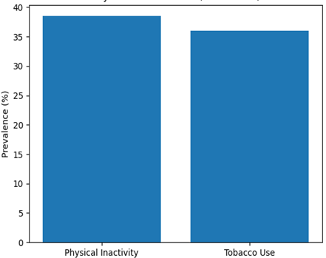
Source: Ministry of Health CP (FY2026-FY2028)
Tonga continues to face significant health challenges, with NCDs remaining the leading cause of mortality, morbidity, and premature deaths. Conditions such as cardiovascular diseases, diabetes, and related complications place a substantial burden on households, communities, and the national health system, with adverse effects on life expectancy, productivity, and long-term healthcare costs. The high prevalence of risk factors, including physical inactivity, tobacco use, and unhealthy diets, continues to drive these outcomes. At the same time, Tonga is managing the dual burden of communicable diseases, emerging health threats, and the impacts of climate change and natural disasters on population health.
The Government is currently implementing the Tuiaki ‘i he ‘Amanaki National NCD Strategy 2021–2025, which has been extended to 30th June 2030 following Cabinet approval in 2024. A review and reprioritization of activities is scheduled for 2026, alongside the anticipated STEPS Survey, to strengthen the effectiveness of interventions over the remaining implementation period.
The Government’s health priorities are anchored in the TSDF2035 specifically National Outcome 2: People and Community Empowered and Strategic Focus Area 2.2: Health, Wellbeing and Inclusive Social Services, while also supporting the achievement of Sustainable Development Goal 3 on ensuring healthy lives and promoting well-being for all ages.
Figure 18: Life Expectancy Trend (Years)
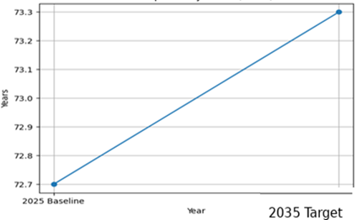
Source: Tonga Strategic Development Framework 2035
Tonga’s progress in health and human development is reflected in key national indicators under the TSDF2035. Life expectancy at birth is estimated at 72.7 years in 2025 (male: 70.2 years; female: 75.3 years), with a national target to increase this to above 73.3 years by 2035, reflecting ongoing efforts to reduce premature mortality, particularly from NCDs. In parallel, the Human Development Index (HDI) stands at 0.77 in 2025, with a long-term target of 0.81 by 2035, signaling improvements in health, education, and living standards. These indicators underscore the Government’s commitment to enhancing the overall wellbeing and quality of life of all Tongans.
The Tonga Health System Strengthening Program Phase 3 (THSSP3) remains a key pillar of health sector reform, supporting system-wide improvements through coordinated investment and technical assistance. The program focuses on strengthening leadership, governance, and accountability; supporting policy and structural reforms to deliver the Package of Essential Health Services (PEHS); improving service delivery planning and implementation; and enhancing community engagement to promote behavioral change and reduce NCD risk factors. It also strengthens health system resilience, enabling Tonga to better prepare for and respond to public health emergencies, natural disasters, and climate-related risks.
The Government will continue to prioritize improving health outcomes in FY2027 through a comprehensive approach focused on reducing the burden of NCDs and strengthening primary health care. Efforts will include promoting healthy lifestyles, implementing fiscal and policy measures to discourage unhealthy consumption, and enhancing early detection, treatment, and access to essential medicines. At the same time, investment will continue in upgrading health infrastructure, expanding and decentralizing services across all islands, and improving referral systems to ensure equitable access to quality care.

AII.4.2 Education Sector
Tonga recognizes the central role of education in economic development, with the Government undertaking marked efforts to promote education accessibility, improve partnerships with non-government schools, and bolster infrastructure resilience. These efforts extend across multiple investment programs, focused on revising the school curriculum and injecting better resources towards the overarching aim of raising the quality of education.
A 10.0 percent increase in grants to non-government schools has been actioned in response to a rise in the cost of living. Secondary and TVET school subsidies have increased to $770 per head and $1,320 per head respectively, with the intention of alleviating financial pressure at home by subsidizing out-of-pocket household expenses. It is also noted that the restructuring of the education system - such as the extensions of government primary schools to include Form 1 & Form 2 - allows for a longer period of free education for students in Tonga. These efforts help address the financial barriers faced by households, which the MET’s ESA has identified as a primary driver of drop-out rates.
Figure 19: Student Enrollment by Education Level
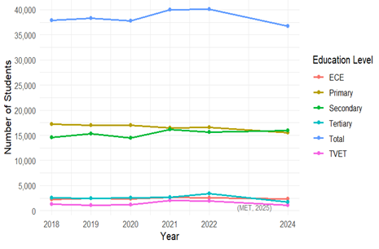
Source: Ministry of Education and Training
Over the 2018-2024 period (covering the most recent data), total enrolments have declined. The decline in enrollments is particularly pronounced at TVET and Tertiary levels due to emigration, labor mobility, and requirements to support household income which can push students into the workforce. This indicates the need for targeted support at the upper education levels, with the GDL scheme launched in FY2026 having been revised to earmark $5m for student loans in upper secondary and tertiary levels. The FY2026 budget will also provide an increase in primary school funding to $17.1m (up from $16.3m), with a focus on operational needs and to better establish ECE and Inclusive Education across key schools in Tonga. Overall, these efforts are intended to directly raise the capacity for productivity growth in the long-term, boosting GDP prospects through human capital development.
Risks to education delivery are present, particularly in the form of climate vulnerabilities. In response, MET is continuing its collaboration with donor partners to complete the construction of more resilient safer schools, with examples including the dormitories of Tonga College, and primary schools such as GPS Kanokupolu and Te’ekiu. In 2026, four school facilities in Ha’apai were upgraded, consisting of two ECE schools (Maamaloa and Maamafo’ou), one government primary school, and Tupouto’a college.
Additionally, the ongoing US-Iran war may impact fuel supply, affecting teaching delivery and leading the sector to consider alternative modes of learning such as homeschool learning or radio broadcasts. It is noted that an eLearning hub (Hama eLearning) has been launched with MET’s online website - providing students with access to exam materials across all levels, and extensive learning materials for students in Form 1 & 2 through the Waka moana learning hub. These conditions will be monitored accordingly.

AII.4.3 Labor Force Participation
The latest data concerning the domestic labor force was compiled in the Labor Force Survey 2023. This found that Tonga’s labor market was relatively stable, with an unemployment rate of 2.2 percent representing a decline of 0.9 percentage points from 2018. Of the 29,253 individuals in the labor force, 650 were unemployed but actively seeking work. Unemployment was higher among females (2.6 percent) than males (1.9 percent), and more pronounced in urban areas, particularly in Tongatapu urban (3.2 percent), while Ongo Niua recorded no unemployment. Youth unemployment stood at 6.0 percent, with higher rates among young females.
Figure 20: Seasonal Worker Flows
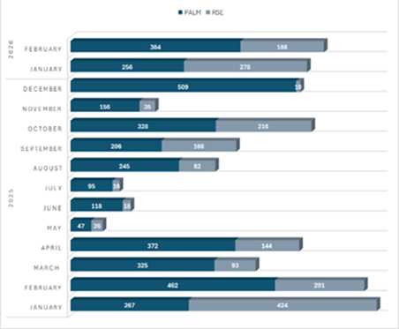
Source: Ministry of Finance
The LFPR was estimated at 45.0 percent, with stronger participation in urban areas compared to rural areas. This is low compared to global averages of c.60 percent, but broadly in-line with other Pacific Island nations. However, Vanuatu (64.4 percent) and the Cook Islands (70.4 percent) demonstrate significantly higher labor force participation, indicating the potential to increase participation in future. Employment was found to be largely concentrated in the services sector, including public sector, while agriculture accounted for the smallest share. Participation was highest among individuals aged 55–59 and lowest among those aged 20–24, indicating lower engagement among younger cohorts.
Labor mobility continues to play a significant role in shaping Tonga’s labor market outcomes. Recent data for 2025 and the first quarter of 2026 indicates sustained participation in employment programs such as the PALM scheme and the New Zealand RSE scheme. These schemes have expanded employment opportunities for Tongans, particularly for low- and semi-skilled workers, while contributing significantly to remittance inflows and household welfare, and becoming an important source of foreign exchange, supporting for Tonga’s external position.
Despite these benefits, labor mobility presents structural challenges for the domestic economy. A significant proportion of Tonga’s working-age population participates in overseas employment schemes, contributing to labor shortages in key sectors such as agriculture, construction, and retail. In addition, increasing reliance on remittances highlights potential vulnerabilities, including reduced domestic labor supply and broader social impacts on households and communities.
Emerging trends also suggest shifts within the schemes themselves. Participation in the PALM scheme has been influenced by changes in contract composition, with a gradual move toward longer-term roles, while the RSE scheme has shown more stable growth supported by established employer practices and worker engagement strategies.
Going forward, policy efforts will need to focus on maximizing the benefits of labor mobility while addressing its challenges. Key priorities include strengthening skills development to support access to higher-value employment opportunities, improving reintegration pathways for returning workers, and enhancing labor market participation, particularly among youth. Strengthening data systems and social support mechanisms will also be important to ensure the long-term sustainability of labor mobility as a driver of economic growth.

AII.4.4 Social Protection & Social Welfare
The Government remains committed to supporting vulnerable groups by continuing the provision of social welfare benefits for both the elderly and persons with disabilities. The total number of beneficiaries currently stands at 6,057 for the elderly and 2,669 for persons with disabilities. Work is underway to revise the existing policy framework.

Annexes III: GFS SUPPLEMENTARY INFORMATION
Table 23: GFS Detailed Overview
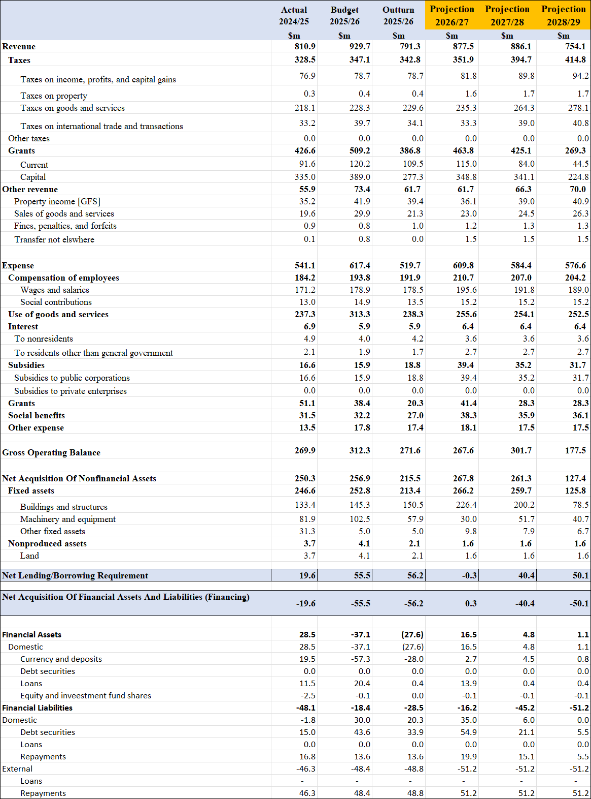
Source: Ministry of Finance

GFS Detailed Revenue
Figure 21: Total Revenue ($m)
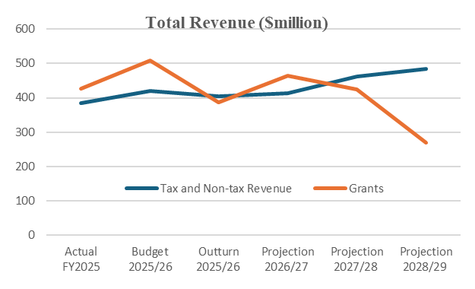
Source: Ministry of Finance
As introduced in earlier sections as an introductory to the economic environment we are facing with fragile outlook based on the uncertainty of the supply of fuel slowing the economy by 0.6 percent to 1.9 percent forecast for FY2027. Fiscal policy focuses on moving the economy while at the same time navigating in cushion the impact of hike in fuel prices. The consolidation of the fiscal sector through improvement of revenue collection, generally effective controls on current spending with donor support. In response to the fuel crisis, an indicative fiscal deficit of 0.8 percent already established in the budget to assist with the fuel crisis while establishing a national response roadmap is established.
The total revenue, with an impact of fuel crisis, is estimated to increase by 10.9 percent in FY2027, estimated at $86.1m increase from estimate outturn for the current financial year. Grants contribute 9.7 percent of the total growth mainly on capital grants and 1.2 percent contribution from Tax and Non-Tax revenues. Domestic revenues slowly pick up with the assumption that fuel crisis will be resolved in the near term.
Figure 22: Grants ($m)
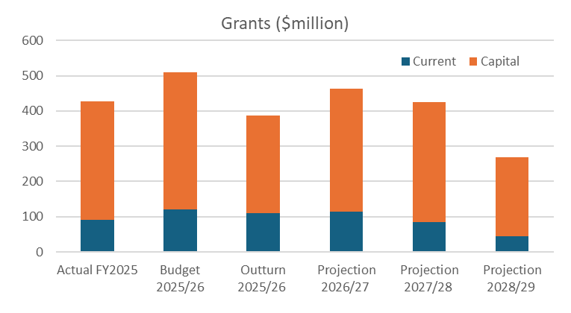
Source: Ministry of Finance
The increase in grants is largely driven by capital grants with a 25.8 percent increase for FY2027 compared to the estimated outturn current capital grant, contributing 9.0 percent to the growth in total revenue. Going forward in the medium, revenue from grants declines reflecting completion some of the projects.
Figure 23: Contribution to Tax Revenue growth (FY2027, %)
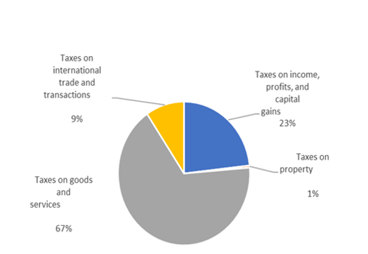
Source: Ministry of Finance
Total current grants from foreign governments and international organizations declined due to a drop in the combined World Bank and ADB funding received as both organizations transitioned towards a joint, sequenced approach to the provision of budget support. Going forward in the medium-term, current grants is expected to decline although it is too early to conclude the exact amount of support which will be received.
The Tax revenue is expected to increase by 2.7 percent for the FY2027 with Taxes on goods and services contributing 1.6 percent to the growth. This forecast is based on a scenario with the least impact of fuel supply in the economy where supply will continue to come but at a higher cost. Excise tax and consumption tax for fuel are expected to be affected as demand for fuel will be affected by the rise in fuel price. Tax on international trade and transactions components is expected to decline by an -2.5 percent for the FY2027 from the current estimated outturn while taxes on income, profits, capital gains is estimated to slight increase by 3.9 percent. Taxes on international trade and transactions are expected to decline as impact of fuel crisis assumed to mount on imports.
GFS Detailed Expenses
Figure 24: Contribution to Expense (%)
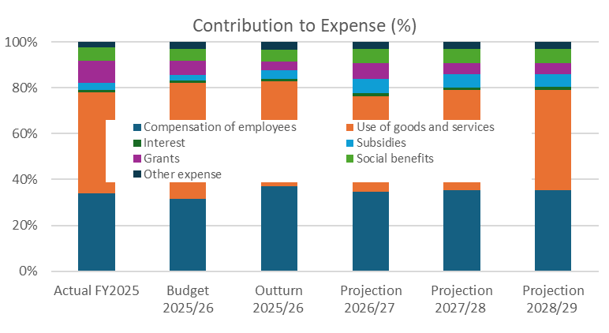
Source: Ministry of Finance
The largest component of Government expense continues to be the use of goods and services, which is expected to reach $255.6m in FY2027. This category includes fuel costs, transport, utilities, and maintenance, and the rise in expenditure is therefore closely linked to the effects of the fuel crisis. However, while expense on this item has risen relative to the $238.3m recorded in FY2026, it does represent a decrease when compared to earlier estimates, reflecting tighter control and reallocation within government operations.
Compensation of employees is expected to increase to $210.7m in FY2027, with a 9.6 percent increase in the wages and salaries allocated to support public service delivery giving an FY2027 total of $195.6m, while social contributions have increased by 12.7 percent to reach a FY2027 total of $15.2m. These two components together highlight the Government’s continued commitment to maintaining workforce stability and service continuity. A 3.0 percent COLA is included to address the impact of high fuel price on cost of living.
Spending on grants and social benefits is also expected to increase in FY2027, with grants rising to $41.4m and social benefits to $38.3m. These increases reflect stronger support for development activities, international commitments, and assistance to vulnerable households affected by higher living costs from the fuel crisis. Other expenses are also expected to rise slightly to $18.1m, reflecting ongoing operational transfers. Overall, the expenditure pattern shows a balance between controlling operational spending and increasing targeted support to households and development needs under current economic pressures.
Net acquisition of non-financial assets for FY2027
Figure 25: Fixed Assets ($m)
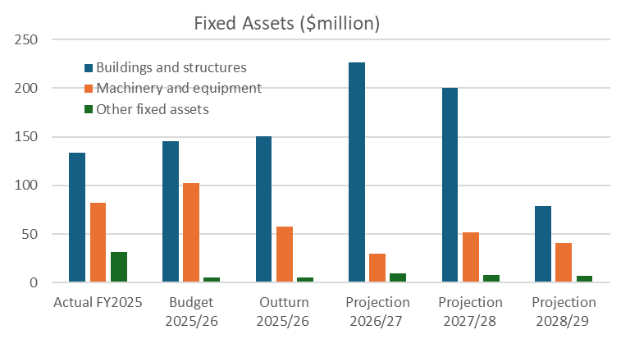
Source: Ministry of Finance
Total Asset acquisition continues to represent a key component of government expenditure, reflecting ongoing investment in strategic infrastructure in line with long-term development priorities. For FY2026, total fixed assets realized an actual amount of $215.5m, lower than the estimate of $256.9m– reflecting delays in project implementation such as SECURE bridge, Vava’u Hospital, and the National Museum. In the medium-term, total fixed assets are projected to increase to $267.9m and $261.3m in FY2027 and FY2028 respectively, signaling the continuity of ongoing projects such as the new parliament house and several energy initiatives. In FY2029, the substantial decline to $127.5m is due to the completion of major projects and the normalization of capital spending.

Net lending/borrowing and Financing
In FY2027, the government moved from a fiscal surplus to a deficit. The net lending/borrowing requirement changes from a surplus of $56.2m in FY2026 to a deficit of $0.3m, meaning the government needs minimal financing to cover the shortfall.
This deficit is mainly financed through domestic financial assets and liabilities such as cash bonds and cash reserves. Net Financial assets increased to $16.5m, especially through currency and deposits ($2.7m) and loans ($13.9m), at the same time, domestic financial liabilities rise to $35.0m, mainly from domestic financing sources.
External liabilities remain high at $51.2m because the government continues making external debt repayments rather than taking new external loans. This means the deficit is managed mainly through domestic financing and existing resources.
In the outer years, fiscal surpluses return as expenditure pressures ease and subsidy costs decline. This reduces financing needs, lowers borrowing pressure, and helps improve fiscal sustainability over the medium-term.

AIII.1 Fiscal Position
Revenue to GDP
Figure 26: Domestic Revenue to GDP
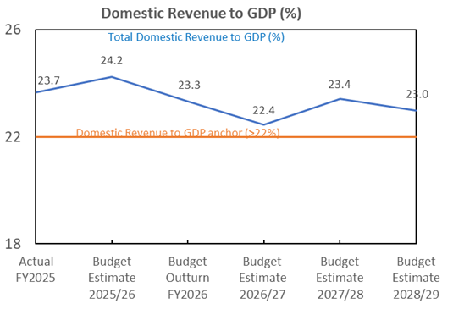
Source: Ministry of Finance
Domestic revenue is expected to be adversely affected by the fuel crisis, as depicted in Figure 26. Excise tax collection is projected to decline following two consecutive increases in fuel prices across April and May, both of which are expected to have reduced fuel demand.
Looking ahead to FY2027, it is anticipated that excise revenue from fuel products will decrease substantially, with central-scenario expectations of the full-year impact estimated to result in a decrease in excise revenue of around 10.0 percent relative to normal conditions. Under a worst case scenario, the decrease in excise tax collection is expected to result in the domestic revenue-to-GDP ratio falling close to, or potentially below, the benchmark level (22.0 percent).
A similar trend is expected for consumption tax, reflecting the anticipated decline in overall consumer demand as a result of worsening economic conditions. These projections remain subject to revision, particularly considering uncertainties surrounding the duration of the ongoing conflict and its implications for global fuel prices.

Fiscal deficit to GDP
Figure 27: Fiscal Deficit to GDP (%)
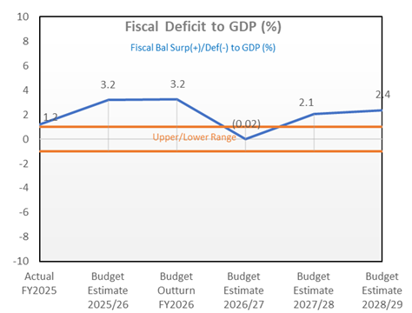
Source: Ministry of Finance
The Government has begun drafting policy responses to address the impacts of the fuel crisis. Particular emphasis is being placed on mitigating the impact on vulnerable groups through existing subsidy mechanisms such as electricity price support. These measures are expected to have implications on grant expenditure.
In addition, Government expenditure on fuel is projected to increase. The implementation of development projects is also expected to slow, reflecting higher operational costs and resource constraints arising from the current situation.

Wage Bill
Figure 28: Wage Bill (%)
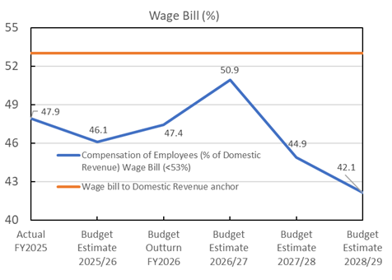
Source: Ministry of Finance
The wage bill fiscal anchor presents an emerging fiscal risk for both the FY2026 and FY2027 budgets, primarily due to the anticipated decline in domestic revenue. Projections indicate that the wage bill is likely to trend closer to its baseline level, suggesting limited fiscal space. Should domestic revenue continue to deteriorate, it will be necessary to consider the implementation of prudent policy measures to contain expenditure and maintain fiscal sustainability.

External Debt to GDP
Figure 29: External Debt to GDP (%)
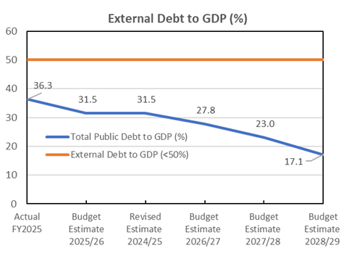
Source: Ministry of Finance
The external debt-to-GDP ratio has declined to approximately 27.8 percent following consistent debt servicing over the past three financial years. This progress leaves the Government with a few years remaining to fully settle its external loan obligations, particularly the Renminbi-denominated debt.

Annexes IV: RECURRENT BUDGET SUPPLEMENTARY INFORMATION

AIV.1 Recurrent Budget Overview FY2027
The FY2027 Budget is strategically focused on responding to the ongoing fuel crisis, safeguarding essential public services, and strengthening national resilience through targeted investment in infrastructure, human capital, and economic recovery initiatives. The budget prioritizes immediate relief measures to cushion the country’s development from rising energy costs, while also supporting medium-term reforms aimed at improving service delivery, workforce efficiency, and economic sustainability. These include allocations have been provided to subsidize electricity tariffs, strengthen contingency financing arrangements, support domestic transportation services, and provide targeted social assistance to vulnerable groups.
The budget will also maintain significant levels of investment in climate-resilient infrastructure and connectivity. This includes the continuation of the Government’s contribution to the Fanga’uta SECURE Bridge, allocations for road maintenance and transport connectivity, and support for strategic energy sector institutions.
The table below highlights the recurrent budget funded key initiatives under each of the SFA for FY2027.
Table 24: Recurrent Budget initiatives by SFA in FY2027
Strategic Focus Area | Recurrent Budget funded Initiatives
- Climate Resilient Infrastructure & Disaster Preparedness | Response measures to strengthen national resilience against the impacts of the fuel crisis:  - $18.0m subsidies allocation to cushion the increase in the electricity tariff for all households, while maintaining the lifeline tariff for the most vulnerable.  - $1.0m as contingencies in case of worsening and prolonged impacts.  - $5.0m for a 3.0 percent COLA for all civil servants  - $3.2m as subsidies to domestic airline Lulutai.  - $3.7m as subsidies to domestic shipping vessels.  - $0.9m as a one-off payment ($100) to top-up the existing social welfare scheme for the elderly and disability’s stipend.  - $5.0m existing allocation from government’s Contingency Fund that would cover other emergencies not just from the fuel crisis such as natural disasters, similar to the $5.0m existing allocation under the National Emergency Fund (NEF) trust fund.  - $0.5m to strengthen the operations of the Tonga Energy Commission.  - Continuation of the $20.0m government contribution to the Fanga’uta SECURE Bridge.  - Continuation of allocation towards road maintenance works – $18.9min addition to $3.7m under the Road Maintenance trust Fund (RMF), totals to $22.6m.
- Quality & Inclusive Education | - School breakfast program at $1.5m (supplemented by additional $1.5m from external partners).  - Continuation of grants to non-government schools at $9.7m.  - Increase in the grant allocation to TNU by $2.0m to $8.3m.  - Increase in the grant allocation to TNQAB by $0.3m to $1.7m.  - $0.2m increase to fund the annual member contribution of Tonga at the USP – totals to $2.2m.  - $0.45m increase to government funded scholarships, totaling to $5.5m.
- Health, Wellbeing, and Inclusive Social Services | - Overtime costs to increase to maintain service delivery in light of growing vacancies. Actual overtime spent by whole of government in FY2025 was $13.5m versus a budget of $5.3m and an estimated outturn of $15.7m in FY2026. The projection for FY2027 is 11.1m (of which $5.6m is for the Ministry of Health) and to be phased out over the medium-term due to current efforts of organizational reviews and workforce planning strategies.  - $1.2m for the operationalization of the dialysis center.  - Continuation of $7.0m for the Queen Salote nursing school and $5.0m for health clinics.  - Continuation of the SWS for the monthly stipends of the elderly ($7.8m) and disability ($3.5m) groups – totals $11.3m.  - Continuation of funding towards the provision of homes for the most vulnerable at $5.0m.  - Continuation of the $1.3m for the island group development committees  - Continuation of $3.7m for overseas medical referrals.  - Reinstating grant of $0.2m to youth and women empowerment programs under MIA’s vote following the launch of their national policies, in addition to $0.1m towards the family protection fund. In addition, $0.1m is also allocated to strengthen the operations of the youth and women departments.  - $1.0m as a youth leadership initiative under the Prime Minister’s Office.  - $0.4m grant allocation for each of the 17 constituencies – an increase from $0.35m or a total additional cost of $0.85m for community development.  - $0.7m increase to the district and town officers’ salaries to strengthen their role in community development.  - Increase in the grant allocation to TNQAB by $0.3m to $1.7m.
- Productive Sectors, Employment & Private Sector Development | - $3.0m Government Policy Obligation (GPO) Fund to support electricity connections for new developments including residentials, tourism, and business sectors.  - $4.0m for a HACCP certified multipurpose packhouse in Vava’u to strengthen trade (also supported by AUD $1.0m from DFAT).  - $2.0m grant to TTA to support tourism marketing efforts – an increase by $0.5m.  - $0.3m to support new tourism products and strategies – yachting, eco-tourism and recreational diving.  - $0.3m to support import substitution program.  - $0.25m for extra liaison officers to strengthen the seasonal worker scheme in Australia.
- Culture & Tourism | - Maintain $1.0m allocation towards the maintenance of tourist, cultural and recreational sites.  (note: initiatives related also to tourism are mostly categorized under SFA 3.1 – Productive Sectors)
- Public Service Delivery | - Centralized vote of $5.7m for e-government efforts aimed at improving service delivery and realizing efficiency gains.  - Debt repayments – an increase by $9.3m to $77.7m, of which $6.3m is related to domestic bonds which have been rolled over. The external debt servicing costs, particularly towards the EXIM-Bank loan, are expected to be cleared by the end of the current medium-term, freeing up fiscal space for government’s further development priorities.  - Bank fees of $2.0m to service the GDL program at TDB.  - $2.0m for the national population census.  - $1.2m to support election of district and town officers next FY.  - $0.7m increase to the civil servants’ insurance scheme – totals to $1.0m  - $0.6m one-off allocation to support Tonga’s hosting of regional events - $0.5m for the Pacific Society for Reproductive Health (PSRH), and $0.1m for the 8th Pacific Meteorology Council Meeting.  - $0.8m for Tonga’s annual hosting fee for the 2031 Pacific Games.  - $0.5m for the establishment of the Communication Commission.  - $0.4m to fund an outsourced government service to provide security and maintenance of public bathrooms.  - $0.5m to support land administration reform program such as the establishment of a call center to help expedite addressing queries on land issues and better management of land records.  - $0.2m to assist in the maintenance and upkeep of the Tu’imatamoana Wharf for improving services in selling fish at a cheaper price.  - $0.1m to strengthen operations of the Fire Emergency services department.
- Security & Law Enforcement | - Continuation of funding towards the Illicit Drugs Response Fund of $5.0m, which will be reviewed subject to the updated national action plan.  - 10x new prison officers and operations to help strengthen security at the prison facilities due to increasing number of inmates particularly those related to illicit drug offences.  - $0.2m increase to the Customs department’s fuel for the operations of the two newly donated patrol and surveillance boats, strengthening Tonga’s borders security.  - $0.5m increase to the Tonga’s overseas missions’ staff to support rising costs of operations; strengthening their role in maintaining relations and diplomatic interests.  - $1.0m to start the design of the construction of Tonga’s mission in Canberra.
- Environment & Resources | - Continuation of existing allocation worth $9.6m in total mainly under the ministries responsible for fisheries, forestry, environment and land & natural resources. Joint efforts include the operationalization of the Oceans Management Act 2025.

Source: Ministry of Finance

AIV.2 Tax Expenditures
Table 25: Tax Expenditures by Type of Tax as at FY2025 and Estimated Revenue forgone of a Selected Expenditure Item FY2021-FY2025
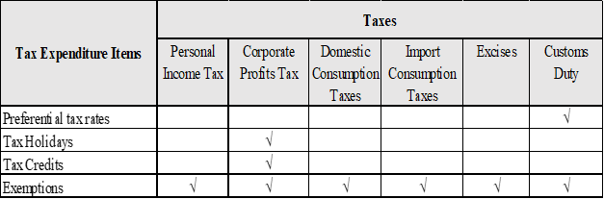

Preferential tax rates apply to PACER Plus Agreement only
*Corporate Profits Tax [Corporate Tax plus Non-Resident Withholding Tax]
*Estimated revenue foregone of a Selected Expenditure Item FY2021- FY2025
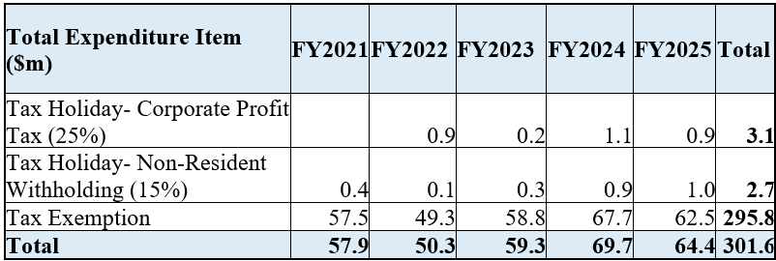

Source: Ministry of Revenue and Custom (MORC)
Tax expenditures are provisions within revenue laws-including legislations, regulations and orders as well as other legislative instruments, that reduce or exempt tax obligations for specific groups or individuals, as outlined in Table 25.
While these measures support specific economic and social objectives, including lowering business costs, encourage investment, supporting priority sectors, and reducing the cost of essential goods and services for households, they also impose a substantial fiscal cost through government revenue foregone, as summarised in Table 25. Of which, 98.1 percent is attributed to tax exemptions while the remaining 1.9 percent relates to tax holiday. Tax exemptions policies apply across various tax types, primarily consumption tax, customs duty, and excise tax.
Figure 30: Exemption by Tax types, FY2019-FY2025
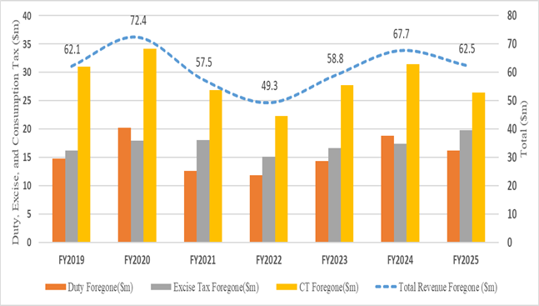
Source: Ministry of Finance
Figure 30 illustrates that from FY2019 to FY2025, total estimated revenue foregone reached $430.3m. Consumption tax exemptions accounted for the largest share at 46.5 percent, followed by excise tax exemptions at 28.2 percent and duty exemptions at 25.3 percent.

Figure 31: Exemptions by Sector with Share Contribution, FY2019-FY2025
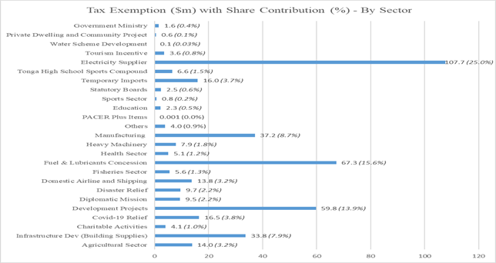
Source: Ministry of Finance
The distribution of tax exemptions across sectors is illustrated in Figure 7. The largest share is allocated to electricity suppliers at 25.0 percent, followed by fuel and lubricants concessions at 15.6 percent, and development projects at 13.9 percent. This distribution indicates that fuel-related exemptions account for 15.6 percent of total exemptions, while the remaining 84.4 percent is attributed to non-fuel sectors, highlighting the relatively larger concentration of exemption is non-fuel activities. The government remains committed to reviewing tax exemption policies in FY2027, building upon policy recommendations from similar reviews conducted by the International Monetary Fund (IMF) in 2020.

Annexes V: DEVELOPMENT BUDGET

AV.1. Development Expenditure by TSDF Pillar
Under the Development Budget in FY2027, National Resilience will have the highest allocation ($167.1m), followed by Inclusive Growth and Public Sector Efficiency ($119.7m). The expectations of development funds will emphasize improving the resilience of the economy through investments in climate-resilient infrastructure and transportation, as well as renewable energy transitions. In addition, inclusive growth and public sector delivery reflects the development of energy resilience via the Grid Enhancement for Sustainable Energy Transition ($14.2m), Tonga Renewable Energy Stabilization Project (TRESP), Nuku’alofa Network Upgrade Project (NNUP) and possible forthcoming assistance from development partners in response to the fuel and fuel crisis; while public sector delivery includes the New Parliament Building ($16.6m), and the Tonga National Museum ($5.1m).
Table 26: Development Budget Allocation by SFA
Source: Ministry of Finance

AV.2. Development Expenditure by Ministry
Ministry of Infrastructure
The estimated budget for the Ministry of Infrastructure in FY2027 is $119.5m, reflecting the highest budget allocation by Ministry with a substantial increase from $64.0m in FY2026. This increase is mainly attributed to the Tonga Sustainable Economic Corridors Urban Resilience (SECURE) Project which became effective on 23 December 2025 as one of the flagship Projects for Government to support the construction of the Fanga’uta Lagoon Bridge, along with associated access roads and drainage systems aimed at strengthening connectivity and enhancing urban resilience and disaster risk reduction.
In addition, the implementation of the Tonga Climate Resilience Transport Project Phase II continues through in supporting civil works for the upgrading of the Nafanua Ports in ‘Eua as well as ongoing national road maintenance in Ha’apai and ‘Eua. Furthermore, the Fuaʻamotu International Airport Improvement Project was signed on the first quarter of FY2026, with construction scheduled to commence in October 2026 and continue through to March 2028 to further strengthen Tonga’s transport infrastructure and connectivity. Closed Projects for the Ministry includes the Nuku’alofa Port Upgrade Project, Hunga Tonga Hunga Ha’apai (HTHH) Project, and the Upgrading of the Royal Tombs.
Ministry of Finance
The Ministry of Finance’s estimated budget for FY2027 is $31.1m, representing a decrease of $40.8m compared to FY2026. This reduction is primarily attributed to the transfer of the Women’s Entrepreneurs Leveraging Innovative Financing in Tonga (WE-LIFT) Project to the Ministry of Commerce. Although reallocated, the project’s funding is still planned to be disbursed over the medium-term to support its full implementation period. In addition, the ADB Local Currency Bond, which is intended to support private sector development, pending the submission of suitable bankable projects.
Notwithstanding the overall reduction in the budget, key initiatives will continue in FY2027. These include the Tonga Renewable Energy Stabilisation Package Project, which supports stability in the energy sector and promotes the advancement of renewable energy initiatives. The Tonga National Museum project, funded by Saudi Arabia, will also continue its implementation. In addition, funding for premium insurance provided through the Pacific Catastrophe Risk Insurance Company (PCRIC) will be maintained to support national disaster risk coverage.
Ministry of Education and Training
The allocated budget for the Ministry of Education and Training in FY2027 is $49.8m, an increase of $8.3m from FY2026. This growth is largely driven by the Tonga Safe and Resilient School Project, which continues the construction of schools identified as vulnerable to tsunami and other risks in Tongatapu, Vavaʻu, Haʻapai, and Niuafo’ou.
Australia and New Zealand also support scholarships for Tongans to study across the region, including undergraduate, postgraduate, and short-term vocational training opportunities. Japan provides ongoing support to Tonga through scholarships and training opportunities that strengthen the capacity of public servants and professionals. These efforts enhance skills, leadership, and knowledge exchange, supporting Tonga’s sustainable development priorities.
Ministry of Meteorology, Energy, Information, Disaster Management, Environment, Climate Change and Communications (MEIDECC)
The MEIDECC estimated budget for FY2027 is $42.6m, reflecting a slight increase from the $41.0m allocated in FY2026. The slight increase is offset by completed Projects and new funds to support the Ministry in the areas of Climate Resilience, Disaster Risk Reduction, Digital and Energy sectors. The Ministry is in the final stages of the Pacific Resilience Project (PREP) and a targeted completion date for the Project is by the end of April 2026, reflecting the completion of the MET/NDRMO Building and Multi Hazard and Early Warning Systems installations.
At the same time, new funds will be expected to support climate change initiatives through the Tonga Climate Change Trust Fund that will trigger the mechanism in operation towards funding climate community projects. The Tala Kei Kapa Grant Project is a new project that supports the Ministry’s mandate with Disaster Risk Reduction and awareness. In terms of digital and communication, the Ministry will be supported on new funds from the US Millenium Challenge Project and Orbit/Spectrum Rights under ITU. For Energy, the Ministry will be accelerating the Nuku’alofa Network Upgrade Project (NNUP) for Area 5 and will be rolling over for Area 4 and at the same time followed by the GREST Project which is closely tied to the Tonga Renewable Stabilization Project. The ongoing Projects include the construction phase of the Tonga Coastal Resilient Project at the eastern district of Tongatapu that will enhance protection against coastal erosion and the impacts of climate change in Hahake.

AV.3. Tonga Development Budget (Expenditure) by Major Project
Table 27 aligns with the Government’s directive to accelerate the delivery of vital Government initiatives to generate sustainable, inclusive growth to refocus resource allocations toward more impactful projects that deliver meaningful improvements to the lives of the people of Tonga. Key initiatives include the construction of the Tonga SECURE Project, Tonga Safe and Resilient Schools Project, Tonga Climate and Resilient Transport Project, GREST, Integrated Aged Care Centres, and the Nuku’alofa Network Upgrade Project.
In addition, Japan will assist with the Improvement of Fua’amotu International Airport, DFAT & MFAT co-financing the construction of Parliament New Building and for the UNDP with the Tonga Coastal Resilience. The Government of Australia, New Zealand and Japan continuously provides local and regional scholarships for Tonga citizens' capacity to learn in various areas. The New Zealand Government continues to support the strengthening of community resilience in the Water Sector through the Climate Change Trust Fund. The Saudi Arabia Government supports the Tourism Sector through the construction of Tonga National Museum.

Table 27: Total Development Budget (Expenditure) by Major Projects
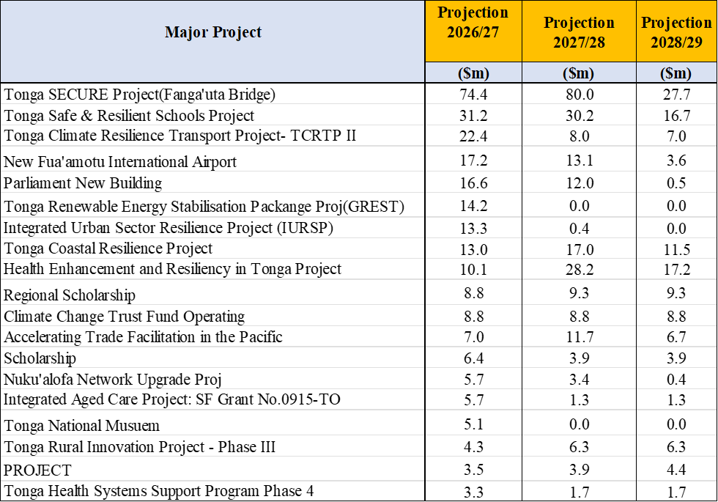
Source: Ministry of Finance

AV.4. Development Funded Project Expenditure by Development Aid Classification (DAC)
Figure 32 illustrates that the majority of investment is allocated to the social infrastructure and services sector, totalling $184.1m, or 53.0 percent of the overall development envelope for FY2027. This aligns with the Government’s directive to accelerate the delivery of vital Government initiatives to generate sustainable, inclusive growth to refocus resource allocations toward more impactful projects that deliver meaningful improvements to the lives of the people of Tonga. Key initiatives include the construction of the Vava’u Hospital, Integrated Aged Care Centers, the Tonga SECURE Project, the Tonga Safe and Resilient Schools Project, the Tonga Climate and Resilient Transport Project, and the Nuku’alofa Network Upgrade Project.
Figure 32: Total Development Budget (Expenditure) by Major Projects
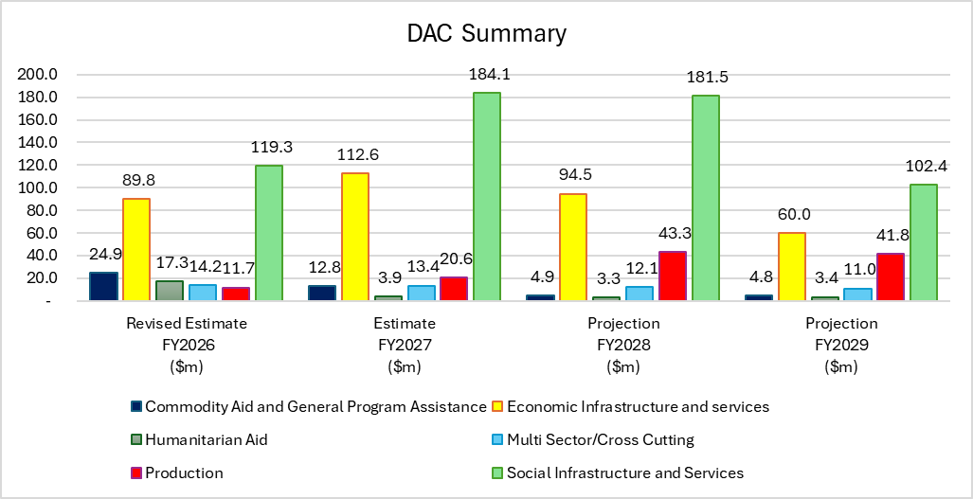
Source: Ministry of Finance
This is followed by the economic infrastructure and services sector, which accounts for $112.6m, or 32.4 percent of total development funding. Major investments in this sector include the construction of a new Parliament Building, Tonga National Museum, Multipurpose Agricultural Packhouse Facility Vava’u, Fua’amotu International Airport, TRESP as well as projects such as the Tonga Climate Resilient Transport Project, the Tonga Coastal Resilience Project, and the GREST Project.
The production sector receives $20.6m, representing 5.9 percent of development funding, and involves collaboration with development partners in Tonga on initiatives such as the Tonga Rural Innovation Project III and the provision of food processing equipment.
Development partners continue to support the remaining sectors, including assistance provided to non-government organizations.

AV.5. Multilateral Development Partners

AV.5.1 World Bank
A total of seven active World Bank-funded projects is scheduled to continue implementation in Tonga for FY2027:
1. Statistical Innovation and Capacity Building (SICB) – This project continues to support the development of quality and efficient statistical welfare data systems, strengthen the institutional and technical capacity of TSD, and improve the production of key national indicators. One of the project’s primary objectives is to support the Household Income and Expenditure Survey (HIES 2025) which was successfully achieved in November 2025. The remaining activities now focus on the delivery of outstanding reports ahead of the project’s closure at the end of December 2026.
2. Tonga Safe and Resilient Schools Project (TSRSP) – The project continues to support enhancing the safety and resilience of educational facilities in tsunami affected communities as well as in other high-risk communities. Reconstruction works on 11 tsunami-damaged schools in Kolomotu‘a, ‘Eueiki, Fonoi, Tungua, Nomuka, Maamaloa and Maamafo’ou as well as Tupouto’a college have been completed. Under the risk-based schools (RBS), two civil work packages have been signed. Package 1 works have commenced in Pea, Tokomololo, and Peteli, and expected completion by end of 2026. Package 2 are the Niuafo’ou schools ‘Alele’uta, Tongamama’o, and Niuafo’ou High School are at mobilising stages. Three more packages 3, 4 & 5 will be expected to commence during FY2027. Slow design, rising cost of construction materials and capacity of local contractors barred the progress of this very important work. The Education Management Information System (EMIS) has been developed and rolled out to all government schools. The revision of primary education curricula has been fully completed across all class levels 1-6. Curricula for High School year 9-13 is due to commence shortly in the upcoming financial year. The project includes a range of teacher training and other technical support including playground equipment for early childhood education, science and ICT equipment for middle and high schools.
3. Tonga Climate Resilient Transport Project II (TCRTP II) – Major roadworks in Vava’u and Tongatapu have been completed. The rehabilitation of roads in Ha’apai (7.5km) and ‘Eua (9.3km) have started and is expected to be completed by early next FY. On Maritime, the major work for the ‘Eua Nafanua Port has started. In terms of the Aviation sector support, the Regional Airport Assets Management supported by the Project will continue until FY2029. This will include the provision of priority equipment and spare parts for the next two years.
4. Health Enhancement and Resiliency in Tonga (HEART) Project - The Project will continue to implement the twinning partnership to assist the MOH with outreach works to address non-communicable diseases (NCDs). The twinning partnership will complement work to encourage behavioral change for more healthy lifestyles and to implement the NCD strategy. The long and short-term medical training continues for the life of the project including scholarships provided for the doctors and nurses including various short studies to strengthen health services. The major work for the Vava’u Hospital Construction is the detailed design, and the construction is expected to be launched later in FY2027. In addition, vehicles for transporting disable patients, and sensitive waste are also due during the FY2027. The project continues to fund the MOF Central Services Unit (CSU) that supports MOF in overseeing World Bank portfolio, including the project PMUsPMU.
5. Correspondent Banking Relations - the Project continues to enable continuous access to correspondent banking services in the participating Pacific Island countries. The upcoming milestones of the Project include procuring and finalizing the selection of the Correspondent Bank Service Provider for Component 1 - to provide CBR support to all the Member countries. The Anti Money Laundering/Countering Financing for Terrorism (AML/CFT) Action Plan was developed and brought to each Member countries with targeted technical assistance for implementation. For Tonga’s (AML/CFT) requires key enabling environment such as the National Payment System Strategy.
6. Accelerated Facilitation Trade Project – is a regional project and was effective in December 2025. The Project aims at transforming trade in Tonga through improve efficiency and reduce cost of trading. The main component is the upgrade of the software for trade clearance (ASYCUDA) and support the establishment of a ‘Tonga National Electronic Single window’ (TNeSW) linking the major stakeholders to ASYCUDA which is still in the design stages. Furthermore, in the next financial year, the project will be procuring inspection equipment, cargo scales, patrol boat and reach stackers, forklifts, vehicle and fender for both Nuku’alofa & Vava’u Ports.
7. Pacific Healthy Islands Transformation Project (PHIT) – is a new regional project in its early stages that focuses on improving health services in the Pacific region with specific focus on NCDs. The Project will sign an agreement with UNICEF for the implementation of the project in developing a center of excellence with digital components regarding telehealth and technical assistance. Overall, the project will support further development in the healthcare workforce, innovative digital healthcare services, improved access to tertiary care, and development of centers of excellence for promising health systems solutions.

AV.5.2 Asian Development Bank
The Asian Development Bank continues to play a vital role in supporting the Government of Tonga across key priority sectors including health, elderly care, transport infrastructure, climate and disaster resilience, renewable energy, urban development, private sector development and public sector management. These areas of engagement are aligned with Tonga’s Strategic Development Framework 2035 (2026 – 2036), which focus on building resilience, enhancing sustainability, and promoting inclusive in Tonga. ADB has 10 active projects in Tonga including:
1. Nuku’alofa Network Upgrade Project II (NNUP): Total financing of US$7.2m which was approved in December 2022. The project aims to reduce technical power losses and improve climate resilience in Nuku’alofa. It comprises improvement of:
  - Nuku’alofa electricity network system,
  - Project implementation capacity of Tonga Power Ltd, and
  - The gender inclusiveness of its operations. The performance rating of the NNUP is currently “For Attention” due to low contract awards. A contract for the last package for upgrading the electricity network, estimated to cost US$1.57m, is expected to be awarded by June 2026. Current implementation progress is 67.0 percent, and the physical work is on track to be completed by Dec 2026. This project closes on 30th June 2027.
2. Grid Enhancement for Sustainable Energy Transition (GREST): Total financing of US$11.33m ($1.0m ADF, $2.1m European Union, $1.5m Clean Energy Financing Partnership Facility, $0.4m Tonga Power Ltd (TPL), $5.6m counterpart funds from the Government of Australia through contribution from the government, and $0.7m non-cash contribution from the government. This project was approved in October 2023 which supports the achievement of the national target of 70.0 percent renewable energy by 2030 in upgrading and strengthening the grid to absorb:
  - An additional planned 20 megawatt (MW) Independent Power Producer (IPP) solar plant; and
  - Other future renewable energy projects.
Three activities need to be finalized to enable progress on the Grid Enhancement for Sustainable Energy Transition (GREST) Project.
These include:
    - Further assessment of the combined impacts of the Renewable Acceleration Independence Project (RAPID), the 20‑megawatt solar photovoltaic project, and GREST project on the Tongatapu network;
    - Land acquisition for the RAPID project; and
    - Refinement of the RAPID project power purchase agreement (PPA).
Completion of these three activities is expected by the end of Q2 2026, which will enable the signing of the RAPID project PPA with the prospective Independent Power Producer.
This will allow the GREST project to move forward, as the invitation to bid for the GREST works package is contingent upon the signing of the PPA. The invitation to bid for the GREST package works is expected in Q3 2026. The project is to be completed by 31 December 2028.
3. Tonga Sustainable Economic Corridors and Urban Resilience (SECURE) Project: Total financing US$145.0m (US$80.0m ADB, US$40.0m WB and US$25.0m Government of Tonga comprising of US$20.0m cash contribution to civil works and about US$5.0m for land compensation). Project cost excludes in-kind contribution of US$24.7m for tax and duties. The civil works contract for the Fanga’uta lagoon bridge as part of the project and the Construction Supervision Consultant (CSC) contract were awarded in September 2025 and January 2026, respectively. The grant has been effective since 23rd December 2025. The project is classified as a Full Mutual Reliance Framework (FMRF) operation with the WB with the SECURE project as ADB’s first leading project under FMRF.
The MLSPNR are currently progressing with the negotiation on land compensation which will assist the contractor’s site access for the timely commencement and the progression of civil works. The contractor has submitted value engineering proposals (VEPs) aimed at achieving potential cost efficiencies which help to mitigate costs associated with project delays. These proposals, including variations in designs, are currently under review by CSC, MOI and PMU and to be submitted to ADB for no objections The VEPs are not expected to compromise the quality of the infrastructure.
4. Women Entrepreneurs Leveraging Innovative Finance in Tonga (WE-LIFT) Project: Total financing of US$9.0m funded from ADB’s Gender Thematic Window. The project was approved and signed in December 2025, and the grant became effective in April 2026. The recruitment for the National Project Manager position is almost finalized, and the remaining PMU consultant positions will be advertised Q3 2026.
5. System Strengthening for Effective Coverage of New Vaccines in the Pacific: Total financing of US$10.4m ($3.9m ADB, $5.5m additional financing under ADB’s Asia Pacific Vaccine Access Facility, and $1.0m from government) This project was approved in November 2018 and supports the introduction of three (3) new vaccines: pneumococcal conjugate vaccines (PCV); human papilloma virus vaccines (HPV) and rotavirus vaccines (RV).
Human papilloma virus vaccine (HPV) is also introduced to adolescent girls and currently at 57.0 percent coverage. The mission acknowledged the significant and continued effort by the Ministry of Health through campaigns to reach the target of 80.0 percent coverage or above for HPV.
The government is currently providing 80.0 percent cofinancing for the project and is expected to provide 100 percent financing, equivalent to approximately $240,000 (USD) for the three vaccines annually, when the project is completed in November 2026 and financially closed in May 2027.
6. Introducing E-Government Through Digital Health Project: Total Financing of US$8.5m ($7.5m ADB and $1.0m Government). The project was approved in July 2019 and is rated ‘on track’ by aiming to improve the enabling environment for the use of digital health data and implement a national digital health information system. The National Health Information System (NHIS) has been rolled out across all health facilities in Tonga. NHIS is also integrating with existing digital health and e-government initiatives. The Personal Health Information Protection Act was enacted in December 2025. This Project is planned to close in February 2027.
7. Integrated Aged Care Project (IACP): Total financing of US$16.7m ($6.0m: ADF; $5.5m: ADF 13 Thematic Pool-SDG5; $3.0m: JFPR; $1.1m: CRPPTF1; $1.1m: Government).This project was approved in November 2023, the proposed project will support the construction of community-based aged care center’s (3 in Tongatapu and 1 in Vava’u), aged care services and programs, and support to care givers. The Integrated Aged Care Project is rated as “For Attention” due to low contract awards however is expected to return to “On Track” once the works package for the Houma Aged Care Centre is awarded by Q2, 2026.The caregiver allowance program is operational and delivering results, with 204 caregivers supporting 209 older persons since mid-2025. Adjustments have been required due to beneficiary mortality and verification issues, and 180 caregivers are currently receiving support. The PMU is identifying replacement beneficiaries to sustain program targets. Caregiver training commenced in November 2025 through Tupou Tertiary Institute (TTI), with ongoing efforts to strengthen practical training capacity, including a proposed cost-effective simulation facility in Vava’u. The home modification component is being redesigned to strengthen technical quality assurance. The initial voucher modality was assessed as high risk; the PMU is therefore proposing structured contractor engagement and/or partnership with Tonga National University. After initial delays, detailed designs for the three network centers (CW02–CW04) have been completed, and final designs and bill of quantities (BOQs) for the Tongatapu Main Center (CW01) were finalized in the week of 23rd March 2026. Works packages are expected to be awarded by June 2026. All procedural steps for issuance of deeds of lease for the four centers have been completed. The completion date for IACP is 31st July 2029.
8. Nuku’alofa Port Upgrading Project (NPUP): Total financing of US$83.5m ($55.0m: ADB; $20.0m: Australian Infrastructure Facility for the Pacific; and $8.5m; Government of Tonga). This project was approved on 3rd December 2020 with additional financing approved on 21st April 2023 to cater for cost escalation. The project is rated ‘on track’ and aims to rehabilitate and upgrade the Queen Salote wharf in Nuku’alofa and improve the port’s operations and resilience to disaster risks and climate change with impacts of safer, more reliable, and more affordable transport infrastructure and services provided in Tonga. The civil works were completed in advance with the commissioning of the upgrading of the wharf in November 2025. However, the ongoing works for the upcoming FY2027 include identified savings to rehabilitate the access roads and upgrade of the gatehouse to be completed by June 2026. The project completion date is 31st December 2026.
9. Tonga Integrated Urban Resilience Sector Project: Total financing of US$21.3m ($18.3m: ADF; $3.0m: Government of Tonga). This project was approved in 2019 aiming to improve urban infrastructure and resilience to floods and climate change in Nuku’alofa by implementing an effective flood risk management infrastructure, improving water supply services, enhancing public and environmental health and strengthening urban resilience.
The project is currently rated as “on track” with 75.0 percent of the total time elapsed, with overall physical progress at approximately 60.0 percent. Two civil works contracts remain ongoing (public drainage & valves), and a final civil works package will soon be awarded (W-02 Tapuhia wastewater treatment plant rehabilitation). The PMU Project Manager replacement is in process and the project completion is by 30th September 2027 and the grant closure on 31st March 2028.
10. Pacific Disaster Resilience Program, Phase 4: Total financing of US$10.0m ADF expanded Disaster and Pandemic Response Facility. This project was approved on 6th March 2023. Contingent disaster financing of US$10.0m is available to be drawn down upon request by the Government on the condition that a disaster event has occurred during the availability period, in connection with the Prime Minister having issued a declaration of a state of emergency in accordance with Tonga’s Emergency Management Act of 2007 or the Minister of Health declaring a public health emergency under the Public Health Act of 2008.
ADB also actively supports Climate and Disaster Resilience and Private Sector Development in Tonga as follows: -
● Climate and Disaster Resilience. ADB’s ongoing portfolio and proposed program both contribute to building climate resilience in Tonga. ADB has approved and awarded grant resources from the ADF14 thematic window on CCA-DRR and is preparing the funding proposal for the Pacific-led Regional Programmatic Approach for Climate Action (RPACA), which is a proposed initiative to streamline the mobilization of climate funds. ADB is in the design and consultation phase of the proposal under RPACA, targeting submission by 30th April 2026 and approval by the Green Climate Fund (GCF) board by October 2026. Downstream, sovereign investments will:
  - Enable the movement of vulnerable populations to less disaster-prone areas through improved transport connectivity on the main island of Nuku’alofa; and
  - Support Tonga’s clean energy transition. Support may also be available to help implement Tonga’s new nationally determined contribution (NDC).
● Private Sector Shift. Ongoing and potential private sector development activities that ADB is supporting in Tonga include:
  - Local currency lending;
  - ADB Frontier (Pacific); and
  - Private Sector Development Initiative (PSDI). PSDI supports Tonga on several initiatives, including strengthening Tonga’s economic and governance frameworks through regulatory development for competition policy and Public Private Partnerships (PPP) capacity building, upgrading the online business and investment registry, supporting the implementation of the Consumer Protection Act, supporting reforms of state-owned enterprises, and providing transaction advisory for solar energy projects. Additional efforts focus on establishing a credit registry for the National Reserve Bank and enhancing governance and investment policies for Tonga’s pension funds.
The indicative resources and pipeline projects for Tonga for 2026 – 2028 are:
  - Project Readiness Financing Facility (PRF) (2026). Indicative total financing: $3.0m ADF country allocation. The purpose of the PRF is to prepare the Healthy Tonga Project to be at a high project readiness level prior to project approval to expedite implementation. The PRF will include provisions for a project design firm and a PMU.
  - Public Sector Reform Program Subprogram 1 (2027). Indicative total financing: $10.0m ADF country allocation. The proposed policy-based operation will build on reforms supported under previous policy-based operations.
Reform areas may include public sector management, social protection, and private sector development. Through the program, ADB will continue to engage in the Joint Policy Reform Matrix dialogue in collaboration with other development partners, who provide parallel budget support cofinancing (not administered by ADB).
  - Pacific Disaster Resilience Sector Program Phase 6 (2027). Indicative total financing: $10.0m ($2.5m ADF country allocation and $7.5m proposed from the ADF Crisis Response Window). The objective of the policy-based program is to strengthen the resilience to disasters triggered by natural hazards and health emergencies. This has been scheduled for 2027 should the ongoing phase be required to be disbursed. The contingent disaster financing is accompanied by policy actions and reforms aimed at strengthening climate and disaster risk management as well as health emergency preparedness.
  - Sustainable and Resilient Power Network Project (2027). Indicative total financing: $6.0m ($1.0m ADF country allocation and $5.0m from the ADF thematic window). The project aims to improve the power network’s reliability and resilience and will focus on upgrading the network in Area 4 to complete the entire Nuku’alofa network upgrade.
  - Healthy Tonga Project (2027 standby and 2028 firm). Indicative total financing: $28.74 ($25.74 million ADF country allocation and $3 million indicative from the ADF thematic window). Building upon ADB’s support to the health sector in Tonga, the proposed project will aim to improve the resilience of Tonga’s health system through:
  - Upgrading of health facilities, including the expansion of the Niu'eiki hospital in ‘Eua and staff housing; subprojects for strengthening 2-3 health centers, and renovation of public health building at Vaiola hospital;
  - Workforce development and clinical governance strengthening, including upskilling of nurses, doctors, and allied health professionals, and improving working conditions and incentives for staff retention, particularly in outer islands; and
  - Promoting innovations in digital health and health security, leveraging on ADB’s existing support in communicable disease control and health information systems to improve service planning, budgeting and monitoring, as well as early detection of disease outbreaks and response to health emergencies.
  - Project Readiness Financing Facility (PRF). Indicative total financing: $5.0m ADF country allocation. This proposed readiness financing facility is to support the preparation of prioritized projects that the government may propose to consider in the longer term after the end of the current ADF cycle (2025-2028) given that there were several investments that were proposed by the Government. As the designated Delivery Partner to the Green Climate Fund (GCF), the MOF remains committed to fulfilling the accreditation requirements necessary to become an accredited entity under the updated GCF framework. Two key policies are the Project Administration Policy and the Environmental and Social Safeguard Policy which are still finalizing their Terms of Reference. These are the main remaining gaps before the GCF accreditation application can be completed and submitted by August 2026.
The Green Climate Fund (GCF) is currently supporting Tonga through a mix of projects and readiness support aimed at climate resilience and education sector.
Coastal Resilience Project - A large-scale project (about US$23.9m) helping Tonga protect vulnerable coastal communities, strengthen climate risk planning, and build adaptation infrastructure. The Project will focus in FY2027 on strengthening knowledge, capacity and engagement for incorporating climate risks into long-term adaptation planning, strengthening national and local capacities for effective monitoring and assessment of climate risks, and reduced vulnerabilities to coastal communities in Hahake to climate hazards. The Project will also undertake a LIDAR assessment in partnership with SPC for FY2027.

Building the Climate Resilience of Children and Communities through the Education Sector (BRACE) Project is a 5-year project, totalling US$8.0m. The initiative will strengthen the resilience of the education sector by retrofitting priority schools and buildings identified by the World Bank as high climate risk. It will integrate climate change into the national curriculum and establish an e-learning platform to support continuity of education. The project will also provide school safety training and improve inclusive WASH (water, sanitation, and hygiene) facilities to ensure safe, accessible, and climate-resilient learning environments. This project is implemented by Save the Children Australia in partnership with Ministry of Education and Training.
GCF Readiness Projects - The primary goal of Green Climate Fund (GCF) readiness projects in Tonga is to strengthen the country’s ability to access and manage climate finance effectively. The readiness projects focus on helping Tonga:
• Build the skills and systems needed to plan and deliver climate projects.
• Meet GCF requirements (like policies, safeguards, and accreditation)
• Develop strong project proposals for funding.
• Coordinate national efforts on climate change.

Overall, the aim is to make Tonga more prepared to secure GCF funding and use it well to address climate challenges like rising sea levels, extreme weather, and resilience building.
At present, there are two active readiness projects: TON-RS-009 and TON-RS-010 being implemented by the Ministry of Lands, Survey, Planning and Natural Resources, and the Ministry of Meteorology, Energy, Information, Disaster Management, Environment, Climate Change and Communications (MEIDECC), which serves as Tonga’s National Designated Authority (NDA) to the GCF. However, five readiness projects have completed their implementation phase and are currently moving toward closure: TON-RS-003, TON-RS-004, TON-RS-005, TON-RS-007, and TON-RS-008.
The most recent readiness project, approved in the second quarter of FY2025, is a multi-year initiative (TON-RS-010) that will support the engagement of a consultant to assist with Tonga’s ongoing GCF accreditation application.

AV.5.3 United Nations
The United Nations presence in Tonga primarily comprises 23 UN agencies, including Resident Agencies (FAO, IOM, UNCDF, UNDP, UNFPA, UNOPS, UN Women, WHO, and the UN Resident Coordinator’s Office) and Non-Resident Agencies (ESCAP, IAEA, IFAD, ILO, ITU, OHCHR, UNCTAD, UNDRR, UNESCO, UNIDO, UNODC, UNICEF, WFP, and WMO).
The Tonga Country Implementation Plan (CIP) 2025–2027 outlines the UN’s strategic engagement to support Tonga in achieving the 2030 Agenda for Sustainable Development. The CIP serves as a framework for UN–Government cooperation, providing targeted interventions across climate resilience, economic diversification, education, healthcare, gender equality and social inclusion, youth empowerment, tourism, migration, governance, and digital transformation.
The key interventions and expected outcomes include:
  - Economic Diversification and Resilience: Strengthening sustainable fisheries, agriculture, and eco-tourism to reduce dependency on imports and external aid.
  - Climate Adaptation and Disaster Resilience: Implementing coastal protection, renewable energy solutions, and sustainable land-use practices.
  - Education and Workforce Development: Expanding vocational training, family life education, digital literacy, and education infrastructure.
  - Health and Well-being: Strengthening primary healthcare access, children, adolescents and youth friendly health services, NCD prevention, protection, mental health and psychosocial support, and water and sanitation services.
  - Governance and Social Inclusion: Enhancing public administration, gender equality policies, and statistical capacity to ensure evidence-based decision-making.

AV.5.4 International Fund for Agricultural Development
Tonga Rural Innovation Project Phase III
The TRIP III is a USD$19.3m co-funded initiative between the Government of Tonga and the International Fund for Agricultural Development (IFAD), implemented over a six-year period from 2026 to 2032. The Project will directly benefit 35,143 people across 128 communities in Tongatapu, Vavaʻu, ʻEua, Haʻapai and the Niua’s, strengthening food and nutrition security, reducing rural poverty, and building long-term climate resilience. Through climate-informed Community Development Plans and Livelihood Development Plans, TRIP III supports with a budget of $2.5m for the transition of subsistence to semi-commercial agriculture, expands sustainable and biodiversity-enhancing production systems, promotes youth livelihood opportunities, strengthens agribusiness partnerships, and introduces innovation and agrometeorological services to advance climate-smart agriculture. The Project also reinforces institutional and policy capacity through coordinated government engagement and incorporates a disaster response financing mechanism to enable rapid recovery during climate or economic shocks. Implemented by MORDI Tonga Trust as Lead Project Agency under multi-sector government oversight, TRIP III represents a flagship national investment aligned with Tonga’s development priorities to advance resilient, inclusive, and commercially viable rural transformation.

AV.6 Bilateral Development Partners

AV.6.1 Government of Australia
Department of Foreign Affairs and Trade (DFAT)- Development Assistance in Tonga
The Australia–Tonga Development Partnership Plan 2024–2029 (DPP) translates into action the development priorities Australia shares with Tonga. The DPP sets out agreed objectives, how we will work together to deliver shared outcomes, and how progress will be monitored. It also identifies where Australia can add value to Tonga’s national development priorities and how Australia will work with other development actors, ensuring the Australian Government contribution to Tonga’s development ambitions is well coordinated. The DPP reflects the full spectrum of Australia’s development support – Australian Government bilateral Official Development Assistance (ODA) as well as significant regional and global ODA and non-ODA development activities.
Thematic Areas of Investment:
1. Improving national resilience to climate change impacts, disasters and security challenges.
2. Strengthening fiscal stability, accountable governance and economic performance.
3. Enhancing health, gender equality and social outcomes for all Tongans.
4. Integrating climate change and gender equality, disability and social inclusion across the program.
Objective 1: Improving national resilience to climate change impacts, disasters and security challenges
Climate change remains the single greatest threat to the livelihoods, security and wellbeing of Tongans. Australia supports the Government of Tonga and communities to lead climate mitigation and adaptation, including by investing in Tonga’s renewable energy transition, sharing climate finance expertise, and helping communities adapt to and manage climate risks through a new national community development program. Australia is integrating climate resilience, adaptation and mitigation across all development investments.
Australia is working with humanitarian partners to build the capacity of Tonga’s national preparedness and response system, including through pre-positioning of supplies, support to government agencies, and new warehousing capabilities. Recognizing the critical role of formal social protection systems in times of crisis, Australia is supporting Tonga to strengthen the quality and coverage of its systems.
Australia is enhancing security partnerships through the Australian Federal Police, Australian Defense Force and Australian Border Force. The Tonga–Australia Policing Partnership continues to combat crime and prevent and respond to family violence, while defense cooperation with His Majesty’s Armed Forces builds capacity, supports maritime security and upholds Tonga’s sovereignty. Border and cybersecurity cooperation is strengthening the integrity of Tonga’s air, land and maritime domains and building capability to counter transnational and serious organized crime.
Key investments include:
• Tala Kei Kapa: Prepare, Respond, Recover Humanitarian Program
• Tonga Australia Partnerships for Resilient Communities
• Tonga Renewable Energy Acceleration Transition
• Defense Cooperation Program
• Pacific Maritime Security Program
• Tonga Australia Policing Partnership
• Border Security Partnership
• Partnerships for Social Protection
• Pacific Humanitarian Warehousing Program
• Australia Assists
• Climate Finance Access Network
Objective 2 Strengthening fiscal stability, accountable governance and economic performance
Tonga’s economy is recovering from successive shocks but remains at high risk of debt distress, requiring stronger public finances, accountable governance, a better business environment, and investment in productive, climate resilient infrastructure. Australia will continue to support these priorities through sustained budget support, technical assistance, and policy reform, enabling the Government of Tonga to lead its development agenda, deliver essential services, strengthen public sector performance, and reduce vulnerability to external shocks. Support will focus on fiscal and debt management, revenue mobilization, public financial management, civil service and procurement reforms, and strengthened accountability institutions, alongside expanded labor mobility, infrastructure financing, regional connectivity, and targeted investments in tourism, agriculture, aviation, and private sector development to drive inclusive and sustainable economic growth.
Australia reconfirmed long-term commitment to supporting Tonga during the special FEMM, hosted in Tonga on 26th March 2025. In this session, Australia and Tonga agreed to an AU$85.0m (TOP$125.0m) budget support program over the next four years to support a stronger economy and national budget. An additional AU$5.0m was announced in June 2025. At the time of writing, AU$26.5m has been disbursed.
Key investments include:
• Nuku’alofa Port Upgrade Project (Queen Salote International Wharf)
• Tonga Parliament Buildings Project
• Tonga Hawaiki Branch System Project
• Kafa-Taha: Tonga Australia Partnership for Governance
• Pacific Engagement Visa (PEV)
• PALM scheme
• Pacific Agreement on Closer Economic Relations (PACER) Plus Implementation Unit
• Pacific Horticultural and Agricultural Market Access (PHAMA) Plus
• Market Development Facility
• Australian Centre for International Agricultural Research (ACIAR)
• Tonga Electoral Support Program
• Australia-Pacific Partnerships for Aviation (P4A)
• Vava’u Hospital redevelopment project (Prince Wellington Ngu Hospital)
• Queen Salote Nursing School
Objective 3 Enhancing health, gender equality and social outcomes for all Tongans
Australia and Tonga are committed to building human capital, so that all Tongans can achieve their potential and drive economic growth. Australia has committed to a twenty (20)-years partnership to support the realisation of UHC in Tonga. This includes providing direct financing and technical support to improve the delivery of essential health services and addressing the NCDs crisis.
Australia is investing in skills initiatives to address shortages in the domestic market. The Australia Awards program supports Tongans to advance their professional and academic skills through tertiary study in Australia and the Pacific. Since 2011, Australia has provided more than six hundred (600) opportunities for Tongans to study through the program, and we are committed to delivering scholarships for around twenty-five (25) scholars annually.
Australia has a strong track record of advocating for gender equality, disability equity and social inclusion. Australia is supporting implementation of Tonga’s National Disability Policy and the Women’s Empowerment and Gender Equality Tonga Policy. The Families Free of Violence remains a flagship project to strengthen the response to family violence across Tonga. Australia supports local civil society, as well as Tonga’s media sector.
As proud sporting nations, sport plays a critical role in connecting our people, promoting development and unity, building leadership skills and encouraging a healthy lifestyle. Through Pacific Aus Sports, Australian national sports organizations will continue to support Pacific athletes and teams across a range of sports, including rugby league, rugby union, netball and soccer.
Key investments include:
• Tonga Health Systems Strengthening Program
• Pacific Australia Skills
• Australia Awards
• Tonga Australia Support Program
• Families Free of Violence program
• Pacific Aus Sports
• Team Up
Tonga Australia Resilient Communities
The TARC Program is a AU$9.7m co-funded partnership between the Government of Tonga and the Government of Australia-DFAT, implemented from December 2024 to December 2029 across all five island groups. The program supports 122 rural communities in Tongatapu, Vavaʻu, ʻEua, Haʻapai and the Niua's, benefiting more than 39,000 people through strengthened climate resilience, community-led infrastructure delivery, and enhanced inclusive local governance systems. Through participatory Community Development Planning, phased infrastructure financing, and strengthened district-level coordination, TARC enables locally prioritized investments that upgrade essential infrastructure, expand clean energy access, and build institutional and technical capacity. Implemented by MORDI Tonga Trust, the program advances Tonga’s national climate adaptation and disaster risk reduction priorities while promoting the active participation of women, youth, and persons with disabilities, contributing to sustainable, resilient, and inclusive development across outer island communities.

AV.6.2 Government of New Zealand
Ministry of Foreign Affairs & Trade (MFAT)- International Development Cooperation with Tonga
An integrated approach: New Zealand is a long-standing partner of Tonga engaging across diplomatic, trade and economic, climate change, environment, security, and development objectives to improve security, economic opportunity, resilience and sustainability.
Current cooperation is guided by the focus areas of the New Zealand – Tonga Statement of Partnership 2024-2028.
Partnership – collaborating and sharing knowledge and expertise
Climate change – working closely together to enhance resilience and addressing this global issue as the single greatest threat to the livelihoods, security, and well-being of the Pacific
Stability and security – working together to ensure the safety and security of Tonga and the Pacific region, across a range of threats.
People – connecting our peoples and growing Tonga’s human capital
Prosperity – fostering mutually beneficial bilateral and regional trade and a resilient and inclusive Tongan economy.
Major Current Projects Include:
New Zealand has advanced Tonga’s climate priorities across water security, resilient infrastructure, nature-based solutions, climate-smart agriculture, climate mobility and disaster risk management (DRM). A cornerstone of this support is flexible climate finance through Tonga’s Climate Change Fund, enabling the Government of Tonga to scale up locally led adaptation and resilience initiatives. In addition, the New Zealand National Emergency Management Agency provides disaster risk management assistance to the Tonga National Disaster Response Management Office (NDRMO) via an MFAT-funded capacity building program, including through a secondee embedded within the NDRMO.
A partnership through the Joint Policy Reform Matrix between Tonga and New Zealand, as well as Australia, ADB and the EU, is a multimillion-dollar investment into Tonga’s fiscal resilience and economic stability. Alongside fiscal resilience, the program is focused on government accountability, such as through improving compliance with public regulations, and supporting a more dynamic and inclusive economy through improving oversight and strengthening regulatory frameworks. In addition, New Zealand provides peer-to-peer support in governance through the Public Service Fale, Pacific Justice Sector Support Program and Regional Audit Support.
The Tonga-New Zealand Policing Program aims to strengthen the policing partnership between Tonga and New Zealand by ensuring the investment in infrastructure and capability development delivered under the concluded Tonga Police Development Program is enhanced and embedded.
New Zealand’s supports Tonga’s health system through regional investments that strengthen sexual and reproductive health, essential medicines and supply chain management, health security, NCD prevention, laboratory quality, and early childhood immunization and nutrition. Two major projects in health include the New Zealand Medical Treatment Scheme and the Tonga Health Workforce Activity. The New Zealand Medical Treatment Scheme provides visiting medical specialists to Tonga, overseas medical referrals to NZ and other initiatives that align with the Ministry of Health’s priorities. In addition, the Tonga Health Workforce Activity has been working with Tonga’s health workforce to deliver quality health services through a well-training, cohesive and supported workforce.
New Zealand provides a range of education support to Tonga, from primary inclusive education through to tertiary scholarships. Building on this foundation, New Zealand is now designing a new bilateral Tonga Education Partnership investment, with plans to commit up to NZ$14.0m.

AV.6.3 The Peoples Republic of China
The Peoples Republic of China continues to support Government priorities for FY2027 aligning to its TSDF Economic and Social Pillars, as follows:
- China Aid Agriculture Technical Cooperation is to further continue to assist with Vegetable farming and livestock production
- Circular Economy Bio-gas Project to decrease Tonga’s dependency on fossil fuels
- Ongoing medical experts to increase capacity in the health sector
- China provides medical referral for Tongan patients, with a focus on cardiovascular cases handled by Qilu Hospital of Shandong University
- Sports Technical Assistance Project enables Tonga Sports team to have first had experience, through an exchange program with Chinese coaches
- Installation of Solar Streetlights
- Ongoing support from China Local Government. Over the years, the municipal government and people of Dongguan City, Guangdong Province, has provided support to the Government of Tonga through the provision of equipment such as tractors for agriculture, computers, and vehicles for both the Ministry of Police and the Tonga Fire & Emergency Services.

AV.6.4 Government of Japan
The Government of Japan was celebrating their 50th anniversary of their diplomatic cordial relations with the Kingdom of Tonga in February 2026. This reflects the closer collaboration and warmly friendship between the Imperial family of Japan and the Royal family in Tonga. The government of Japan continuously supports the Government of Tonga’s focus areas through:
- General Grant Aid (GGA): remains a critical financing mechanism supporting Tonga’s development priorities particularly with infrastructure, health, energy, water and sanitation, disaster risk reduction and essential public services.
The complete GGA Projects was handed over to the Government of Tonga under this program was the National Early Warning System Projects and the Wind Farm Project at Niutoua. These two projects are operating under the MEIDECC.
This program also assists with the Upgrading of Fua’amotu International Airport, and the grant agreement was signed on the 19th August 2025. The bidding announcement was in April 2026, and the bidding evaluation will be in June 2026. The contractor awards will be in July 2026 in which the contractor will be mobilized from October 2026 to March 2027 for the construction to be started.
The MOI, MOF and the Government of Japan have signed the Memorandum of Discussion for the upcoming project of the Improvement of Seawall in Nuku’alofa (West side of the Palace to Sopu).
- Non-Project Grant Aid (NPGA) Program supports Tonga in addressing urgent economic and social needs, with a focus on resilience, essential services, and economic stability. This includes disaster response and recovery assistance, provision of critical imports to stabilize the economy and strengthening public services, health and infrastructure.
The seven on-going projects implementation in closer coordination with the Government of Tonga to ensure alignment with national priorities.
- Ministry of Public Enterprise:
  - 2021 - Ports Authority Tonga: Tugboat (received)
  - 2022 - Waste Authority Limited: Trucks, wheel loader, Excavators (received)
  - 2022 - Tonga Water Board: Excavators, Trailers, Cargo trucks, Grane Truck, Dump Truck, Drainage pump and Generators (received)
- 2022 - Ministry of Revenue and Customs: Two Guardships and two Cradle Trailers, Trace detection system machine (received)
- 2023 – Ministry of Agriculture Food and Forestry: All Food processing equipment is assuming to be received by December 2026.
In 2024 an exchange of notes was signed between the Government of Tonga and the Government of Japan for providing fire trucks, water trucks and pick-up trucks for Tonga Fire & Emergency Services. However, there were two exchanges of notes also signed in 2025 for HMAF and Tonga Broadcasting Commission in providing drones and uniforms, solar power system, and pole mounted transformer. These assistants are still under procurement.
- Grant Assistance for Grass-root Human Security Project (GGP) is an annual assistant committed to small grass-roots level community projects with ten recently supported communities provided below:
- 2022 – Water Supply System in Kanokupolu Village amounted to US$91,399.0 is totally complete and the handover ceremony will be in June 2026.
- 2023 – Improvement of Water Supply System in Te’ekiu village which is 90.0 percent completed, and the handover ceremony is expected to be held in May 2026.
- 2024 – Construction of Koulo Evacuation Centre and Community Hall is 85.0 percent completed, and the handover ceremony was in April 2026.
  - Improvement of Water Supply System in ‘Utulau Village only 70.0 percent complete.
  - Construction of Tonga Rugby Union Training Facility as 20.0 percent completion.
  - Improvement of Water Supply System in Mataika Village (Vava’u) is currently in the procurement stage.
  - Providing Fire Truck for Ha’apai Airport expecting to be handover in April 2026.
- 2025 - Construction of ‘Eueiki Evacuation Centre and Community Hall, the handover ceremony is expected to be held in June 2026.
  - Renovation of Cooking Facility of Tupou College is currently progressing.
  - Construction of Science and Computer Rooms together with a Multi-purpose Hall for Kolovai FWC Primary and Middle School was signed in February 2026.
- MEXT Scholarship aims to foster human resources who will become bridges of friendship between Tonga and Japan through study in Japan and who will contribute to the development of both countries and the wider world. The Government of Japan has awarded two MEXT Research Scholarships and a MEXT Undergraduate Scholarship for 2026.
- JICA Technical Cooperation
            - The Project for Pacific Co-Learning towards Resilient Health and System from June 2023-June 2028) under MOH - The project aims to strengthen essential health service delivery during crisis by focusing on non‑communicable diseases (NCDs) through guideline development, human resource capacity building, and experience sharing to ensure continued NCD care in emergencies.
            - The Project for Pacific Region Waste Management Project phase3 -JPRISM3 from July 2023 – July 2028 under MEIDECC coordinating with WAL - This project aims to strengthen mechanism for self-sustaining solid waste management and 3R+Return initiative.
            - The Project for Improving Grid Operation under the Centralized Control Centre from August 2024- July 2026 implementing under TPL - Japan has supported Tonga’s electricity sector by providing a microgrid system and a wind power generation system. With ADB support, TPL is upgrading its Energy Management System (EMS) and next‑generation Supervisory Control and Data Acquisition (SCADA) to improve grid efficiency amid growing renewable energy use. This project will integrate the Japan‑supported facilities into the new systems and strengthen capacity for maintaining and managing fiber‑optic communication lines.
            - The Project for Strengthening Capacity to Implement the Vision of Build Back Better from May 2025- October 2027 under NSPAO - The project was formulated based on the result of Preliminary Survey for the Formation of Disaster Recovery Projects following the HTHH volcanic eruption and tsunami damage (completed in late 2023). It supports development aligned with Tonga’s Build Back Better (BBB) Vision.
            - Pacific Region Projects:
              - The Project for Innovative Solutions for Pacific Climate Change Resilience with PCCC from March 2024 - March 2027 implementing under MEIDECC - In collaboration with SPREP in Samoa the project strengthens the Pacific Climate Change Centre (PCCC) by enhancing capacity development and innovation functions, developing practical projects, expanding regional knowledge resources, and reinforcing networks to support stronger climate resilience in the Pacific.
              - The Project for Energy Transition in the Pacific Islands Countries (March 2024– March 2029) implementing under TPL - The project strengthens power supply, grid planning, and demand response (DR) capabilities to support the energy transition.
              - Science and Technology Research Partnership for Sustainable Development [SATREPS] (May 2024-May 2029) - the project for Disaster Risk Reduction of Widespread Volcanic Hazards in Southwest Pacific Countries. This joint research with Fiji and Vanuatu aims to establish the foundation for reducing the risk of widespread eruption disasters from oceanic and island volcanoes in Tonga, Vanuatu, and Fiji through the three-country network.
            - JICA Individual Expert - The Advisor for Capacity Development of Road Planning, Road Asset Management and Car Inspection from May 2024 to March 2027 under MOI.
            - SDGs Global Leaders Program (2019-2026) – these are the scholarship programs that offers opportunity for Tonga’s citizens to promote their learning capacities in varies areas in PHD, Master and Undergraduate levels.
            - Knowledge Co-creation Program – this is the Young Leaders training courses and there were fifteen (15) Courses for ten (10) Sectors for Tonga was approved by Government of Japan’s Cabinet.
            - JICA Volunteers: Continuously dispatched in various sectors such as Education, Fisheries, Disaster Management and Environment.

AV.6.5 United Kingdom
United Kingdom’s Assistance to Tonga
The United Kingdom continues to partner with Tonga through a range of sources and delivery mechanisms to maximize benefits for the Tongan people. The UK’s assistance is channeled through a range of channels including multilateral institutions, regional programs, and small grants.
Multilateral Contributions
The main multilateral channels for UK assistance to Tonga continue to be the World Bank, Green Climate Fund, the ADB, and the Global Partnership for Education. The UK remains the third largest donor to the GCF and the largest donor to the Global Partnership for Education.
Scholarships
Chevening and Commonwealth Scholarships
Small Grants Funding
- Tonga Judiciary: subscriptions to the Lexis Nexis online legal database.
- Commonwealth Games Baton Relay Cleans Oceans project to clear plastic waste from the Tongatapu waterfront.
- Ministry of Tourism – Refurbishment of Cook Landing historic site.

AV.6.6 Country of the Regional Organizations in the Pacific (CROP Agency)
Secretariat of the Pacific Regional Environment Program (SPREP)
Tonga is an engaged and valued member of SPREP, receiving both direct financial support through the national treasury and significant in-kind assistance across a range of program areas. During FY2026, SPREP has made direct assistance to the Government of Tonga under the following initiatives:
  - ClimSA (Climate Services for Pacific Islands) -Funded by the European Union, this project focuses on strengthening climate information services and building national capacity to generate, interpret, and apply climate data for development planning and disaster risk reduction.
  - Used Oil Management Pilot -A targeted initiative under SPREP's waste management and pollution control mandate, supporting Tonga in establishing systems for the responsible collection, storage, and disposal of used oil, addressing a critical gap in the country's pollution management framework.
  - Waterfront Clean-Up Initiative - Supporting recycling and waste management activities along Tonga's waterfront, this initiative promotes community engagement in litter reduction and fosters the transition toward more sustainable waste practices at the local level.
  - Environmental Monitoring - Providing direct support for national environmental monitoring activities to strengthen Tonga's capacity to track environmental conditions and generate data to underpin evidence-based policymaking.
Tonga has benefited from extensive in-kind assistance through SPREP’s regional programs. As part of twenty-nine (29) initiatives, it has received training, technical expertise, and policy support across all program areas, including key efforts in climate resilience, waste management, and biodiversity conservation. Key contributions include support through the Weather Ready Pacific program—championed by Tonga—the Pacific Climate Change Centre, the PacWastePlus II and Pacific Ocean Litter Project (POLP), as well as biodiversity conservation initiatives such as invasive species eradication across several Tongan islands. Collectively, these in-kind contributions provide significant added value to Tonga’s environmental management capacity and broader national development outcomes.
SPREP’s partnership with Tonga demonstrates its commitment to sustained country-led environmental action. Through a mix of direct funding and regional programs, SPREP supports Tonga in addressing key environmental priorities and meeting its regional and global environmental commitments.

AV.6.7 Pacific Catastrophe Risk Insurance Company (PCRIC)
      - Insurance payouts to date - Tonga is a founding member of PCRIC and has received a total of US$11.2m in accumulated insurance payouts since 2014. The payouts are mainly for Tropical Cyclone coverage. These payouts underscore the effectiveness of enhanced modelling techniques and the accuracy of policy triggers. Product modelling and associated products for Tonga are developed with input from key stakeholders relevant to disaster management. These key stakeholders comprise the National Emergency Management Office, Tonga Meteorological Services, and the MOF.
      - Tonga was the first Pacific Island to adopt PCRIC's drought policy and is poised to be the first in the region to trigger a payout under this policy. This drought insurance product is increasingly in demand among Pacific Island nations in the mid and northern Pacific, where stakeholders have communicated to PCRIC that drought is a significant peril they frequently encounter.
      - The year 2026 indicate that Tonga is eligible for a payout of US$18,480 under the country's drought policy. The Niua cluster was activated when the index value for February 2026 reached 18.1 percent, surpassing the short-term preparedness trigger threshold of 16.0 percent. The payout is intended to support actions taken in advance of more severe impacts if drought conditions worsen. This is an example of "Anticipatory Action" (AA), where PCRIC payouts can be utilized to finance preparedness activities before the full effects of a disaster event are felt.
      - Extra benefits received from PCRIC - PCRIC is a member-driven regional organization focused on enhancing disaster preparedness and resilience among its members. To achieve this, PCRIC offers a variety of services, including scholarships, regional workshops, and direct capacity-building support for the line agencies of member countries. The estimated assistance for Tonga is amounted to US$135,000.
      - Premium and Coverage - Tonga, like other Pacific Island nations, is classified as highly vulnerable according to the UN Multi-Vulnerability Index. The country is at risk of significant damage from tropical cyclones, earthquakes, and tsunamis. Additionally, data on climate change indicate an increasing frequency and severity of hazards affecting the Pacific region.
Parametric insurance is one of several tools Pacific nations can use to enhance their resilience and prepare for the effects of disasters. So far, Tonga has taken a proactive approach by purchasing an insurance policy that provides coverage of up to US$15.3m. PCRIC insurance products serve as a quick relief mechanism for member countries, providing payouts within 10 days after confirmation from the calculation agent. The payment is issued as a lump sum payment in US dollars.

AV.6.8 The Pacific Community (SPC)
The Pacific Community (SPC) is supporting Tonga through the NDRMO under MEIDECC with key initiatives to strengthen climate and disaster resilience. These include the Building Safety and Resilience in the Pacific II (BSRP II) project, the Country Implementation Plan, and the Tonga Climate Change Policy Review and Loss and Damage Integration Project. These programs help improve disaster preparedness, strengthen national policies, and enhance Tonga’s ability to respond to climate change and natural hazards.
Regional Programmatic Approach to Climate Action (RPACA)
The Resilient Pacific and Adaptation to Climate Change (RPACA) initiative was created to better coordinate climate and disaster support for Pacific countries like Tonga, in line with national plans such as the Climate Finance Access and Mobilization Strategy (CFAMS) and regional frameworks like the Framework for Resilient Development in the Pacific. It helps bring different projects and funding together under one approach, with the Pacific Community (SPC) and the Secretariat of the Pacific Regional Environment Program (SPREP) working together to strengthen systems, improve access to funding, and build long-term resilience.

AV.6.9 Other Donor Funds
The Republic of Korea provides development assistance to Tonga through its Official Development Assistance (ODA) Program, in partnership with organizations such as the World Health Organization. In the health sector, Korea’s support to Tonga has included the provision of essential medical equipment and supplies, aiming at strengthening primary healthcare services and supporting public health response.
Joint Policy Reform Matrix FY2026-2028
The MOF continues to work closely with its Development Partners such as World Bank, ADB, DFAT, MFAT and EU under the Joint Policy Reform Matrix (JPRM) framework for cooperation.
The upcoming Financial Year will mark the new sets of JPRM Policy Reform Cycle for FY2026-2028 and are grounded under 3 Key Pillars that are relevant to the Government’s priority reforms under the TSDF2035:
  - Pillar 1. Strengthening fiscal foundations
  - Pillar 2. Building Environmental and Social Resilience
  - Pillar 3. Fostering private sector development
The JPRM will allow Development Partners to release budget support to the Government contingent on achieving agreed upon policies during the budget support cycle. This also takes into account the ongoing negotiations to factor economic circumstances like the current fuel crisis and various challenges to the Government’s fiscal space.
Rapid Result Option Contingent Emergency Response Project (RRO-CERP)
In addition to other donors, the World Bank can quickly disburse one of its rapid emergency funds through the Rapid Result Option Contingent Emergency Response Project (RRO-CERP). The Project will provide funding on limited positive list of quick-disbursing essential emergency expenditures and essential services for key personnel needed for the crisis response. The RRO-CERP will have a project lifetime of 12 months with potential drawdown of additional support in June 2027.

Annexes VI: KEY NEW AND ONGOING INITIATIVES
Table 28: Key New and Ongoing Initiatives
 | Key Initiatives (New and Ongoing) | Recurrent Budget FY2027 | Development Budget FY2027 (Cash and In-kind)
Strategic Focus Area 1.1 Climate Resilient Infrastructure & Disaster Preparedness
New | Response measures to the fuel crisis  - Subsidy to electricity including lifeline tariff.  - Subsidy to domestic shipping  - Subsidy to domestic airline (Lulutai)  - 3 percent COLA for the public service  - One-off $100 payment to the social welfare program beneficiaries  - Contingency | $18.0m  $3.7m  $3.2m  $5.0m  $0.9m  $1.0m | $0.1m (World Bank CERP response facility)
 | Government Contingency Fund allocation for anticipated emergencies, including dengue fever outbreak, but not limited to energy-related shocks | $5.0m
 | National Emergency Fund trust fund allocation. | $5.0m
 | Fanga’uta SECURE Bridge and connecting roads | $20.0m | $74.4m in-kind (ADB)
 | Road Maintenance | $18.9m | $9.9m (World Bank)
 | Tonga Resilience Climate Project II: for ‘Eua Nfanua wharf |  | $9.3m (World Bank)
New | New Fua’amotu International Airport Project |  | $17.2m in-kind (Japan)
 | Nuku‘alofa Network Upgrade Project (NNUP) |  | $5.7m in-kind (ADB)
 | Grid Enhancement for Sustainable Energy Transition (GREST) |  | $14.2m cash (AUS); $0.7m in-kind (ADB)
New | Tala Kei Kapa Grant Preparedness, Response and Recovery |  | $2.6m (AUS)
New | Tonga Climate Change Trust Fund (TCCF) |  | $8.3m (NZ); $0.5m (UNDP)
 | Insurance premium contributions to PCRIC | $2.5m | $1.4m in-kind PCRIC
 |  | $57.1m
Strategic Focus Area 2.1 Quality & Inclusive Education
New | School breakfast program | $1.5m | $1.5m in-kind (local community)
 | Grants to non-government schools | $9.7m
 | Tonga National University grant allocation (increase grant by $2.0m) | $8.3m
 | Tonga annual member contribution to USP (increase by $0.2m) | $2.2m
 | Government-funded scholarships (increase by $0.45m) | $5.5m
Strategic Focus Area 2.2 Health, Wellbeing & Inclusive Social Services
 | Queen Salote Nursing School | $7.0m
 | Health clinics | $5.0m
 | Overseas medical referrals | $3.7m | $1.2m (in-kind)
 | Vava’u hospital |  | $10.0m (WB)
New | Pacific Healthy Islands Transformation Project (PHIT) |  | $3.5m (WB)
 | Social welfare scheme for elderly and less advantaged groups (stipend) | $11.3m
 | Affordable housing | $7.2m
 | Aged-care centers | $0.4m | $4.3m in-kind ADB; $1.3m ADB
 | Island group development committees | $1.3m
New | Youth and women empowerment programs, family protection fund, and departmental operations | $0.4m
 | Youth leadership initiative under the Prime Minister’s Office | $1.0m
 | Constituency grants for 17 constituencies (increase by $50k each to $0.4m) | $0.85m
 | District and town officers’ salaries revision | $0.7m
 | Gender equality project |  | $2.7m in-kind DFAT
Strategic Focus Area 3.1 Productive Sectors, Employment & Private Sector Development
 | GDL private sector development component | $0.4m
New | Government Policy Obligation Fund for electricity connections for new developments | $3.0m
 | Micro—financing scheme for women-owned SMEs (WE-LIFT Project) |  | $1.3m in-kind (ADB)
New | HACCP-certified multipurpose packhouse in Vava’u | $4.0m | $1.7m AUS
 | Agriculture: Bio-gas production project | $1.5m
New | Tonga Rural Innovation Project III (TRIP III) |  | $2.0m (IFAD); $2.3m in-kind (AUS)
New | Food processing equipment |  | $3.1m in-kind (Japan)
 | Commercial fishing vessel management | $0.4m
 | Tourism marketing through Tonga Tourism Authority (increase by $0.2m) | $1.7m
New | New tourism products and strategies, including yachting, recreational diving and eco-tourism | $0.3m
 | Tourism Fua’amotu resort | $0.1m | $1.0m in-kind  (USA private funding)
 | Additional liaison officers for seasonal workers scheme in Australia and New Zealand | $0.25m
New | Accelerating Trade and Facility Project (ATFP) |  | $4.8m; $2.2m in-kind (WB)
Strategic Focus Area 4.1 Culture & Tourism
 | National museum |  | $5.1m (KSA)
 | Outsourced security and maintenance of public bathrooms | $0.4m
 | (note initiatives related also to tourism are categorized under SFA 3.1 – Productive Sectors)
5.1 Public Service Delivery
 | Parliament House |  | $16.6m in-kind pooled funds
 | E-government centralized vote | $5.7m
 | Bank fees to service the GDL program at TDB | $2.0m
 | National population census | $2.0m
 | Civil servants’ insurance scheme (increase by $0.7m) | $1.0m
New | Regional events hosted by Tonga: $0.5m PSRH and $0.1m Pacific Meteorology Council Meeting. | $0.6m
New | Establishment of Communication Commission and to support Energy Commission ($0.5m each) | $1.0m
 | Fire Emergency Services operations | $0.1m
 | ‘Atalanga residence | $1.5m
 | Public Service Training Institute | $0.5m
Strategic Focus Area 6.1 Security & Law Enforcement
 | Illicit Drugs Response Fund | $5.0m
New | Design of Tonga’s mission office building in Canberra | $1.0m
 | Increase Customs fuel for operations of two donated patrol and surveillance boats | $0.2m
 | Increase Tonga overseas missions staff support | $0.5m
New | Ten new prison officers and prison operations (40 percent of annual vacant post) | $0.05m
Strategic Focus Area 7.1 Environment & Resources
 | Existing allocations under ministries responsible for fisheries, forestry, environment, land and natural resources | $9.6m

Source: Ministry of Finance

Annexes VII: Acronyms
 | AA | Anticipatory Action |  | DFAT |  | Government of Australia Department of Foreign Affairs and Trade
 | ACC | Anti-Corruption Commissioner in Tonga |  | DPP |  | Director of Public Prosecution
 | ACIAR | Australian Centre for International Agricultural Research |  | DR |  | Demand Response
 | ADB | Asian Development Bank |  | DRM |  | Disaster Risk Management
 | ADF | Australian Defence Force |  | DWS |  | Disability Welfare Scheme
 | AFSI | Aggregate Financial Stability Index |  | ECE |  | Early Childhood Education
 | AGO | Attorney General’s Office |  | EMIS |  | Education Management Information System
 | AML/CFT | Anti-Money Laundering/Counter Financing Terrorist |  | EMS |  | Energy Management System
 | ASYCUDA | Automated System for Customs Data |  | ESA |  | Education Sector Analysis
 | ATFP | Accelerating Trade and Facility Project |  | ESCAP |  | Economic and Social Commission for Asia and the Pacific
 | ATM | Average Term to Maturity |  | EU |  | European Union
 | ATR | Average Time to Maturity |  | EXIM |  | Export-Import Bank
 | AUD | Australian Dollar |  | FAO |  | Food and Agriculture Organization
 | BBB | Build Back Better |  | FDX |  | Financial Development Index
 | BOP | Balance of Payment |  | FED |  | Foreign Exchange Dealers
 | BOQs | Bill of Quantities |  | FEMM |  | Forum of Economic Ministers Meeting
 | BSRP | Building Safety and Resilience in the Pacific |  | FFA |  | Forum Fisheries Agencies
 | CBD | Central Business Unit |  | FMRF |  | Full Mutual Reliance Framework
 | CBR | Correspondent Banking Relations |  | FSI |  | Financial Soundness Index
 | CCA-DRR | Climate Change Adaptation-Disaster Risk Reduction |  | FVI |  | Financial Vulnerability Index
 | CEO | Chief Executive Officer |  | FWC |  | Free Weslyan Church
 | CERP | Contingent Emergency Response Project |  | FX |  | Foreign Exchange
 | CFAMS | Climate Finance Access and Mobilization Strategy |  | FY |  | Financial Year (July-June)
 | CIP | Country Implementation Plan |  | G20 |  | Group of 20
 | ClimSA | Climate Services for Pacific Islands |  | GCF |  | Green Climate Fund
 | CNY | Chinese Yuan |  | GDL |  | Government Development Loan
 | COLA | Cost of Living Adjustment |  | GDP |  | Gross Domestic Product
 | COVID-19 | Novel Coronavirus Disease 2019 |  | GFS |  | Government Finance Statistics
 | CPI | Consumer Price Index |  | GGA |  | General Grant Aid
 | CROP | Council of Regional Organizations in the Pacific |  | GGGI |  | Global Green Growth Institute
 | CRPPTF | Community Resilience Partnership Program Trust Fund |  | GGP |  | Grassroots Grant Project
 | CSC | Construction Supervision Consultant |  | GPA |  | Government Priority Agenda 2018-2021
 | CSU | Central Services Unit |  | GPO |  | Government Policy Obligation
 | CT | Consumption Tax |  | GPS |  | Government Primary School
 | DAC | Development Assistance Committee |  | GREST |  | Grid Enhancement for Sustainable Energy Transition
HACCP |  |  | Hazard Analysis and Critical Control Points |  | MEIDECC |  | Ministry of Meteorology, Energy Information Disaster Management Environment and Climate Change
HDI |  |  | Human Development Index |  | MET |  | Ministry of Education and Training
HEART |  |  | Health Enhancement and Resiliency in Tonga |  | MFAT |  | Government of New Zealand Ministry of Foreign Affairs and Trade
HIES |  |  | Household Income Expenditure Survey |  | MIA |  | Ministry of Internal Affairs
HMAF/HMDS |  |  | His Majesty’s Armed Forces |  | MLSPNR |  | Ministry of Lands, Survey, Planning, and Natural Resources
HPV |  |  | Human papilloma virus vaccine |  | MOF |  | Ministry of Finance
HTHH |  |  | Hunga Tonga Hunga Ha’apai |  | MoF |  | Ministry of Fisheries
IACP |  |  | Integrated Age Care Project |  | MOH |  | Ministry of Health
IAEA |  |  | International Atomic Energy Agency |  | MOI |  | Ministry of Infrastructure
ICT |  |  | Information Communication Technology |  | MORC |  | Ministry of Revenue and Customs
IDA |  |  | World Bank International Development Association |  | MORDI |  | Mainstreaming of rural development innovation
IDRF |  |  | Illicit Drug Response Fund |  | MOT |  | Ministry of Tourism
IFAD |  |  | International Fund for Agriculture Development |  | MOU |  | Memorandum of Understanding
IFMIS |  |  | Integrated Financial Management Information System |  | MPE |  | Ministry of Public Enterprises
ILO |  |  | International Labor Organization |  | MTDS |  | Medium Term Debt Strategy
IMF |  |  | International Monetary Fund |  | MTED |  | Ministry of Trade and Economic Development
IOM |  |  | International Organization for Migration |  | MTFF |  | Medium-Term Fiscal Framework
IPP |  |  | Independent Power Producer |  | MW |  | Megawatt
ITU |  |  | International Telecommunication Union |  | NAPID |  | National Action Plan on Illicit Drugs
IUCN |  |  | International Union for Conservation of Nature |  | NCDs |  | Non-Communicable Diseases
IURSP |  |  | Integrated Urban Resilient Sector Project |  | NDA |  | National Designated Authority
JFPR |  |  | Japan Fund for Poverty Reduction |  | NDRMO |  | National Disaster Risk Management Office
JICA |  |  | Japan International Cooperation Agency |  | NEER |  | Nominal Effective Exchange Rate
JPRISM |  |  | Japanese Technical Cooperation Project for Promotion of Regional Initiative on Solid Waste Management in Pacific Island Countries |  | NEF |  | Nationally Emergency Fund
KSA |  |  | Kingdom of South Arabia |  | NEMO |  | National Emergency Management Office
LFPR |  |  | Labor Force Participation Rate |  | NGOs |  | Non-Government Organizations
LHS |  |  | Left Hand Side |  | NHIS |  | National Health Information System
LICs |  |  | Low-Income Countries |  | NNUP |  | Nuku’alofa Network Upgrade Project
LIDAR |  |  | Light Detection and Ranging |  | NPGA |  | Non-Project Grant Aid
MAFF |  |  | Ministry of Agriculture, Food and Forests |  | NPL |  | Non-performing Loans
MCCTIL |  |  | Ministry of Commerce, Consumer, Trade, Innovation and Labor |  | NPUP |  | Nuku’alofa Port Upgrading Project
MDAs |  |  | Ministries, Departments and Agencies |  | NPV |  | Net Present Value

NRBT | National Reserve Bank of Tonga | PSRH | Pacific Society for Reproductive Health
NSPAO | National Spatial Planning Authority Office | RAPID | Renewable Acceleration Independence Project
NSW | National Single Window | RBS | Risk-Based Schools
NZ | New Zealand | REER | Real Effective Exchange Rate
NZD | New Zealand Dollar | RHS | Right Hand Side
ODA | Overseas Development Assistance | RMF | Road Maintenance Fund
OECD | Organization for Economic Cooperation and Development | RPACA | Regional Programmatic Approach for Climate Action
OET | Overseas Exchange Transaction | RRO-CERP | Rapid Result Option Contingent Emergency Response Project
OHCHR | Office of the United Nations High Commissioner for Human Rights | RSE | Recognized Seasonal Employment
OMB | Office of the Ombudsman | RV | Rotavirus Vaccines
P4A | Australia-Pacific Partnerships for Aviation | SATREPS | Science and Technology Research Partnership for Sustainable Development
PACER | Pacific Agreement on Closer Economic Relations | SCADA | Supervisory Control and Data Acquisition
PALM | Pacific Australia Labor Mobility | SDG | Sustainable Development Goals
PCCC | Pacific Climate Change Centre | SDPFA | Sustainable Development Policy Financing Agreement
PCRIC | Pacific Catastrophic Risk Insurance Company | SDR | Special Drawing Rights
PCV | Pneumococcal Conjugate Vaccines | SFA | Strategic Focus Area
PEHS | Package of Essential Health Services | SICB | Statistical Innovation and Capacity Building
PEV | Pacific Engagement Visa | SMEs | Small and Medium Enterprises
PFM | Public Financial Management | SPC | South Pacific Community
PHAMA | Pacific Horticultural and Agricultural Market Access | SPREP | South Pacific Regional Environmental Program
PHD | Doctor of Philosophy | SRD | Statutory Reserve Deposit
PHIT | Pacific Healthy Islands Transformation  Project | ST FX | Short Term Foreign Exchange
PIFS | Pacific Islands Forum Secretariat | SWSE | Social Welfare Scheme for the Elderly
PMO | Prime Minister’s Office | TARC | Tonga Australia Resilient Coommunities
PMU | Project Management Unit | TC | Tropical Cyclone
POLP | Pacific Ocean Litter Project | TCCF | Tonga Climate Change Trust Fund
PPA | Power Purchase Agreement | TCRTP | Tonga Climate Resilience Transport Project
PPP | Public Private Partnerships | TDB | Tonga Development Bank
PRC | People’s Republic of China | THS | Tonga High School
PREP | Pacific Resilience Project | THSSP3 | Tonga Health System Strengthening Program Phase 3
PRF | Project Readiness Financing Facility | TNU | Tonga National University
PSC | Public Service Commission | TNQAB | Tonga National Qualifications and Accreditation Board
PSD | Public Sector Development | TOAG | Tonga Office of the Auditor General
PSDI | Private Sector Development Initiative | TOP | Tongan Pa’anga

TPL | Tonga Power Limited | UNICEF | United Nations International Children’s Emergency Fund
TRIP | Tonga Rural Innovation Project | UNIDO | United Nations Industrial Development Organization
TSDF2035 | Tonga Strategic Development Framework 2035 | UNODC | United Nations Office on Drugs and Crime
TSRSP | Tonga Safe & Resilient School Project | UNOPS | United Nations Office for Project Services
TTA | Tonga Tourism Association | US | United States
TTI | Tupou Tertiary Institute | USA | United States of America
TVET | Technical and Vocational Education and Training | USD | US Dollar
UAE | United Arab Emirates | USP | University of the South Pacific
UHC | Universal Health Coverage | VEPs | Value Engineering Proposals
UK | United Kingdom | WAL | Waste Authority Limited
UN | United Nations | WASH | Water, sanitation, and hygiene
UNCDF | United Nations Capital Development Fund | WB | World Bank
UNCTAD | United Nations Conference on Trade and Development | WECI | World Economic Conditions Index
UNDP | United National Development Program | WE-LIFT | Women’s Entrepreneurs Leveraging Innovative Financing in Tonga
UNDRR | United Nations Office for Disaster Risk Reduction | WFP | World Food Program
UNESCO | United Nations Educational, Scientific and Cultural Organization | WHO | World Health Organization
UNFPA | UN Family Planning Association | WMO | World Meteorological Organization

Further details are provided in Annex I
Further details are provided in Annex II.1
Further details are provided in Annex II.3
Major projects completed in FY2025 include Tonga High School Sports Complex, Wind Turbine (Lapaha), Tonga Renewable Energy Project (TREP), SET Project, E-Government, Pathway to Sustainable Oceans Project (PSOP)
Infrastructure projects subject to delays in FY2026 include: ADB Local Currency Bonds, Women Entrepreneurship Leveraging Innovative Financing in Tonga (WE-LIFT), Long-line fishing vessels, and the Biogas production project.
Further details are provided in Annex II.3.1
Further details are provided in Annex II .3.2
Further details are provided in Annex II.3.3
Further details are provided in Annex II.4
Further details are provided in Annex II
Further details are provided in Annex II
Ministry of Meteorology, Energy, Information, Disaster Management, Environment, Climate Change and Communications
Excludes bond receipts
Excludes bond payments
Additional information on development partner funding is provided in Annex V
The composition of other Donor covers Pasai, the International Ombudsman Institute of Austria, PICRIC as well as other minor donors.
IMF World Economic Outlook Report (April 2026).
OECD Economic Outlook Interim Report (March 2026).
World Bank Group, East Asia and Pacific Economic Update (April 2026).
OECD New Zealand Economic Snapshot (March 2026).
$1m STG grant for library & classroom resources NZ commits $14m for childhood education
International Labour Organization, Pacific labour market review (2020).
Inclusion of staff, operations and capital works
Customs Excise & Management Regulations 2008, and Customs (PACER PLUS) Regulation 2020.
Income Tax Orders, Consumption Tax Orders, Custom Duty Orders, and Excise Tax Orders)
Asian Development Bank Act, Bretton Woods Agreement Act, Diplomatic Relation Act, Electricity Act, International Organizations (Immunities and Privileges of Certain Officers) Act, Legislative Assembly Retirement Benefits Scheme (Amendment) Act 2020, National Reserve Bank of Tonga Act, National Retirement Fund Benefits Act, and Retirement Fund Act.

